LECTURE NOTES ON TOOL ENGINEERING

For 4th Semester Mechanical Engineering
(SCTE&VT Syllabus)

PREPARED BY
SANTOSH KUMAR PATRA LECTURER STAGE-1
MECHANICAL ENGINEERING



GOVERNMENT POLYTECHNIC NAYAGARH

CHAPTER-1

2 MARKS QUESTIONS

Q1. What is meant by Mechanics of Metal Cutting?
Answer:
Mechanics of metal cutting deals with the study of chip formation, cutting forces, heat generation, and deformation of metal during machining operations like turning, milling, and drilling.

Q2. State any two requirements of a good cutting tool.
Answer:
Two important requirements of a good cutting tool are:
- High hardness at elevated temperature (hot hardness)
- High wear resistance

Q3. What are cutting forces in metal cutting?
Answer:
Cutting forces are the forces acting on the cutting tool during machining.
They are mainly: Cutting force (F_{c}), Feed force (F_{f}), Radial force (F_{r})

Q4. List any two types of chips formed in metal cutting.
Answer:
Two types of chips are:
Continuous chips – formed while machining ductile materials (e.g., mild steel)
Discontinuous chips – formed while machining brittle materials (e.g., cast iron)

Q5. Define Chip Thickness Ratio.
Answer:
Chip thickness ratio (r) is defined as $r=\frac{t_{1}}{t_{2}}$
Where t₁= uncut chip thickness, t2= chip thickness after cutting.

Q6. Simple Numerical on Chip Thickness Ratio.
Uncut chip thickness 𝑡₁=0.25mm & t2=1.0mm.
Find chip thickness ratio.

Solution: We know chip thickness ratio formula:$r=\frac{t_{1}}{t_{2}}$
𝑡₁=0.25mm & t ₂=1.0mm. $r=\frac{0.25}{1.0}$ =0.2

Q7. Define Shear Angle.
Answer:
Shear angle (ϕ) is the angle between the shear plane and the cutting direction.
It decides the amount of shear deformation and cutting force.

Q.8. Define cutting speed and feed in metal cutting.
Answer:
Cutting speed is the linear speed at which the cutting edge of the tool moves relative to the surface of the work piece during a machining operation. It represents how fast the material is being cut and is usually expressed in meters per minute (m/min).
It is represented by formula V=$\frac{πDN}{1000}$​
Where:
V = cutting speed (m/min), D = diameter of work piece (mm), N = spindle speed (rpm).
Feed is the distance the cutting tool advances relative to the work piece for each revolution of the work piece (or per stroke in shaping/planning) during machining. It indicates how much material is removed along the length of cut and directly affects surface finish and machining time.
Turning: mm/rev,Milling: mm/tooth or mm/min, Drilling: mm/rev
Feed rate=f×N where f=feed per revolution (mm/rev) and N = spindle speed (rpm).

9. Differentiate between Orthogonal and Oblique Cutting.

Answer:
Oblique Cutting | Orthogonal Cutting
Cutting edge is inclined to direction of cutting. | Cutting edge perpendicular to direction cutting.
Chip flows sideways | Chip flows straight
More practical | Simpler analysis

10. What are cutting fluids? State any two applications.
Answer:

Cutting fluids are liquids used during machining to cool the cutting zone and lubricate the tool–work interface.
Applications:
Reduce heat generation, improve tool life and surface finish

11. State types tool wear.
Answer:
Flank wear, Crater wear, Notch wear

12. Tool Life Equation.

Answer:
VT^{n} = C
Where:
V = Cutting speed
T= Tool life
n,C = constants

5 MARKS QUESTIONS

1. What is cutting fluids? Explain types, characteristics and application.

Answer:

Cutting fluids are liquids (or gases) used during machining operations to cool the cutting zone and lubricate the tool–work piece interface. They help in reducing heat, friction, tool wear, and improve surface finish.

Types of Cutting Fluids
- Straight Oils (Cutting Oils)
  - Mineral/vegetable oils used without dilution
  - Provide excellent lubrication
  - Used in low-speed operations (threading, tapping)
- Soluble Oils (Emulsions)
  - Oil mixed with water (milky appearance)
  - Good cooling + moderate lubrication
  - Commonly used in turning and milling
- Synthetic Fluids
  - Chemical solutions without oil
  - Best cooling action and clean working area
  - Used in high-speed grinding
- Semi-synthetic Fluids
  - Mix of soluble oils and synthetics
  - Balanced cooling and lubrication

Characteristics (Properties) of a Good Cutting Fluid
A good cutting fluid should have:
- High cooling capacity – to remove heat from cutting zone
- Good lubricating property – to reduce friction and wear
- Non-corrosive – should not corrode tool or machine
- Non-toxic and safe for operator
- Good wetting ability – to penetrate tool–chip interface
- Easy chip removal and clean working condition
- Stable at high temperature

Applications (Functions) of Cutting Fluids
Cutting fluids are used to:
- Reduce cutting temperature
- Increase tool life
- Improve surface finish
- Reduce cutting forces and power consumption
- Flush away chips from cutting zone
- Prevent rusting of work piece and machine parts
2. Difference between Orthogonal and Oblique Cutting.

Answer:

Feature | Orthogonal Cutting | Oblique Cutting
Orientation of cutting edge | Cutting edge is perpendicular (90°) to the cutting velocity | Cutting edge is inclined to the cutting velocity
Chip flow direction | Chip flows straight ahead, normal to cutting edge | Chip flows sideways along the tool face
Nature of cutting | Two-dimensional cutting | Three-dimensional cutting
Force analysis | Simpler force analysis | More complex force analysis
Practical use | Mostly for theoretical study and analysis | Most practical machining operations
Surface finish | Comparatively less smooth | Generally better surface finish
Examples | Idealized turning with straight edge | Real turning, milling, drilling

3. What is tool wear? Types of tool wear and tool life with tool life equation.

Answer:

Tool wear is the gradual loss of material from the cutting tool due to continuous rubbing, high temperature, and chemical action at the tool–chip and tool–work piece interfaces during machining.

Tool wear leads to poor surface finish, higher cutting forces, loss of dimensional accuracy, and tool failure.

Types of Tool Wear

Flank Wear

Occurs on the flank face of the tool (contact with machined surface).

Caused by abrasion and rubbing.

Increases surface roughness and dimensional error.

Crater Wear

Occurs on the rake face of the tool where chip flows.

Caused by high temperature and chemical diffusion.

Weakens the cutting edge.

Notch Wear

Occurs at the depth of cut line.

Caused by work hardening and oxidation at the boundary.

Tool Life:
Tool life is the useful cutting time during which a tool performs satisfactorily before it becomes too worn to produce acceptable surface finish or accuracy and needs regrinding/replacement.
Tool life depends on cutting speed, feed, and depth of cut, tool material, and work material.

VT^{n}=C​

Where V= cutting speed (m/min), T = tool life (minutes), n = tool life exponent (depends on tool–work material) and C = constant for given tool and work material.
Higher cutting speed results in shorter tool life whereas reducing speed increases tool life significantly.

4. in an orthogonal cutting operation, the uncut chip thickness is 0.30 mm and the chip thickness after cutting is 0.90 mm. The rake angle of the tool is 12°. Find the shear angle.
Answer:
Data given:
t1=0.30mm
𝑡2=0.90mm
𝛼= 12°
Solution:

r=$\frac{t1}{t2}$ , tan $∅$=$\frac{r\cos{α}}{1-rsinα}$

r=$\frac{ 0.30}{0.90}$​
r=0.33

cos12∘=0.9781, sin12∘=0.2079
tan $∅$=$\frac{r\cos{α}}{1-rsinα}$
tan $∅$= $\frac{0.33×cos12∘}{1-0.33×sin12∘}$
tan $∅$=$\frac{0.326}{0.9307}$
$∅$= $\tan^{-1}{0.350}≈19.3$°

5.Define the importance of shear angle in metal cutting.
Answer:
Shear angle (ϕ)is the angle between the shear plane and the cutting direction. It plays a crucial role in metal cutting performance.
- Controls Cutting Force
  - A larger shear angle reduces the shear plane area, so cutting force decreases.
  - A smaller shear angle increases cutting force.
- Affects Chip Thickness & Chip Flow
  - Higher shear angle → thinner chips and smoother chip flow.
  - Lower shear angle → thicker chips and more deformation.
- Influences Power Consumption
  - Higher shear angle → lower power required for cutting.
  - Lower shear angle → higher power consumption.
- Affects Tool Life
  - Lower cutting forces and temperature (with higher shear angle) → longer tool life.
  - Poor shear angle → higher wear and shorter tool life.
- Determines Surface Finish
  - Proper shear angle leads to better surface finish due to smoother cutting action.

10 MARKS QUESTIONS

Q1: Explain the Mechanics of Metal Cutting with Proper Diagram.
Answer:
  - Mechanics of metal cutting is the study of the physical phenomena involved in removing material from a work piece in the form of chips by a cutting tool.

  - It includes the analysis of chip formation, shear deformation, tool geometry, cutting forces, friction, heat generation, and tool wear during machining operations such as turning, milling, and drilling.

  - Understanding metal cutting mechanics helps in selecting proper cutting parameters to improve productivity, surface finish, and tool life.

Mechanism of Chip Formation (Shearing Action)

- When a sharp cutting tool penetrates the work piece, the layer of metal ahead of the tool is subjected to compressive stress.
- The metal does not separate by simple fracture; instead, it undergoes plastic deformation and shears along a plane called the shear plane.
- The deformed metal flows over the rake face of the tool forming a chip.
- The orientation of this shear plane is defined by the shear angle (ϕ).

Shear Plane and Shear Angle (ϕ)
- The shear plane is the plane along which the material slips during cutting.
- The shear angle (ϕ) is the angle between the shear plane and the cutting direction.
- A larger shear angle results in:
  - Thinner chips
  - Lower cutting force and power
  - Less heat generation
- A smaller shear angle increases deformation, cutting force, and tool wear
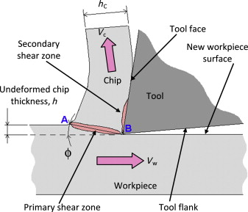

Role of Tool Geometry
- Rake Angle (α):
    - Facilitates easy chip flow.
    - Higher rake angle → lower cutting force and temperature.
- Clearance Angle:
i) Prevents rubbing between tool flank and machined surface.
ii) Proper tool geometry ensures smooth cutting action, reduced friction, and better surface
Finish.

Cutting Forces in Metal Cutting

Heat is generated mainly due to:
- Plastic deformation in the primary shear zone.
- Friction between the chip and the rake face of the tool.
Excessive temperature leads to:
Rapid tool wear & Poor surface finish. Hence, cutting fluids are used to cool and lubricate the cutting zone.

Types of Chips (Effect on Cutting Mechanics)
Depending on work material and cutting conditions, different chips are formed:
- Continuous chips: Ductile materials (good surface finish).
- Discontinuous chips: Brittle materials (irregular cutting).
- Built-Up Edge (BUE): Adhesion of work material on tool tip causing rough surface.
Chip type influences friction, heat generation, and surface quality.
Tool Wear and Its Relation to Cutting Mechanics
- High cutting force and temperature accelerate tool wear (flank wear, crater wear).
- Proper selection of cutting speed, feed, depth of cut, and tool material minimizes wear and increases tool life

2. Discuss Different Types of Chips and Their Formation Conditions.
Answer:

During metal cutting, the material ahead of the cutting tool is removed in the form of chips. The type of chip formed depends on the work material properties, cutting speed, tool geometry (rake angle), and cutting conditions. Chip type strongly influences surface finish, cutting force, heat generation, and tool life.
Different Types of Chips (Names Only):

- Continuous Chip
- Discontinuous (Fragmented) Chip
- Continuous Chip with Built-Up Edge (BUE)
Continuous Chips:
These are long, ribbon-like curls. They are generally considered the "gold standard" for a stable machining process, though they can be a safety hazard if they wrap around the tool.
- Materials: Ductile metals like mild steel, aluminum, or copper.
- Conditions: High cutting speeds, large rake angles, and low friction at the tool-chip interface (often aided by high-quality lubricants).
- Outcome: Provides a high-quality surface finish and longer tool life.
Discontinuous Chips
- These consist of small, separate segments. They form when the material is brittle or when the cutting conditions cause the metal to fracture rather than flow.
- Materials: Cast iron, bronze, or brass.
- Conditions: Low cutting speeds, small rake angles, or deep cuts.
- Outcome: Usually results in a poor surface finish and excessive tool vibration, but they are very easy to clear from the machine.
Continuous Chip with Built-Up Edge (BUE)

During the formation of a continuous chip, high friction and heat cause the material to "weld" itself to the tip of the tool. This creates a "built-up edge" that acts as a blunt cutting surface.
- Materials: Ductile materials that work-harden easily.
- Conditions: Low to medium cutting speeds and insufficient lubrication.
- Outcome: Bad news. The BUE eventually breaks off, damaging the surface finish and potentially chipping the tool.

3.(a) Explain tool life’s equation and its significance.
(b) A carbide tool has a tool life of 80 minutes when cutting at 150 m/min. For this tool-material combination, the exponent n is 0.25. If you increase the cutting speed to 200 m/min, what will the new tool life be?
Answer:

F.W. Taylor found experimentally that tool life (T) decreases rapidly as cutting speed (V) increases. The relationship between cutting speed and tool life follows a power law.

From experiments:
$$V∝\frac{1}{T^{n}}$$
Introducing constant $C$,
$$VT^{n}=C$$
This is called Taylor’s Tool Life Equation.

Extended Taylor’s Equation (Practical Form)
Considering effect of feed (f) and depth of cut (d):
$$\boxed{VT^{n}f^{m}d^{p}=C}$$Where:
V = Cutting speed (m/min)
T = Tool life (minutes)
f = Feed (mm/rev)
d = Depth of cut (mm)
n,m,p = Tool–work material constants
C = Constant for given tool–work combination

Tool Material | Value of $n$
HSS | 0.10 – 0.15
Carbide | 0.20 – 0.25
Ceramic | 0.30 – 0.40
CBN / Diamond | 0.40 – 0.60

Significance / Importance of Taylor’s Tool Life Equation
1. Selection of Cutting Speed
Helps in choosing optimum cutting speed for desired tool life.

$$V=\frac{C}{T^{n}}$$2. Economic Machining
Used to determine economic cutting speed and tool replacement policy to reduce machining cost.

3. Production Planning
Helps in:
- Estimating tool life
- Scheduling tool changes
- Planning machine downtime

4. Tool Material Comparison: By comparing values of nandC, different tool materials (HSS, carbide, ceramic) can be evaluated for performance.
5. Optimization of Machining Parameters: Extended equation helps optimize:
Speed, Feed& Depth of cut for maximum tool life or maximum production rate.
(b) Problem:
We need to find the machining constant (C) using the known conditions:
V₁ = 150 m/min, T₁ = 80 min, n = 0.25
Using the equation V T^{n} = C
150 × (80)^{0.25} = C
$C≈448.5$
Use the constant to find the new tool life T₂ at the higher speed V₂ = 200 m/min:
200×T₂^{0.25} = 448.5
T₂^{0.25} $=\frac{448.5}{200}=2.242$
T₂$≈25.3$mins

4.Explain difference between orthogonal and oblique cutting with diagrams.
Answer:

The table below differentiates between orthogonal cutting and oblique cutting.
Aspect | Orthogonal Cutting | Oblique Cutting
Tool Orientation | Tool is perpendicular to motion direction | Tool is at an oblique angle to motion direction
Types of Plane cutting | It is a 2-D cutting operation. | It is a 3-D cutting operation.
Component of forces | Two components of the cutting forces act on the tool.They are mutually perpendicular to each other i.e. tangential force and axial force | Three components of the cutting forces act on the tool. They are radial force, tangential force and axial force.
Chip Flow | Chip flows smoothly along the tool edge | Chip flow is curved or spiral, not along the edge
Tool Wear | Higher tool wear due to concentrated forces | Lower tool wear, leading to longer tool life
Location of maximum Chip thickness | The maximum chip thickness occurs at its middle. | The maximum chip thickness may not occur at the middle.
Cutting edge | The cutting edge is longer than the width of the cut. | The cutting edge may or may not be longer than the width of the cut.
Cutting Forces | Generally higher cutting forces | Cutting forces are distributed more evenly
Power Consumption | Higher power consumption | Potentially lower power consumption
Surface Finish and Precision | Excellent surface finish and precision | Good surface finish and precision
Applications | High precision, low volume machining | Versatile for various machining applications
Diagram: | 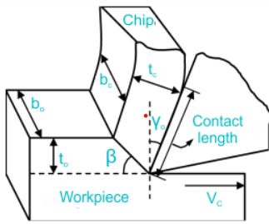 | 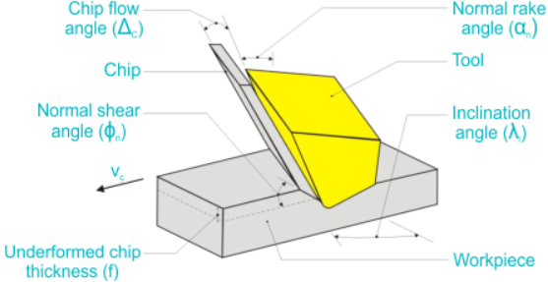

CHAPTER 2
2 MARKS QUESTIONS
Q1. Define Machinability.
Answer: Machinability is defined as the ease with which a material can be machined (cut) with a cutting tool under a given set of cutting conditions. It is usually judged by tool life, surface finish produced, and power consumption.
Q2. What is the Machinability Index? Answer:
The Machinability Index is a relative measure used to compare the machinability of different materials. It is usually expressed as a percentage, comparing the cutting speed of a specific material to that of a standard reference material (usually free- cutting steel, rated at 100%) for a fixed tool life.
Machinability Index(%) =$\frac{Cutting speed of the material being tested for a given tool life.}{Cutting speed of the standard steel (AISI 1212) for the same tool life.}$

Q3. List four important characteristics required for a cutting tool material.
Answer
- Hot Hardness (Red Hardness): Ability to retain hardness at high temperatures.
- Wear Resistance: Ability to resist abrasion.
- Toughness: Ability to withstand shock and impact loads.
- Low Friction: To reduce heat generation and power consumption.

Q4. Name four common types of cutting tool materials.
Answer:
            - High-Speed Steel (HSS)
            - Cemented Carbides
            - Ceramics
            - Diamond (PCD) / Cubic Boron Nitride (CBN)

Q5. What is the purpose of Heat Treatment for tool steels?
Answer: Heat treatment is performed to improve the mechanical properties of the tool steel. Specifically, it increases hardness (to cut other metals), improves wear resistance, and ensures the material has sufficient toughness to prevent breakage during cutting.

Q6. What do the ISO color codes P, M, and K stand for in Carbide specifications?
Answer:
P (Blue): For cutting long-chipping materials like Steel.
M (Yellow): For mixed applications (Stainless Steel, Cast Steel).
K (Red): For short-chipping materials like Cast Iron and Non-ferrous metals.
Q7. What are Ceramic Coatings on tools?
Give two examples. Answer: Ceramic coatings are thin layers of hard, wear-resistant material applied to the surface of HSS or Carbide tools to increase tool life.
Examples: Titanium Nitride (TiN) - Gold colour; Titanium Carbonitride (TiCN).

Q8. Differentiate between a Single Point and Multi-Point cutting tool.
Answer:
Single Point: Has only one cutting edge (e.g., Lathe tool, Shaper tool).
Multi-Point: Has more than one cutting edge engaged simultaneously (e.g., Milling cutter, Drill bit, Reamer).
Q9. What is the function of the Rake Angle on a cutting tool?
Answer: The rake angle guides the chip flow away from the cutting zone. A positive rake angle reduces cutting force and power consumption, making the edge sharper, while a negative rake angle strengthens the tool edge for heavy cuts.
Q10. What is a Reamer used for?
Answer: A reamer is a multi-point rotary cutting tool used for finishing a previously drilled hole. It removes a very small amount of metal to provide accurate sizing (tolerance) and a high-quality surface finish.

5 MARKS QUESTIONS

1. Explain the factors affecting Machinability.
Machinability is not an inherent property but depends on several variables:
- Material properties of work: Higher hardness and tensile strength generally lower machinability. Ductile materials may cause built-up edges (poor finish).
- Chemical Composition: Elements like Lead and Sulphur improve machinability (free-cutting steels), while Carbon and Nickel generally reduce it.
- Microstructure: A uniform grain structure allows for smoother cutting. Large grains may result in a rough finish.
- Cutting Conditions: Higher cutting speeds typically reduce tool life (lower machinability rating), though they may improve surface finish.
- Rigidity of Machine Tool: A vibrating machine leads to poor surface finish and tool failure, effectively reducing machinability.

2.Discuss the characteristics and applications of High-Speed Steel (HSS).
Answer:
Characteristics:
- HSS contains alloying elements like Tungsten (W), Chromium (Cr), and Vanadium (V). Red Hardness: It can retain its hardness up to about 600°C.
- Toughness: It is tougher than carbides, making it less prone to chipping. Easily shaped and ground.
Common Composition (18-4-1):
18% Tungsten, 4% Chromium, 1% Vanadium.
Applications:
- Drill bits (Twist drills). Milling cutters.
- Single-point lathe tools for general machining.
- Taps and dies.

3.Explain the heat treatment process of Tool Steels (HSS).
Answer:
Proper heat treatment is vital for HSS to achieve maximum hardness.

            - Preheating: The steel is heated slowly to 850°C to prevent thermal shock.
            - (Austenitizing): Heated rapidly to a high temperature (approx. 1200°C - 1280°C) to dissolve carbides into the matrix.
            - Quenching: Cooled rapidly in oil, air, or a salt bath to transform the structure into Martensite (very hard structure).
            - Tempering: The tool is reheated to 550°C-560°C two or three times. This relieves internal stresses caused by quenching and transforms retained austenite, ensuring stability and toughness (secondary hardening).

4.Write a note on Ceramic Coatings: Types and Advantages.
Answer:

Coatings are applied via CVD (Chemical Vapour Deposition) or PVD (Physical Vapour Deposition).

Types:
- Titanium Nitride (TiN): General purpose, gold colour, reduces friction.
- Titanium Aluminum Nitride (TiAlN): High thermal stability, excellent for high-speed machining.
- Diamond-Like Carbon (DLC): Extremely hard, low friction.

Advantages:
Increases tool life by 300% to 500%. Allows for higher cutting speeds.
Reduces diffusion wear and chemical reaction between tool and chip. Improves surface finish of the workpiece.

5.Draw and explain the geometry of a Twist Drill.
Answer:

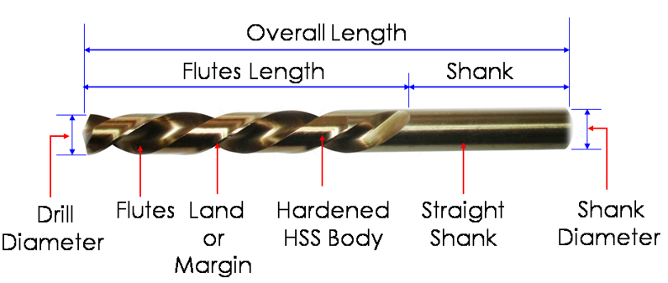

Explanation:

            - Axis: The longitudinal center line of the drill.
            - Body: The part of the drill between the point and the shank.
            - Shank: The part held in the holding device (Straight or Tapered).
            - Flutes: The helical grooves cut into the body. They remove chips and allow coolant to reach the cutting edge. Point Angle: The angle included between the cutting lips. Standard angle is 118°. Harder materials require a larger angle (135°).
            - Helix Angle: The angle between the leading edge of the land and the axis.

5.Briefly explain the geometry of a Plain Milling Cutter.
Answer:

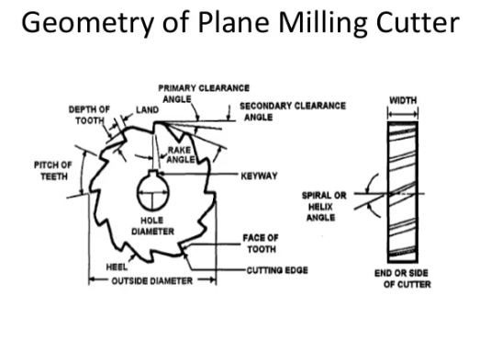
Key Angles:

- Radial Rake Angle: The angle between the face of the tooth and the radius of the cutter. Positive rake reduces power; negative rake is for carbide inserts.
- Relief (Clearance) Angle: The angle behind the cutting edge that prevents the back of the tooth from rubbing
against the workpiece.

- Helix Angle: The teeth are usually helical rather than straight. This ensures that the tooth enters the cut gradually, reducing shock and vibration (chatter).

10 MARKS QUESTIONS

1.Explain the geometry of a Single Point Cutting Tool with a neat diagram.Define all the major angles.
Answer: The geometry of a single point tool (used in lathes/shapers) is defined by seven parameters known as the "Tool Signature".

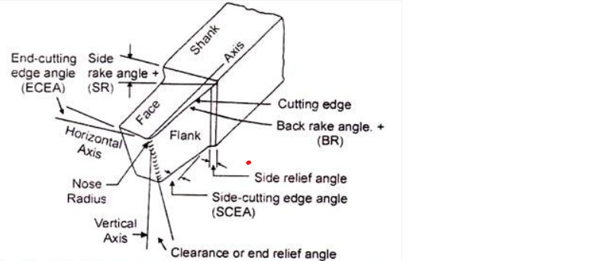 | 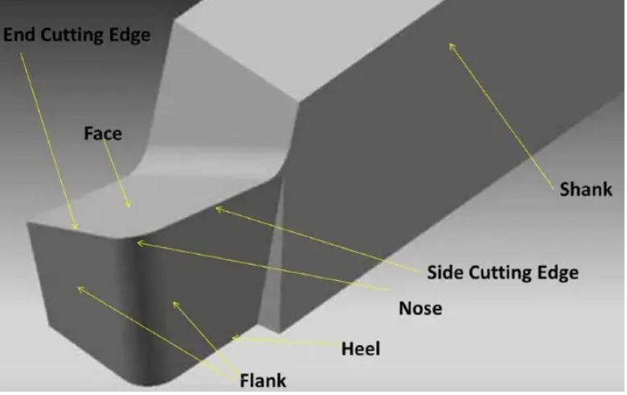

- Top Face: The top face (or rake face) of a single-point cutting tool is the surface over which chips slide away from the workpiece during machining. It is located adjacent to the cutting edges, typically featuring rake angles that facilitate smooth chip flow and influence tool strength and cutting force.

- Flank (Side and End): In a single-point cutting tool, the flank is the surface(s) directly below and adjacent to the cutting edge, crucial for guiding the tool and preventing excessive friction with the workpiece. A tool typically has two flanks: the major (side) flank, which controls side clearance, and the minor (end) flank, which controls end clearance.
- Nose Radius: The nose radius in a single-point cutting tool is the small radius applied to the tip where the side and end cutting edges intersect. It ranges from 0.6–1.5 mm for conventional tools to a few microns for precision tools. It increases tool life, strengthens the cutting tip, improves surface finish, and reduces chatter.
  - Back Rake Angle($α_{b})$: The angle between the face of the tool and a line parallel to the base of the shank. It controls chip flow direction.
  - Side Rake Angle($α_{s})$:: The angle between the tool face and a line perpendicular to the shank side. It controls chip thickness.
  - End Relief (Clearance) Angle${(γ}_{e}$):The angle between the end flank and a line perpendicular to the base. It prevents rubbing between the tool end and the workpiece surface.
  - Side Relief (Clearance) Angle${(γ}_{s}$): It prevents rubbing between the side flank and the workpiece
  - End Cutting Edge Angle(C_{e}):Angle between the end cutting edge and a line perpendicular to the shank. It prevents the trailing edge from rubbing the machined surface.
  - Side Cutting Edge Angle(C_{s}):Angle between the side cutting edge and the side of the shank. A larger angle increases tool life by distributing the cutting force.
  - Nose Radius(R): The curvature at the tip. A larger radius improves surface finish and strength but increases vibration.
Standard Tool Signature (ASA System):
Back Rake - Side Rake - End Relief - Side Relief - End Cutting Edge - Side Cutting Edge - Nose Radius
For example:
A "tool signature" format: 0-7-6-8-15-16-0.8
2.Classify Cutting Tool Materials. Compare High-Speed Steel (HSS), Cemented Carbides, and Ceramics in terms of composition, hardness, speed range, and cost.
Answer:
Classification:
- Cutting tool materials are classified based on their composition, hardness, and thermal resistance, ranging from traditional steels to super-hard materials.
- Major categories include High-Speed Steel (HSS), Cemented Carbides, Ceramics, Cubic Boron Nitride (CBN), and Diamond (PCD), selected based on required cutting speed, toughness, and workpiece material to withstand high heat and pressure.

Comparison Table:

Feature | High-Speed Steel (HSS) | Cemented Carbide | Ceramics Ceramics
Composition | Fe, C, W, Cr, V, Co | Tungsten Carbide (WC) + Cobalt binder | Aluminium Oxide (Al2O3), Silicon Nitride
Feature | High-Speed Steel (HSS) | Cemented Carbide | Ceramics
Hardness (Room Temp) | High (approx.65 HRC) | Very High (approx. 90 HRA) | Extremely High
Hot Hardness limit | Up to 600°C | Up to 1000°C | Up to 1200°C+
Toughness | Good (can withstand shock) | Moderate to Low (Brittle) | Very Low (Very Brittle)
Cutting Speed | Low (30 - 50 m/min) | Medium/High (150 - 250 m/min) | Very High (300 - 600 m/min)
Cost | Low | Moderate | High
Application | Drills, Taps, Complex cutters | Lathe inserts, CNC turning | High-speed finishing of hard metals

3. Describe the Specification of Carbide Tips (Inserts) according to ISO standards with examples.
Answer:

Carbide inserts are specified by a code consisting of letters and numbers (e.g., CNMG 120408). This tells the user the shape, size, and tolerance of the insert.

The Breakdown of the ISO Code:
Shape (1st Letter):
Describes the geometry.
C = Rhombic (80°), T=Triangular (60°), S = Square (90°)
Relief Angle (2nd Letter):
The clearance angle on the insert.
N=0°(Negativeinsert,usedforheavyduty)
C = 7° (Positive insert)

Tolerance (3rd Letter):
The dimensional accuracy.
M = Moulded (General purpose) G = Ground (High precision)

Clamping/Chip Breaker (4th Letter):
How the insert is held or hole type.
G = Cylindrical hole and Double-sided chip breaker. A = Cylindrical hole, no chip breaker.

Size (Next 2 digits): Length of the cutting edge (e.g., 12 = 12mm).
Thickness (Next 2 digits): Thickness of insert (e.g., 04 = 4.76mm).
Nose Radius (Last 2 digits): Radius of the corner (e.g., 08 = 0.8mm).

Example: TNMG 160404

T: Triangular Shape
N: 0° Relief Angle
M: Moulded Tolerance
G: Hole with chip breaker
16: 16mm cutting edge length 04: 4.76mm thickness
04: 0.4mm nose radius

4.Explain the geometry and types of Milling Cutters.
Answer:

Milling Cutter Geometry
The geometry of a milling cutter defines how the tool interacts with the material. Key features include:

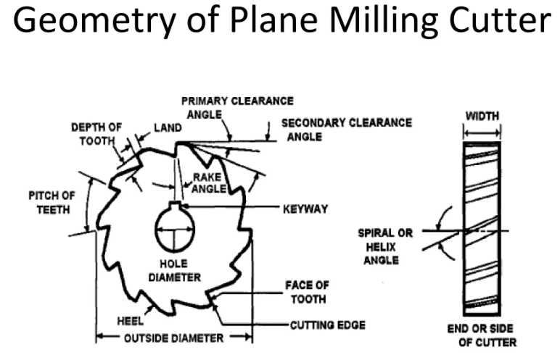
- Rake Angles:
  - Radial Rake: The angle between the tooth face and a radial line from the cutter's center. Positive rake reduces cutting force and heat, while negative rake strengthens the cutting edge for hard materials.
  - Axial Rake: The angle formed by the tilt of the peripheral edge relative to the center axis. It helps direct chip flow away from the workpiece.
- Clearance & Relief Angles: These angles (Primary and Secondary) prevent the tool's flank from rubbing against the newly machined surface, reducing friction and heat.
- Helix Angle: The angle of the flutes along the tool's body. A higher helix angle (e.g., 45°) provides a smoother shearing action and better chip evacuation in soft materials like aluminium.
- Land: The narrow surface behind the cutting edge that is relieved to provide clearance.

Common Types of Milling Cutters
Milling cutters are broadly categorized by their application and how they are mounted (arbormounted or shank-mounted).
1. End Mills
One of the most versatile cutters, feature cutting edges on both the tip and the sides. They can cut axially (like a drill) and laterally.
- Square End Mill: Used for slotting and creating sharp 90° corners.
- Ball Nose End Mill: Has a hemispherical tip, ideal for 3D contouring and complex curved surfaces.
- Roughing End Mill: Also called "Hog Mills," these have jagged teeth to break up chips and remove large amounts of material quickly with less vibration.
2. Face Mills
are designed for machining large, flat surfaces. They typically use replaceable carbide inserts and cut primarily with the face of the tool rather than the sides. This ensures a smoother finish on wide horizontal surfaces.
3. Specialty Cutters
- Slab Mills: Large, cylindrical cutters used for "surface milling" wide flat areas, usually on horizontal milling machines.
- T-Slot Cutters: Shaped like a "T" to mill T-slots in machine tables and fixtures.
- Woodruff Cutters: Used specifically to cut semi-circular keyway slots for Woodruff keys in shafts.
- Side and Face Cutters: Have teeth on the perimeter and the sides, allowing them to cut deep vertical or diagonal grooves.

CHAPTER 3
02 MARKS QUESTIONS
1. What is a Simple Die?
Answer:
- A simple die, or single-operation die, is a manufacturing tool designed to perform only one cutting or forming operation such as blanking, punching, bending, or trimming per press stroke.

- It is characterized by lower tooling costs and shorter lead times, making it ideal for low-volume production and simple, straightforward tasks.

2. Define Compound Die.
Answer:
- A compound die is a type of metal stamping tool that performs multiple operationssuch as blanking (cutting the outer shape) and piercing (punching inner holes)simultaneously in a single press stroke at one station.

- It is primarily used for producing flat, high-precision parts like washers and small components.

3. What is a Progressive Die?
Answer:
- A progressive die is a metalworking tool used in a stamping press that performs multiple, sequential operations (such as punching, bending, and cutting) on a single strip of metal as it advances through the machine.

- It transforms raw material into a finished, complex part in one pass, making it highly efficient for high-volume, high-precision production.

4. What is a Combination Die?
Answer:
- A combination die is a specialized metal stamping tool that performs multiple, distinct operations typically combining cutting (blanking/piercing) with forming (bending/drawing) in a single stroke of a press.
- It consolidates these steps at one station to increase production efficiency and part accuracy, differing from compound dies, which usually only combine cutting operations.

5. What is the function of a Pilot in press tools?
Answer:
Pilot is used to ensure accurate positioning of the strip in the die and maintain proper pitch in progressive dies.

6. What is a Stripper Plate?
Answer:
A stripper plate removes the sheet metal or component from the punch after the cutting operation.

7. What is a Misfeed Detector?
Answer:
A misfeed detector is a safety device which detects improper feeding of strip and stops the press to prevent tool damage.

8. What is a Pressure Pad?
Answer:
Pressure pad applies holding pressure on the sheet metal during cutting or forming operation to prevent wrinkling.

9. What is a Feed Stop?
Answer:
Feed stop is a device used to control and fix the feed length of the strip during operation.

10. What is the function of Guide Bush?
Answer: Guide bush maintains proper alignment between punch and die, ensuring accuracy and reducing wear.

5 MARKS QUESTIONS
1. Explain Simple Die with construction and applications.
Answer:
- A simple die is a press tool designed to perform only one operation in one stroke of the press, such as blanking or piercing.
- Construction:
It consists of die block, punch, punch holder, stripper plate, die holder, guide pillars and bushes.
- Working:
When the press ram moves downward, the punch shears the sheet metal against the die opening. The stripper removes the strip from the punch during return stroke.
- Applications:
Used for small batch production, simple components like washers, small blanks.
- Advantages:
Simple construction, low cost, easy maintenance.
2. Explain Compound Die with neat sketch.
Answer:
Compound Dies:
- In these dies, two or more operations may be performed at one station. Such dies are considered as cutting tools since, only cutting operations are carried out.
- Figure shows a simple compound die in which a washer is made by one stroke of the press.
- The washer is produced by simulation blanking and piercing operations.
- Compound dies are more accurate and economical in production as compared to single operation dies.

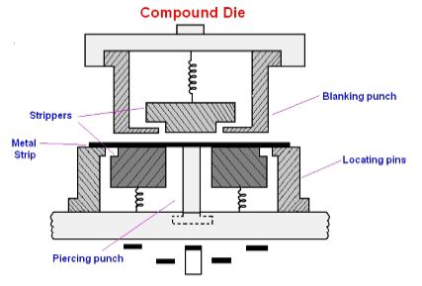

- Simultaneous blanking and piercing are achieved by providing blanking and piercing element in both the member of die, i.e. the upper and the lower member of the die.
- These elements are set exactly opposite to each other so that piercing punch acts in the opposite direction with respect to the blanking punch.
- In this way blanking and piercing operations are performed simultaneously.
- Angular clearance is provided in the piercing die.
- This helps in easy removal of scrap from the die. The blanking punch acts as a piercing die.
- The sidewall, which is adjacent to cutting edges of blanking die opening, is straight so that the blank does not pass through the die.
- Knock out stroke is actuated during the return stroke of the press. It ejects the blank.
- Compound dies are slow in operation but give close tolerance on workpiece.
- The flatness of the blank is achieved during cutting operation by knockout plate.
- Large parts can be blanked in a smaller press by using compound die.

3. Explain Combination Die with suitable example.
Answer:
- A combination die performs cutting and forming operations in a single stroke of the press.’
- A combination die works by integrating multiple functional operations into one die tool set so that several tasks are completed in a single press cycle. The die is mounted in a stamping press, and as the press ram descends, the die performs coordinated cutting and forming actions to shape the metal workpiece.
- Example:
Piercing and bending of a component in one stroke
- Advantages:
High productivity, reduced handling, accurate parts.
- Applications:
Combination dies are utilized in high volume production for medium and small metal stamping where accuracy and precision are paramount, and apply to automotive components, aerospace parts, electronics and electrical enclosures industrial hardware and brackets.

4. Explain Stripper Plate and its types.
Answer:
Stripper plate removes the workpiece from the punch after cutting.
Types:
1. Fixed stripper
2. Spring-loaded stripper
Functions:
Prevents lifting of sheet metal, improves safety, maintains accuracy and protects punch.

5. Comparison between progressive and compound dies.
Answer:
SL NO | PROGRESSIVE DIES | COMPOUND DIES
1 | It performs one operation at a time in each station. | It performs more than one operation at a time in each station.
2 | Tonnage requirement is less. | Tonnage requirement is more
3 | It is simple in design and construction of die set, | It is complicated in design construction of die set.
4 | It ensures less accurate position relationship between various elements of the job. | It ensures more relationship between various elements of the job.
 | It is less expensive to construct and repair. | It is more expensive to construct and repair.

6. Explain Punch and Die Mountings with functions.
Answer:
- Punch and Die Mountings:
- Pilots – Accurate strip positioning.
- Strippers – Remove strip from punch.
- Pressure Pads – Hold sheet during forming.
- Knock-outs – Eject finished component.
- Stock Guides – Guide metal strip.
- Feed Stop – Controls feed length.
- Guide Pins & Bushes – Maintain alignment.
- Misfeed Detectors – Safety device.

10 MARKS QUESTIONS

1. Explain types of dies with construction and applications.
Answer:

- Die is a tool used to cut or shape the material in a press. Dies are custom designed on the basis of parts to be produced.
- Die is a tool used to cut or shape the material in a press. Dies are custom designed on the basis of parts to be produced. A die set is the fundamental portion of every die.
- It consists of two halves such as upper shoe and lower shoe. The die block is attached on the lower shoe. The die opening (female part of the die set) is machined on the die block. The punch plate is attached on the upper shoe. The punch (male part of the die set) is fastened on the punch plate.
- Both die block and punch plate are separate from die shoes by backup plates. Both die shoes are connected by guide pins or guide posts which provide a precise alignment of these two halves during die operation.

The dies may be classified according to the type of operation performed and according to the type of construction of die. The various types of dies are as follows.
Types of Dies:
1. Simple Die
2. Compound Die
3. Progressive Die
4. Combination Die

SIMPLE DIES
Simple dies are designed to perform any single specific operation such as blanking, punching, notching, trimming, etc. It consists of standard components of a die set. It may also be called a single operation die. Stop pins are also provided in the die for indexing the strip of sheet metal.

COMPOUND DIE

In a compound die, two or more cutting operations such as blanking and piercing operations are combined and carried out in one stroke of the press at one station only. In order to perform this operation, both upper and lowerelements of the die set carry punching and blanking elements are placed directly opposed to each other. In other words, the piercing punch acts in the opposite direction with respect to the blanking punch.

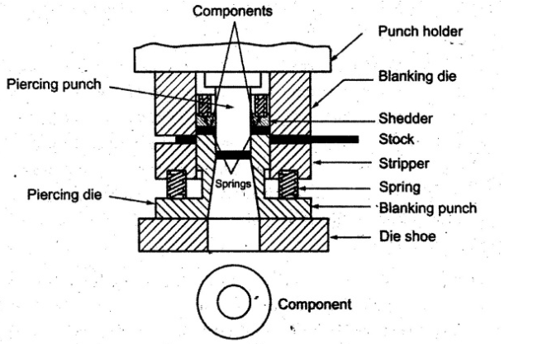

Compound Die Figure

The above Figure shows a simple compound die. It is used for producing a workpiece (i.e., washer) which is pierced and blanked at one station in one stroke. Here, the blanking punch also serves as the piercing die. The

blanking punch and blanking die opening are mounted in an inverted position. The sidewalls adjacent to cutting edges of the blanking die opening are straight because the blank does not pass through the die. During part of the stroke, the hole is pierced on the stock and upon further travel, the blanking operation is done. Angular clearance must be provided on the piercing die to allow slugs to drop through the die.

PROGRESSIVE DIE

Progressive die is also known as cut-carry die. It is a multi-station die that performs several operations in a single stroke of the ram in a press. The stock strip is advanced through a series of stations that perform one or more distinct die operations on the workpiece. The strip must move through each succeeding station to produce a complete workpiece. After that, a complete workpiece is produced with each stroke of the ram. Example, piercing operation is carried out in one station and it is further progressed to the next station to perform blanking operation. At the same time, the next piercing operation will be performed for the second washer while blanking the first washer.

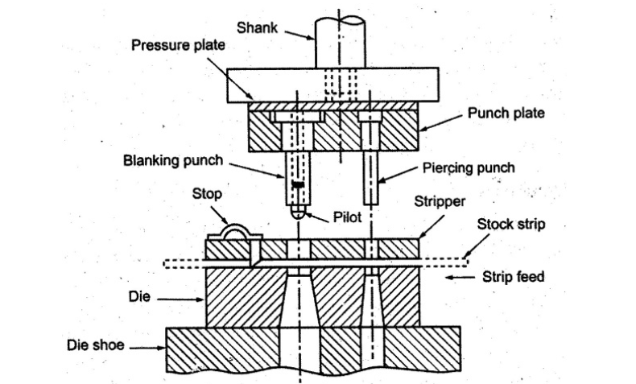

Progressive Die Figure

The above figure shows a progressive die to carryout both piercing and blanking operations. The stock strip is fed into the die mechanically or by hand. The primary stop is pushed-in by hand to hold against the lead end of the sheet metal. The primary die stop is drawn back after the hole is pierced. The hole is pierced by the piercing die set in the first cutting stroke of the ram.

After the primary die stop is released, the stock advances to the next station where it contacts the automatic button die stop. The correct spacing is obtained by the help of a secondary stop pin. In the second cutting stroke of the ram, the pilot of the blanking punch enters the pierced hole and it ensures exact alignment of the stock as the part is blanked. At the same time, the blanking punch descends and shears the metal to form a washer. While the blanking operation is performed; the piercing punch produces a hole for the next washer at the first station. Thus, after the first stroke, when only a hole is punched, each stroke of the press produces a finished washer.

The blanking and piercing punches should not be of same height. A stepping is given in order to reduce forces. For piercing operations, the punch will have the shear and the die will be flat. For blanking operations, the punch will be flat and the shear is given to the die.

COMBINATION DIES
In combination dies, in addition to cutting operations, non-cutting operations are also performed. In other words, both cutting and non-cutting operations (forming) are combinedly carried out in one stroke of the press. The typical cutting operations that may be performed in the combination die are blanking, punching, trimming, cutting-off, etc., whereas non-cutting operations are bending, forming, extruding, embossing, etc. Figure 4.15 shows a combination die that blanks and draws a cup.

The upper die block has a blanking punch at its centre. As the punch descends, the metal is first sheared and required size of the blank is obtained. The drawing punch is now actuated and drawn out the metal while the blanking punch serves as a pressure pad. A spring stripper strips the skeleton from the blanking punch. A knock out bar extending through the centre opening is used to eject the drawn-out part at the end of stroke.

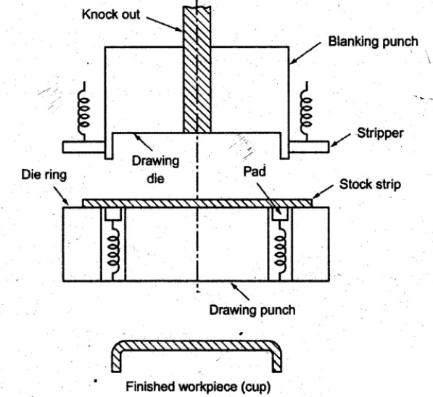

Combination Dies Figure

2.Explain Progressive Die with neat labelled diagram and working along with advantages,
disadvantages and application.
Answer:
Progressive die is also known as cut-carry die. It is a multi-station die that performs several operations in a single stroke of the ram in a press. The stock strip is advanced through a series of stations that perform one or more distinct die operations on the workpiece. The strip must move through each succeeding station to produce a complete

workpiece. After that, a complete workpiece is produced with each stroke of the ram. Example, piercing operation is carried out in one station and it is further progressed to the next station to perform blanking operation. At the same time, the next piercing operation will be performed for the second washer while blanking the first washer.

Progressive Die Figure

The above figure shows a progressive die to carryout both piercing and blanking operations. The stock strip is fed into the die mechanically or by hand. The primary stop is pushed-in by hand to hold against the lead end of the sheet metal. The primary die stop is drawn back after the hole is pierced. The hole is pierced by the piercing die set in the first cutting stroke of the ram.

After the primary die stop is released, the stock advances to the next station where it contacts the automatic button die stop. The correct spacing is obtained by the help of a secondary stop pin. In the second cutting stroke of the ram, the pilot of the blanking punch enters the pierced hole and it ensures exact alignment of the stock as the part is blanked. At the same time, the blanking punch descends and shears the metal to form a washer. While the blanking operation is performed, the piercing punch produces a hole for the next washer at the first station. Thus, after the first stroke, when only a hole is punched, each stroke of the press produces a finished washer.

The blanking and piercing punches should not be of same height. A stepping is given in order to reduce forces. For piercing operations, the punch will have the shear and the die will be flat. For blanking operations, the punch will be flat and the shear is given to the die.

Advantages:
(i) The number of operations can be performed with one handling of the stock strip.
(ii) For every stroke of the ram, one workpiece is made.
(iii) It is fairly simple to construct and it is more economical to repair.
(iv) It is suitable for mass production.
Disadvantages:
(i) Thin stock of soft materials may cause troubles by bending or tearing around piloting holes.
(ii) Workpiece may become dished as they are pushed through the die since they have less support.
(iii) It is complicated design of die set as compared with simple dies.
(iv) The cost of die set is high when compared to simple die set.
Application:
Applications include automotive components, electronics, aerospace, and appliances.

3.Explain Compound Die with neat labelled diagram and working along with advantages, disadvantages and application.
Answer:
In a compound die, two or more cutting operations such as blanking and piercing operations are combined and carried out in one stroke of the press at one station only. In order to perform this operation, both upper and lower elements of the die set carry punching and blanking elements are placed directly opposed to each other. In other words, the piercing punch acts in the opposite direction with respect to the blanking punch.

Compound Die with neat labelled diagram
Advantages:
(i) More accurate work piece can be produced.
(ii) Large parts can be blanked in a small press if compound dies are used.
(iii) Shorter length of strip materials can be used
(iv) The cost of production is less.
Disadvantages:
(i) It is more expensive to construct and repair.
(ii) It is slower in operation as compared with progressive dies.
(iii) The design of the die set is complicated when compared to progressive dies.
(iv) The tonnage requirement is high.
Application:
    - Automotive: Producing washers, brackets, gaskets, shims, and intricate, flat components.
    - Electronics: Manufacturing electrical connectors, terminals, and circuit board components.
    - Appliances: Creating internal parts, structural panels, and electrical insulation components.
    - General Manufacturing: Producing small, simple, and flat parts, including motor laminations
    - Materials: Suitable for working with metal sheets, as well as rigid materials like plastic, fish paper

4.Explain misfeed detectors and pressure pads.
Answer:
Misfeed detectors:
Misfeed detectors are sensors, such as contact, whisker wire, or photo-electric types, installed in stamping dies to ensure the material is in the correct position before the press operates.
- Purpose: To prevent "die crashes" by stopping the press if the material is misfed (short, long, or off-center).
- Mechanism: A detector pin or sensor monitors the material edge or pilot holes. If the material is not properly positioned, the sensor activates (e.g., a pin is pushed up, triggering a micro switch), sending a signal to immediately stop the press machine.

- Types:
  - Contact Type: A pin touches the material, detecting misalignment, and works well for conductive materials.
  - Proximity/Photoelectric: Non-contact sensors suitable for detecting edge positioning without touching the material.
- Significance: High-speed, accurate, and essential for automating production and reducing waste.

Pressure Pads
- Pressure pads (often part of a stripper plate or clamping mechanism) apply consistent force to the material during the stamping process.
- Purpose: To hold the metal sheet securely, flatten it, and prevent it from shifting or wrinkling while the die is performing operations like cutting or bending.
- Mechanism: They operate under high pressure (often hydraulic or pneumatic), acting on a workpiece to ensure it is held in place, allowing the punch to create precise cuts or forms.
- Functionality: They often incorporate sensors themselves to ensure proper clamping force is maintained.
- Significance: Essential for dimensional accuracy, minimizing material deformation, and protecting the longevity of the die tooling.

CHAPTER 4
2 MARKS QUESTIONS

1: Define blanking.
Answer:
- Blanking is a shearing operation in which the desired part is cut out from the sheet metal, and the remaining sheet is scrap.
- The cut-out piece is the useful product.
- Example: Producing washers, coins, or flat components from metal sheets.

2: Define piercing.
Answer:
- Piercing is a sheet metal shearing operation in which holes are produced in the sheet, and the removed metal is scrap, while the sheet with the hole is the required product.
- Making bolt or rivet holes in sheet metal plates.

3: What is die clearance?
Answer:
- Die clearance is the intentional gap provided between the punch and the die opening during shearing operations (blanking/piercing) to allow proper cutting of sheet metal.
- It is usually expressed as a percentage of sheet thickness (typically 5–10% per side, depending on material).
- Proper clearance gives clean cut edges, lower cutting force, and longer tool life.

4: Define strip layout.
Answer:
- Strip layout is the arrangement of blanks on the metal strip in such a way that minimum material is wasted and smooth, economical production is achieved during press working operations.
- It is the planning of blank positions on the strip to obtain maximum material utilization and proper feeding.

5: What is material utilization factor?
Answer:
- Material Utilization Factor (MUF) is the ratio of the area of useful blank produced to the total area of strip material consumed, usually expressed as a percentage.
- $\text{Material Utilization Factor}=\frac{\text{Area of blank}}{\text{Area of strip consumed}}×100$
- It indicates how efficiently the sheet metal is used in a given strip layout (higher value = less scrap).

6: Define shearing.
Answer:
- Shearing is a metal cutting operation in which sheet metal is separated along a straight line by applying opposing cutting forces between a punch and die (or blades), causing fracture along the shear line.
- Shearing is the process of cutting sheet metal by shear force without forming chips.

7: What is die set?
Answer:
- A die set is the complete assembly that holds and guides the punch and die in correct alignment during press operations.
- It consists of upper shoe (punch holder), lower shoe (die holder), guide pillars and guide bushes.
- Die set is the supporting and guiding framework for accurate die operation in press working.

8: Define coining.
Answer:
- Coining is a sheet metal forming operation in which the material is compressed between punch and die under very high pressure to produce fine details, sharp impressions, or surface patterns on the workpiece.
- Coining is a high-pressure squeezing operation used to create precise impressions on sheet metal.

9: What is embossing?
Answer:
- Embossing is a sheet metal forming operation used to produce raised (projected) or sunken (recessed) designs on the surface of sheet metal without cutting or removing material.
- Embossing creates decorative or functional surface patterns on sheet metal by plastic deformation.

10: Define bending.
Answer:
- Bending is a sheet metal forming operation in which the metal is plastically deformed along a straight axis to obtain a desired angle or shape without significant change in thickness.
- Bending is the process of turning a flat sheet into an angular or curved shape by plastic deformation.

5 MARKS QUESTIONS

1. Explain Blanking and Piercing Operations.
Answer:

Blanking Operation:

- In blanking, the required part is cut out from the sheet metal, and the remaining sheet is treated as scrap.
- The cut piece is called the blank and is the useful product.
- The size of the blank is equal to the die opening.
- Used for making components like washers, gaskets, coins, electrical laminations, etc.

Piercing Operation

- In piercing, holes are produced in the sheet metal, and the removed portion (slug) is scrap, while the sheet with holes is the useful product.
- The size of the hole is equal to the punch size.
- Used for making bolt holes, rivet holes, ventilation holes, etc.

2. Explain drawing process.
Answer:
- The drawing process in tool engineering is a metal-forming manufacturing technique used to reduce the cross-sectional area of a work piece (wire, bar, or tube) by pulling it through a tapered die.
- It is primarily a cold-working process that enhances material strength, surface finish, and dimensional accuracy.
Principle of Drawing
- A flat blank is placed over the die opening.
- Ablank holder (pressure pad) holds the blank to prevent wrinkling.
- The punch moves downward, pulling the metal into the die cavity.
- The metal flows plastically from the flange area into the die, forming a cup-like shape.
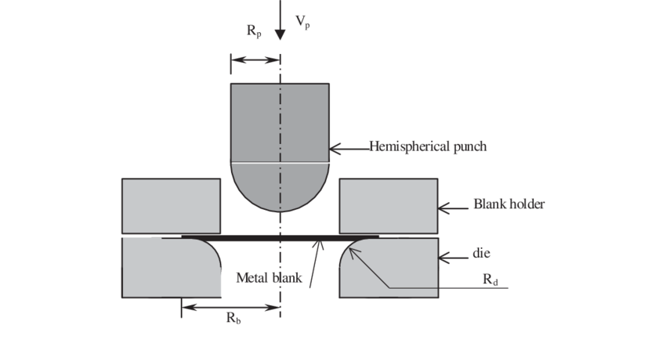
2. Briefly explains strip layout and its objective.
Answer:
- Strip layout is the planned arrangement of blanks or pierced parts on a metal strip showing the sequence of operations, pitch, margins, and scrap so that parts can be produced economically with maximum material utilization in a press tool (progressive/compound die).
- It indicates the pitch, margins, web, carrier strip and the sequence of operations.
- The main objective of strip layout is to achieve maximum material utilization with minimum scrap and to ensure smooth feeding of the strip into the die.
- Proper strip layout also helps in balanced cutting forces, better tool life and higher production rate.
- The layout depends on component shape, material thickness, type of dies and grain direction of the sheet.

3.Explain embossing and stamping.
Answer:

Embossing
- Embossing is a sheet metal forming operation in which raised or sunken designs are produced on the surface of sheet metal using matched punch and die without cutting the material.
- It is mainly used for decorative purposes, identification marks and to improve stiffness of components.
- Applications: Name plates, logos, decorative panels, Appliance panels, Automotive body designs, Coins, patterns on metal sheets
Stamping
- Stamping is a broad term used for press-working processes in which sheet metal is cut, bent or formed into desired shapes using a punch and die in a press machine.
- Stamping includes operations such as blanking, piercing, bending, drawing, embossing and coining. Stamping is widely used for mass production of automobile parts, electrical components and household items due to high production rate, accuracy and economy.
- Automobile parts Electrical and electronic components Washers, brackets, clips Kitchenware and enclosures.
4.Define notching, lancing and coining.
Answer:
Notching:
- Notching is a cutting operation in which a small portion of material is removed from the edge of a sheet metal strip or blank to produce a notch or cut-out.
- It is mainly used to prepare the work piece for subsequent bending or forming operations or to obtain required shape at the edge.
- Example: Cutting V-notches at the edges of sheet metal before bending.
Lancing:
- Lancing is a combined cutting and bending operation in which the sheet metal is partially cut and then bent or raised, without removing any material.
- It produces tabs, louvers, or ventilation openings in sheet metal.
- Example: Making ventilation slots in electrical panels.
Coining:
- Coining is a severe compressive forming operation in which the metal is squeezed between punch and die to produce sharp details, fine impressions, or raised/sunken features, with localized reduction in thickness.
- High pressure is used to obtain accurate and sharp profiles.
- Example: Coining of coins, logos, serrations on metal parts.

5. Discuss shearing and bending operation.
Answer:
Shearing:
Shearing is a cutting operation in which sheet metals is separated along a straight line by the action of a punch and die or by blades, due to shear stress exceeding the material’s shear strength.

Working Principle
- The sheet is placed between punch and die.
- As the punch moves down, the material first deforms plastically, then fractures, causing separation.
- Proper die clearance is required for clean cut edges.

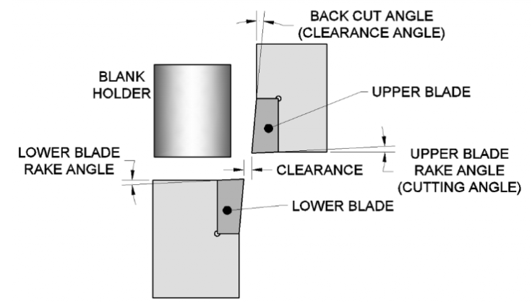

Bending:
Bending is a forming operation in which sheet metal is plastically deformed along a straight axis to change its shape into V, U, channel, or angle forms without changing thickness significantly.

Working Principle
- The sheet is placed on a die and bent by a punch.
- The outer fibers undergo tension and inner fibers compression.
- After unloading, springback occurs and must be compensated.

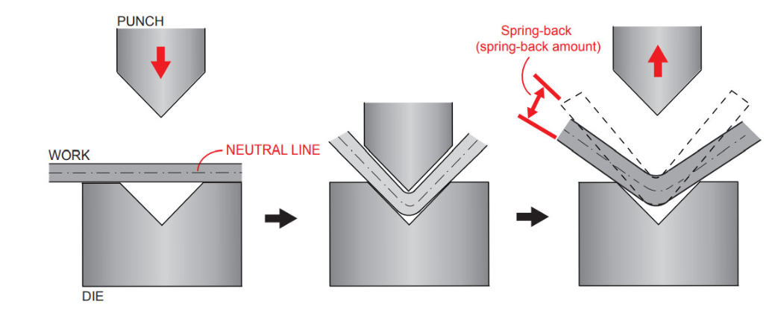

QUESTION OF 10 MARKS

            - (a)A circular blank of 50 mm diameter is to be produced from a metal strip in a progressive die. The side margin is 5 mm on each side and the scrap bridge between successive blanks is 6 mm. Design the strip layout and calculate Strip width Pitch Material Utilization Factor (MUF).

(b) A rectangular blank of size 80 mm × 50 mm is to be blanked from 2 mm thick mild steel. Shear strength of MS = 300 N/mm². Cutting force Minimum die area required if allowable bearing pressure on die steel = 1000 N/mm².
(a)
Answer.Given:
- Diameter of blank, D=50D = 50D=50 mm
- Side margin on each side = 5 mm
- Scrap bridge = 6 mm
Strip width=D+2×side margin =50+2(5)=60 mm

Pitch=D+scrap bridge=50+6=56 mm

Area of Blank:
A_{b} =$\frac{π}{4}×d^{2}$=$\frac{π}{4}{50}^{2}=$1936.5 mm²
Area of Strip Consumed:
As​=Strip width × Pitch
As=60×56=3360 mm²
Material Utilization Factor:
MUF= $\frac{Ab}{As}$=$\frac{1963.5}{3360}$=58.43%

(b)
Perimeter of blank
P=2(L+B)= 2(80 + 50) = 260 mm
F=Perimeter × t × τs​
F=260×2×300=156,000 N =156 KN
Die area
Die area​ =$\frac{Allowable pressure ​}{ Cutting force}$
A_{d}=$\frac{156,000​}{1000}=$156 mm²

2.A 2 mm thick mild steel sheet is to be blanked and pierced. Recommended clearance for mild steel 8% of sheet thickness per side. Calculate: Clearance per side, Total clearance& Punch and die sizes for
a) Blanking a circular blank of 40 mm diameter
b) Piercing a circular hole of 40 mm diameter
^{Given:}
^{Thickness=2 mm}
^{Clearance per side = 8}
c=0.08×t=0.08×2=0.16 mm (per side)
^{Total clearance =2c=0.32 mm}

Blanking Die Dimensions
In blanking, the die controls the blank size.
Required blank diameter = 40 mm
Die opening = 40 mm
Punch diameter = Die size − 2c
Punch diameter=40−0.32=39.68 mm
Punch diameter=40−0.32=39.68 mm
Blanking Sizes:
Die diameter = 40.00 mm
Punch diameter = 39.68 mm
Clearance per side = 0.16 mm

(b) Piercing Die Dimensions
- Required hole diameter = 40 mm
- Punch diameter = 40 mm
- Die opening = Punch size + 2c=Die diameter=40+0.32=40.32 mm

Piercing Sizes:
Punch diameter = 40.00 mm
Die diameter = 40.32 mm
Clearance per side = 0.16 mm

3. Define drawing operation and its working principles. Mentions its types of drawing operation and application.
Drawing (Deep Drawing) is a sheet metal forming operation in which a flat sheet metal blank is converted into a hollow component (such as a cup or box) by forcing it into a die cavity with a punch, usually with the help of a blank holder to control material flow and prevent defects. Examples: cans, cups, kitchen sinks, cartridge cases, shells, containers.
Construction of Drawing Die Set
The main parts of a drawing setup are:
- Punch: pushes the blank into the die cavity.
- Die: provides the cavity shape of the drawn component.
- Blank holder (Pressure pad): holds the blank to prevent wrinkling.
- Die set: upper and lower shoes with guide pillars and bushes for alignment.
- Lubrication: reduces friction and tearing.

Working Principle
- The blank is placed over the die opening and held by the blank holder with controlled pressure.
- The punch moves downward, causing the blank to flow radially into the die cavity.
- During drawing, the flange region undergoes compressive stresses, while the wall experiences tensile stresses.
- Proper clearance between punch and die and corner radii allow smooth metal flow.
- If the depth is large, redrawing operations are used in stages.

Types of Drawing
- Shallow drawing
- Deep drawing
- Redrawing (multiple stages)
- Reverse drawing
- Ironing (wall thickness reduction, if required)
Applications
- Beverage cans, cooking vessels
- Automotive body parts
- Electrical and electronic enclosures
- Ammunition shells and containers

CHAPTER-5
2 MARKSQUESTIONS

1. Define "Bend Allowance" and why it is necessary?
Answer:
Bend allowance is the length of the arc along the neutral axis of a metal part between the bend lines. It is necessary because metal stretches on the outside of a bend and compresses on the inside; calculating the allowance ensures the final part meets specific dimensional requirements.

2. What is "Spring Back" in bending, and how can it be compensated?
Answer:
Spring back is the elastic recovery of metal after the forming pressure is released, causing the part to partially return to its original shape. It can be compensated by over-bending the part beyond the required angle or using bottoming/spanking dies to set the metal.

3. Define bending pressure.
Answer:
Bending pressure (also known as bending force) is the total amount of force that a press must exert on the punch and die to deform a piece of sheet metal into a desired shape.

4. What is a pressure pad?
Answer:
A pressure pad is a device used to hold the sheet metal firmly during bending or drawing to prevent wrinkling and slipping.

5. Define single action die.
Answer:
A single action die performs one operation (such as drawing) in one press stroke.

6. Define double action die.
Answer:
A double action die has two movements: one for blank holding and the other for punch movement in drawing.

7.What is a pressure die casting die?
Answer:
It is a mold used to inject molten metal under high pressure to produce precise cast components.

8. What is metal flow during drawing?
Answer:
Metal flow is the controlled movement of material from the flange into the die cavity during drawing operation.

9. What is a metal extrusion die?
Answer:
A metal extrusion die is a tool with a shaped orifice through which heated or cold metal is forced to produce long products of uniform cross-section.
10. State two main parts of a metal extrusion die.
Answer:
Die orifice (die opening) and mandrel (for hollow sections).

5 MARKSQUESTIONS

1. Explain Metal Flow during Drawing.
Answer.
  - During drawing, metal flows radially inward from the flange region into the die cavity.
  - The flange is under compressive stresses while the wall is under tensile stresses.
  - Controlled metal flow is achieved by:
- Proper blank holder force
- Suitable lubrication
- Correct die and punch radii
- Uncontrolled flow leads to wrinkling, tearing, earing.

2. Explain Drawing Operation with principle.
Answer:

Drawing is a sheet metal forming process in which a flat blank is converted into a hollow component (cup, shell) using punch, die and blank holder.
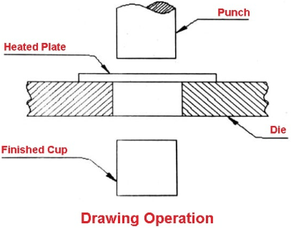
The metal flows from the flange into the die cavity. Proper blank holder force and lubrication prevent wrinkling and tearing.
Applications: cups, cans, automobile body parts.

3. Explain Bending Pressure, Pressure Pads and Spanking.
- Bending pressure: Force required to plastically deform the sheet to required angle; depends on thickness, material, bend length and die opening.
- Pressure pads: Hold the blank firmly during bending to prevent slipping and wrinkling.
- Spanking (Coining/Bottoming): High pressure is applied at the end of bending stroke to reduce spring back and obtain accurate angle.
4. Explain Spring Back and methods to reduce it.
Answer.
Spring back is the elastic recovery of sheet metal after removal of bending force, causing the bend angle to open slightly.
Causes: Elastic nature of material, large bend radius, high yield strength.
Reduction methods:
- Over-bending
- Coining/bottoming
- Smaller die radius
- Applying higher bending pressure
- Proper material selection

5. Explain Variables affecting metal flow during drawing.
Answer:
Metal flow is affected by:
- Blank holder force
- Lubrication
- Die and punch corner radii
- Clearance between punch and die
- Material properties (ductility, thickness)
- Drawing ratio
Proper control prevents wrinkling, tearing and uneven thickness.

10 MARKSQUESTIONS

1. Explain Injection Molding Dies and explain its key component with working principle.

Injection molding dies (or molds) is custom-engineered metal tools typically made from hardened steel or aluminum used in injection molding machines to shape molten plastic or metal into precise parts.

They consist of two halves that form a cavity, which is filled under high pressure, cooled, and solidified to create, for example, automotive, electronic, or consumer goods components.

Key Components and Features of Injection Molding Dies

- Cavity & Core: The one half (cavity) forms the outer shape, while the other half (core) forms the inner shape.
- Feed System: Channels (sprue, runners, and gates) that guide molten material from the machine nozzle into the cavity.
- Ejection System: Pins or plates on the other half that push the finished part out after it cools and the mold opens.
- Cooling System: Channels inside the mold that circulates water or oil to quickly solidify the molten material.
- Alignment Components: Leader pins and bushings ensure the both halves align perfectly every cycle.

Die Materials and Types:
- Materials: Hardened tool steel, pre-hardened steel, or aluminum (often used for prototypes or low-volume runs due to lower cost and faster machining).
- Types: Single-cavity (one part per cycle) or multi-cavity (multiple, identical, or family parts per cycle).
Operating Principles:
- The die is clamped together, and molten material is injected under high pressure into the cavity.
- After a brief cooling period, the die opens, and ejector pins remove the solidified, finished part, making them essential for high-volume, cost-effective manufacturing.

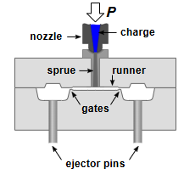

2. (a)A cylindrical cup of diameter 60 mm and height 40 mm is to be produced by deep drawing from a circular blank of sheet metal.Determine the required blank diameter. Assume negligible thinning of sheet metal.
(b)State any five factors affecting metal flow during drawing.
Answer:

(a) In deep drawing, area of blank = area of drawn cup

Area of blank=Area of base of cup+ Area of cylindrical wall

$\frac{π}{4}×{D_{b}}^{2}=\frac{π}{4}×D_{p}×$ h
- Db​ = Diameter of blank (mm)
- Dp ​= Punch (cup) diameter = 60 mm
- h = Height of cup = 40 mm

Now $\frac{π}{4}×{D_{b}}^{2}=\frac{π}{4}×60×40$
$D_{b}≈$115 mm

(b)Variables Affecting Metal Flow during Drawing
Metal flow during drawing is the controlled movement of material from the flange region into the die cavity. The following factors influence it:
- 1.Blank Holder Force (BHF):
  - Low BHF promotes Wrinkling
  - High BHF also helpsin Tearing
  - Proper BHF ensures smooth metal flow.
- Lubrication:
  - Reduces friction between blank–die–punch.
  - Improves metal flow and surface finish.
- Die and Punch Corner Radii:
  - Larger radii → smoother flow, less tearing.
  - Sharp corners increase risk of cracks.
- Clearance between Punch and Die:
  - Too small → high friction, tearing.
  - Too large → poor shape, wrinkling.

- Material Properties:
  - Ductility, strain hardening, thickness.
  - More ductile materials draw more easily.
- Drawing Ratio:
  - High drawing ratio increases risk of tearing.
  - Limiting drawing ratio ensures safe forming.

