MEPC301 — METROLOGY AND MEASUREMENT
LECTURE NOTES

LECTURE NOTES ON
METROLOGY AND MEASUREMENT For 5th Semester Mechanical Engineering
(SCTE&VT Syllabus)

PREPARED BY
SANTOSH KUMAR PATRA LECTURER STAGE-1
MECHANICAL ENGINEERING



GOVERNMENT POLYTECHNIC NAYAGARH

UNIT I
Introduction to Measurement, Errors, and Measuring Instruments

1. Introduction to Measurement

1.1 Definition of Measurement
Definition — Measurement: the process of comparing an unknown quantity with a predefined, internationally accepted standard (unit) to express the magnitude of the quantity numerically.

Every measurement essentially answers the question ‘how much?’ by comparing a physical quantity such as length, mass, temperature or pressure against a reference standard of the same kind. The result of a measurement is always expressed as a number together with a unit, e.g., ‘the shaft diameter is 25.02 mm’. Without a unit, a numerical value conveys no engineering meaning.

1.2 Significance of Measurement
Measurement forms the backbone of quality control and interchangeable manufacturing. Its significance in engineering can be summarized as follows:
- Ensures components manufactured at different locations fit and function together (interchangeability).
- Enables quality control and process control during manufacturing.
- Helps in research, product development and design verification.
- Provides a scientific basis for accepting or rejecting a manufactured part.
- Assists in cost reduction by minimizing rework, scrap and rejection.
- Forms the basis of scientific investigation — ‘you cannot control what you cannot measure’.

1.3 Methods of Measurement

(a) Direct Method
The value of the quantity is obtained directly by comparing the unknown quantity with a standard, without the use of any intermediate device that performs a computation.
Example: Measuring the length of a shaft using a steel rule, or its diameter using a vernier caliper — the reading is taken directly off the scale.

(b) Indirect Method
The value of the quantity is obtained by measuring other quantities that are functionally related to the required quantity, and then computing the result.
Example: Determining the effective diameter of a screw thread by the three-wire method, where wire diameters and micrometer readings are measured and the effective diameter is calculated using a formula; or measuring an angle using a sine bar and slip gauges (h and L are measured, θ is calculated).

1.4 Generalized Measuring System
A chain of elements known as the Generalized Measurement System can represent every measuring instrument, irrespective of the quantity it measures, functionally. This concept allows engineers to analyse any instrument systematically.
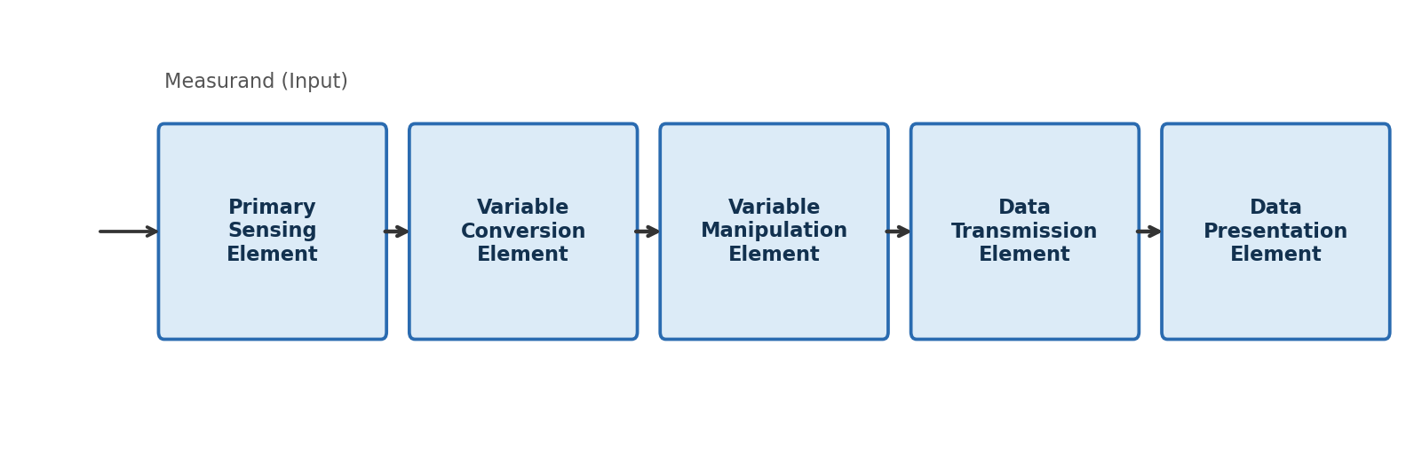
Fig. 1.1 — Functional elements of a Generalized Measurement System
Element | Function
Primary Sensing Element | First element that receives the physical quantity (measurand) and converts it into a detectable form, e.g. a Bourdon tube sensing pressure.
Variable Conversion Element | Converts the output of the sensing element into a more convenient physical variable (e.g., mechanical displacement into an electrical voltage) while preserving the information content.
Variable Manipulation Element | Manipulates (amplifies, filters, or otherwise modifies) the signal to make it more usable, without changing the nature of the variable.
Data Transmission Element | Transmits the signal from one location to another, e.g. from a remote sensor to a control room.
Data Presentation Element | Presents the measured value in a form intelligible to the observer — analogue dial, digital display, chart recorder, etc.

1.5 Standards of Measurement
A standard is a physical embodiment of a unit of measurement, used as a reference for calibrating other instruments. Standards are classified hierarchically:

(a) Primary Standards
Maintained by international bodies (e.g., International Bureau of Weights and Measures, BIPM) with the highest possible accuracy, free from human error as far as possible. They are not available for ordinary use and are used only for comparison with secondary standards. Example: the international prototype of the kilogram.

(b) Secondary Standards
Reproductions of primary standards, maintained by national laboratories (e.g., National Physical Laboratory, NPL India) of a country. These are periodically checked against primary standards and are used for calibrating reference and working standards used in industry.
Below secondary standards lie Reference Standards (kept in individual industries), Working Standards (used daily on the shop floor, e.g., slip gauges), forming a traceability chain from the shop floor instrument back to the primary standard.

1.6 Factors Influencing Selection of a Measuring Instrument
- Range of the instrument compared to the range of the quantity to be measured.
- Required accuracy and precision of measurement.
- Sensitivity, resolution and repeatability required.
- Cost of the instrument versus the accuracy demanded.
- Environmental conditions — temperature, vibration, dust, humidity at the point of use.
- Ease of use, portability and time required per measurement.
- Nature of the workpiece — material, size, surface condition.
- Whether the measurement is a laboratory (static) or shop-floor (dynamic/in-process) application.

2. Terms Applicable to Measuring Instruments

2.1 Accuracy and Precision
Definition — Accuracy: the closeness of a measured value to the true (actual) value of the quantity being measured. It indicates the degree of freedom from error.
Definition — Precision: the closeness of agreement among a series of repeated measurements of the same quantity, i.e., the degree of repeatability/reproducibility of a set of readings, irrespective of whether they are close to the true value.
A set of readings can be precise without being accurate (all readings tightly clustered but off from the true value due to a systematic bias), and can be accurate on average without being precise (readings scattered widely but averaging to the true value). This distinction is best visualised with the classic ‘target’ analogy:
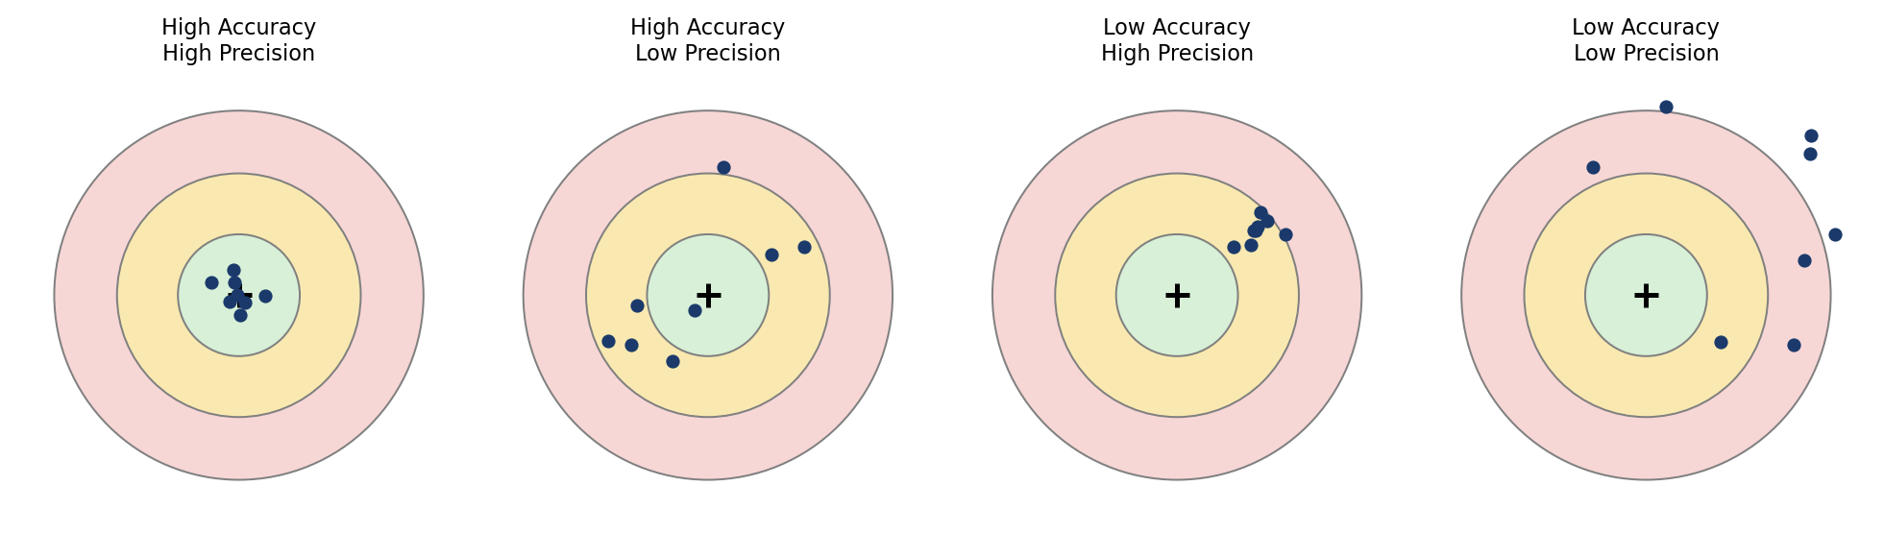
Fig. 2.1 — Accuracy vs. Precision represented as shots on a target

2.2 Sensitivity
Definition — Sensitivity: the ratio of the magnitude of the output response (deflection/displacement) of an instrument to the magnitude of the input quantity (measurand) that causes it.
Sensitivity = Change in Output Response / Change in Input Signal
A highly sensitive instrument produces a large output deflection for a small change in input. Sensitivity is also referred to as the scale factor or gain of the instrument, and it is a key factor in selecting an instrument for fine measurements.

2.3 Repeatability and Reproducibility
Definition — Repeatability: the ability of an instrument to give the same output value for repeated applications of the same input value, under the same conditions, by the same observer, in a short interval of time.
Definition — Reproducibility: the closeness of agreement among repeated measurements of the same quantity carried out under changed conditions — different observer, instrument, location, or time.

2.4 Range and Span
Definition — Range: the minimum to maximum values of the input quantity that an instrument is designed to measure.
Span is the algebraic difference between the upper and lower limits of the range, i.e., Span = Maximum value − Minimum value.

2.5 Threshold
Definition — Threshold: the minimum value of input below which no output change can be detected by the instrument, i.e., the smallest detectable input starting from zero.

2.6 Hysteresis
Definition — Hysteresis: the difference between the output of an instrument for a given input value when that value is approached from an increasing (ascending) direction and from a decreasing (descending) direction.
Hysteresis arises due to energy storage effects such as friction, backlash in gear trains, or elastic deformation in the mechanical elements of the instrument, and appears as a loop when output is plotted against input for a full ascending-descending cycle.

2.7 Calibration
Definition — Calibration: the process of comparing the readings of an instrument with a known, traceable standard of higher accuracy, and adjusting or noting the deviation, so as to determine or correct the accuracy of the instrument.
Calibration establishes a relationship between the values indicated by an instrument and the corresponding known values of the reference standard. It is carried out periodically to maintain measurement traceability and confidence in the readings produced by an instrument.
Solved Problem 1: Sensitivity of a Pressure Gauge
Given: A pressure gauge pointer deflects by 8 mm when the pressure applied to it increases from 2 bar to 4 bar.
Find: The sensitivity of the pressure gauge.
Solution:
Change in output, Δ(output) = 8 mm
Change in input, Δ(input) = 4 − 2 = 2 bar
Sensitivity = Δ(output) / Δ(input) = 8 / 2 = 4 mm per bar
Result: The sensitivity of the pressure gauge is 4 mm/bar.

3. Errors in Measurement
Definition — Error of Measurement: the difference between the measured value of a quantity and its true value: Error = Measured Value − True Value.
No measurement, however carefully made, is completely free from error. Errors arise from the limitations of the instrument, the environment, and the observer. Understanding and classifying errors is essential to interpret measured data correctly and to estimate the confidence that can be placed in a result.

3.1 Classification of Errors
Type | Description | Examples
Gross Errors | Large errors caused mainly by human carelessness, misreading, wrong recording or improper use of instruments. | Misreading a vernier scale; wrong data recording; using a wrong instrument constant.
Systematic (Controllable) Errors | Errors that occur in the same direction and by the same amount for repeated measurements under the same conditions; can, in principle, be identified and corrected. | Instrumental errors (worn parts, zero error); environmental errors (temperature, humidity); observational errors (parallax).
Random Errors | Small errors caused by numerous unpredictable and uncontrollable variations that remain even after all systematic and gross errors have been eliminated. They vary in magnitude and sign in an unpredictable manner and are treated statistically. | Small fluctuations in supply voltage; minute vibrations; human reaction-time variation.
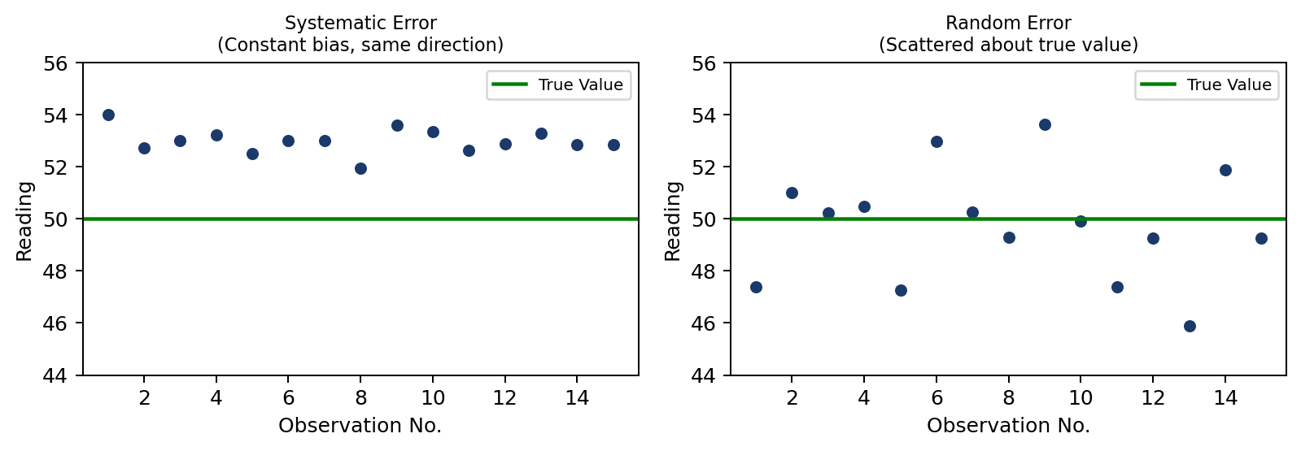
Fig. 3.1 — Systematic error (constant bias) vs. Random error (scatter about the true value)

3.2 Systematic Errors — Sub-types
- Instrumental Errors — due to inherent shortcomings, wear, or improper calibration of the instrument (e.g. zero error, backlash).
- Environmental Errors — caused by external conditions such as temperature, humidity, pressure, dust and vibration acting on the instrument or the workpiece.
- Observational Errors — introduced by the observer, most commonly parallax error while reading a scale, or estimation error while interpolating between graduations.

3.3 Statistical Analysis of Random Errors
Since random errors cannot be eliminated, they are analysed statistically using a set of repeated readings of the same quantity. The important statistical quantities are:

(a) Arithmetic Mean
x̄ = (x₁ + x₂ + … + xₙ) / n = Σxi / n

(b) Deviation from the Mean
di = xi − x̄
Note: The algebraic sum of all deviations from the arithmetic mean is always zero, i.e., Σdi = 0.

(c) Standard Deviation
Standard deviation is a measure of the dispersion (scatter) of the set of readings about the mean. For a finite sample of n readings, it is calculated (using Bessel's correction) as:
σ = √[ Σ(di²) / (n − 1) ]

(d) Probable Error
The probable error defines the range within which 50% of all the observed readings are expected to lie on either side of the mean. It is related to the standard deviation by:
r = 0.6745 σ
Solved Problem 2: Mean, Standard Deviation and Probable Error
Given: Five repeated measurements of the length of a gauge block (in mm): 25.02, 25.00, 25.04, 24.98, 25.01
Find: (i) Arithmetic mean, (ii) Standard deviation, (iii) Probable error.
Solution:
(i) Mean, x̄ = (25.02 + 25.00 + 25.04 + 24.98 + 25.01) / 5 = 125.05 / 5 = 25.01 mm
(ii) Deviations di = xi − x̄ : +0.01, −0.01, +0.03, −0.03, 0.00 mm
Squares di² : 0.0001, 0.0001, 0.0009, 0.0009, 0.0000 → Σdi² = 0.0020 mm²
σ = √(0.0020 / (5−1)) = √(0.0005) = 0.0224 mm
(iii) Probable error, r = 0.6745 × 0.0224 = 0.0151 mm
Result: x̄ = 25.01 mm, σ = 0.0224 mm, r = ±0.0151 mm

4. Measuring Instruments
This section covers the principal measuring instruments included in Unit I of the syllabus: thread measurement, angle measurement, limit gauges, comparators, surface finish measurement, and the coordinate measuring machine (CMM).

4.1 Thread Measurement — Thread Gauge and Micrometer
Screw threads are checked either by limit gauges (functional check — Go/No-Go screw plug and ring gauges that check whether the thread will assemble correctly) or by measuring individual elements (major diameter, minor diameter, effective/pitch diameter, pitch angle) using a thread micrometer.
- A thread gauge (screw pitch gauge) is a flat blade with V-shaped teeth of known pitch, used to quickly identify the pitch of an unknown thread by matching it against the workpiece.
- A thread micrometer has specially shaped anvils — a V-anvil that fits the thread profile and a conical (pointed) spindle — so that the effective (pitch) diameter of the thread can be read directly.
Detailed derivations for effective diameter using the two-wire and three-wire methods are covered under Unit IV (Screw Thread Measurement); at this introductory stage, students should be able to identify the thread gauge micrometer and explain its use for a quick check of thread size.

4.2 Angle Measurement

(a) Bevel Protractor
A bevel protractor consists of a base plate and a rotatable blade fitted with a graduated circular dial (vernier scale in a universal bevel protractor) that allows angles to be read directly, typically to an accuracy of 5 minutes of arc. It is placed with its base against one face of the workpiece and the blade rotated to align with the second face; the angle between the two faces is read off the dial.

(b) Sine Bar
A sine bar is a precision angle-measuring device consisting of an accurately ground steel bar with two cylindrical rollers of equal diameter fixed at its two ends, at a precisely known centre distance L (commonly 100 mm or 200 mm). One roller rests on a surface plate; the other roller is raised on a stack of slip gauges of height h, tilting the bar to the required angle θ.
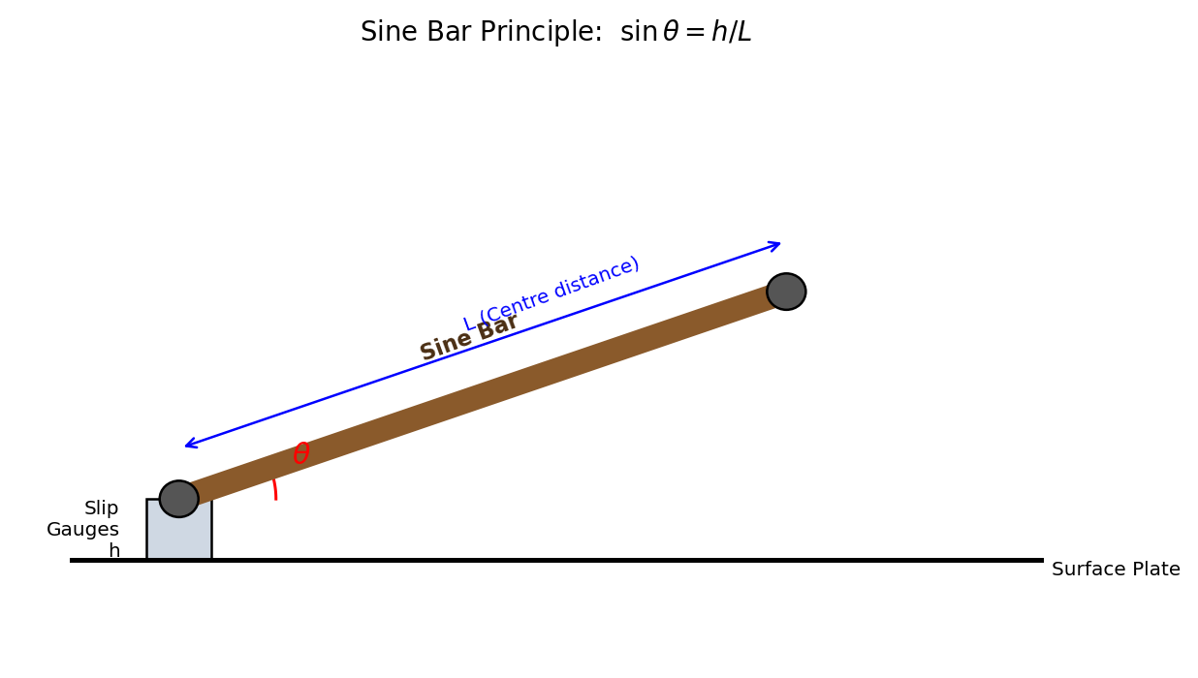
Fig. 4.1 — Principle of the Sine Bar
Derivation: Since the sine bar, the surface plate, and the slip-gauge stack form a right-angled triangle with the sine bar as the hypotenuse (length L) and the slip-gauge height as the opposite side (h):
sin θ = h / L ⇒ θ = sin⁻¹(h / L)
The sine bar is generally accurate for angles up to about 45°; beyond this, the method becomes increasingly inaccurate because a small error in the slip-gauge height translates into a large error in the computed angle, and the sine function flattens near 90°.
Solved Problem 3: Angle Measurement using a Sine Bar
Given: A sine bar of length L = 200 mm is used to set a workpiece at an angle. A slip gauge stack of height h = 69.40 mm is placed under one roller, the other roller resting on the surface plate.
Find: The angle θ set by the sine bar.
Solution:
sin θ = h / L = 69.40 / 200 = 0.3470
θ = sin⁻¹(0.3470) = 20.30° (i.e., 20° 18')
Result: The sine bar sets an angle of approximately 20.30°.

4.3 Gauges — Plain Plug, Ring, Snap and Limit Gauges
Limit gauges are used for functional (Go/No-Go) inspection in mass production — they do not indicate the actual size, only whether the component lies within the specified tolerance limits. They work on Taylor's Principle of Gauge Design.
Definition — Taylor's Principle: the GO gauge should be designed to check the maximum metal condition (MMC) of the component over its full form and length, while the NO-GO gauge should check the least metal condition (LMC) at individual cross-sections and should ideally contact at a point or a line.
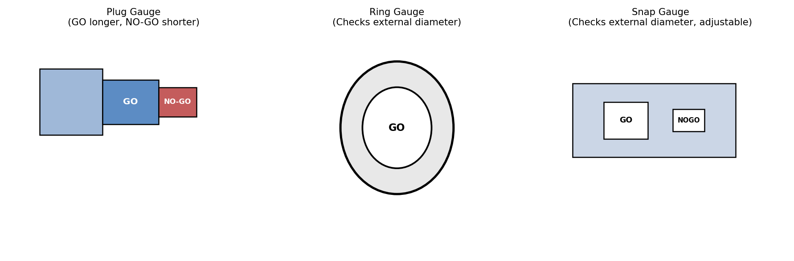
Fig. 4.2 — Plain plug gauge, ring gauge, and snap gauge
Gauge | Used for | Description
Plain Plug Gauge | Checking internal diameters (holes) | Cylindrical gauge with a GO end (sized to the lower/min. limit of the hole) and a shorter NO-GO end (sized to the upper/max. limit).
Ring Gauge | Checking external diameters (shafts) | A ring with a precisely bored hole; GO ring corresponds to the maximum shaft size, NO-GO to the minimum shaft size.
Snap Gauge | Checking external diameters (shafts), quick shop-floor use | A U-shaped (horseshoe) frame with fixed or adjustable GO and NO-GO gaps/anvils.
Limit Gauge (general) | Any Go / No-Go functional check | General term for gauges designed only to confirm a dimension lies within its high and low limits, without indicating the exact size.
Solved Problem 4: Design of GO and NO-GO Plug Gauge
Given: A hole is to be manufactured to the size 25 (+0.02 / −0.00) mm (i.e., hole limits are 25.00 mm to 25.02 mm).
Find: The basic sizes of the GO and NO-GO plug gauges (ignoring gauge tolerance).
Solution:
By Taylor's Principle, the GO plug gauge checks the Maximum Metal Condition (MMC) of the hole, which is the smallest permissible hole size.
GO gauge size = Lower limit of hole = 25.00 mm
The NO-GO plug gauge checks the Least Metal Condition (LMC), the largest permissible hole size.
NO-GO gauge size = Upper limit of hole = 25.02 mm
Result: GO plug gauge = 25.00 mm; NO-GO plug gauge = 25.02 mm.

4.4 Comparators
Definition — Comparator: an instrument that does not measure the actual dimension directly, but shows the deviation of a dimension from a set master/reference size, by mechanical, optical, electrical or pneumatic amplification of very small displacements.

Characteristics of a Good Comparator
- High magnification (amplification) with linear response.
- High sensitivity and low observational (parallax) error.
- Robust, compact and easy to operate on the shop floor.
- Minimal moving parts to reduce friction, backlash and wear.
- Quick response with negligible hysteresis.

Types of Comparators
Type | Principle | Typical Magnification
Mechanical | Rack-and-pinion or lever-and-gear train amplifies plunger movement to a pointer on a dial (e.g., dial indicator). | 500–1000×
Optical | A lever tilts a mirror; a beam of light reflected off the mirror is projected onto a screen, giving very high (optical) magnification. | up to 5000× or more
Electrical / Electronic | Displacement changes an electrical parameter (inductance, capacitance, resistance) of a transducer (e.g., LVDT), amplified electronically and displayed digitally. | very high, digital resolution
Pneumatic | Displacement changes the escape area of an air jet; the resulting change in air pressure or flow is displayed on a manometer/dial. | high, contact-free measurement possible

4.5 Surface Finish
Definition — Surface Finish (Surface Texture): the nature and degree of surface irregularities left on a machined surface as a result of the manufacturing process, comprising roughness, waviness, lay and flaws.

Terminology
- Roughness — the finer, closely-spaced surface irregularities resulting directly from the cutting action (e.g., tool marks).
- Waviness — the more widely-spaced component of surface texture, often caused by machine or work deflections, vibrations, or chatter.
- Lay — the direction of the predominant surface pattern produced by the machining process.
- Centre Line (Mean Line) — the reference line about which the roughness profile is measured, drawn such that the sum of the areas above the line equals the sum of the areas below it.
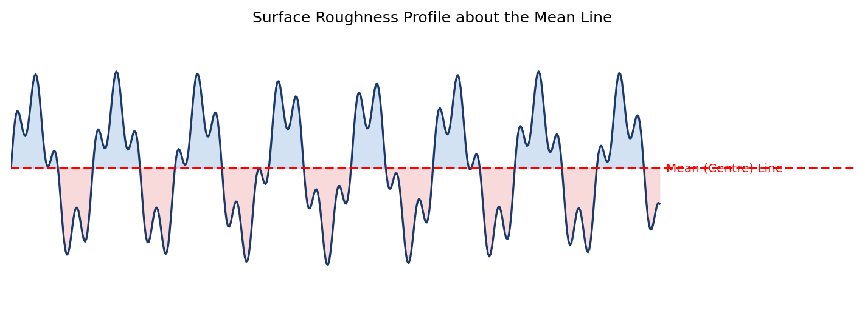
Fig. 4.3 — Roughness profile about the mean (centre) line

Roughness Value — Ra (Centre Line Average, CLA)
Ra is the arithmetic average of the absolute values of the profile height deviations recorded within the sampling length, measured from the mean line.
Ra = (1/L) ∫₀ᴸ |y| dx (continuous form) Ra = (1/n) Σ |yi| (discrete/digital form)
Other common parameters are Rz (based on the average of the 5 highest peaks and 5 deepest valleys within the sampling length) and Rt (the total peak-to-valley height over the entire evaluation length).

Talysurf Surface Roughness Tester
The Talysurf is a stylus-type electronic instrument. A fine diamond stylus (tip radius as small as ~2 µm) is drawn across the surface at a constant speed; its vertical movement, following the surface irregularities, moves the core of an LVDT-type inductance transducer. The resulting electrical signal is amplified, filtered to separate roughness from waviness, and processed electronically/digitally to compute Ra, Rz and other parameters, which are displayed numerically and/or plotted as a profile trace.
Solved Problem 5: Calculation of Ra from Profile Ordinates
Given: The heights of a roughness profile, measured from the mean line at 8 equally spaced points (in micrometres, µm), are: +3, −2, +4, −3, +2, −4, +3, −1
Find: The centre line average roughness value, Ra.
Solution:
Take the absolute value of each ordinate: 3, 2, 4, 3, 2, 4, 3, 1
Sum of absolute ordinates = 3+2+4+3+2+4+3+1 = 22 µm
Ra = Σ|yi| / n = 22 / 8 = 2.75 µm
Result: Ra = 2.75 µm

4.6 Coordinate Measuring Machine (CMM)
Definition — CMM: a highly versatile measuring machine that determines the geometry of a component by recording the X, Y and Z coordinates of points on its surface using a touch-trigger or scanning probe, and computing dimensions, form and position from these coordinates via computer software.
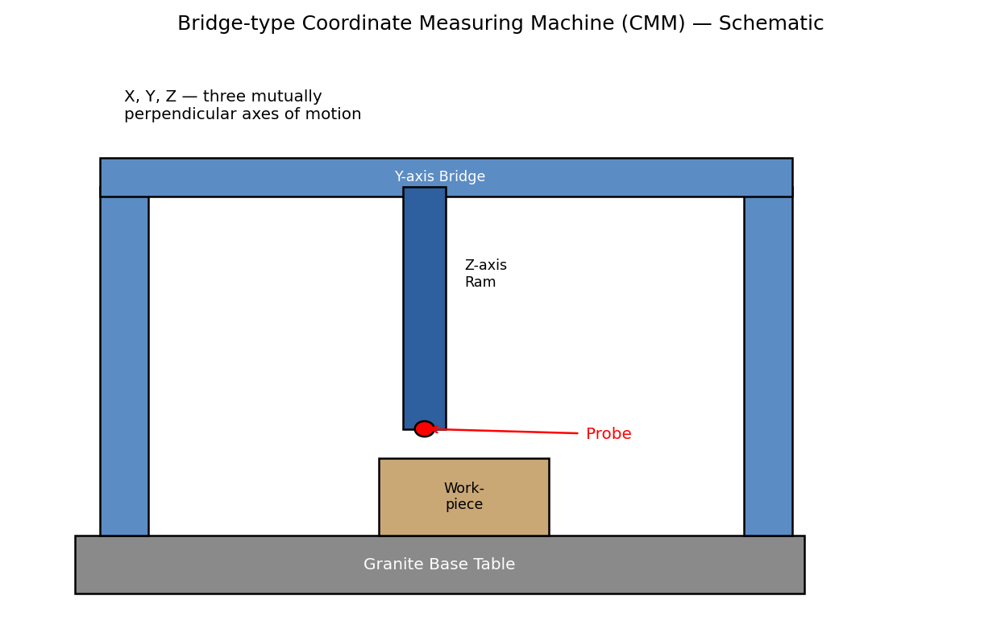
Fig. 4.4 — Schematic of a bridge-type CMM

Working Principle
The workpiece is placed on a highly accurate granite base table. A probe, mounted on a ram that can move along three mutually perpendicular axes (X, Y, Z), is brought into contact with (or, in scanning mode, moved along) the surface of the component. Linear scales along each axis record the probe position at the instant of contact; the computer collects these coordinate points and, using geometric algorithms, computes distances, diameters, angles, form errors (flatness, roundness) and position errors, comparing them against the CAD model or design tolerances.

Common Types (by structural configuration)
- Bridge type — the most common; the Y-axis bridge moves along the length of the base.
- Cantilever type — offers good accessibility for smaller components but lower rigidity.
- Gantry type — used for very large components; the structure is mounted overhead.
- Horizontal-arm type — a horizontal probe arm, well suited to automotive body and sheet-metal inspection.

Applications
- Dimensional and geometric inspection of complex 2D/3D profiles.
- Reverse engineering — digitising an existing component to generate a CAD model.
- First-article and in-process inspection in high-precision manufacturing (aerospace, automotive, tool & die).

5. Summary of Key Formulas
Sl.No. | Quantity | Formula
1 | Sensitivity | Sensitivity = Δ Output / Δ Input
2 | Arithmetic Mean | x̄ = $\frac{Σxi }{n}$
3 | Deviation | di = xi − x̄ (Σdi = 0)
4 | Standard Deviation | σ = $\sqrt{\frac{Σdi² }{(n-1) }}$
5 | Probable Error | r = 0.6745 σ
6 | Sine Bar Angle | sin θ = $\frac{h}{L}$
7 | GO Plug Gauge (hole) | = Lower (minimum) limit of hole
8 | NO-GO Plug Gauge (hole) | = Upper (maximum) limit of hole
9 | Centre Line Average Roughness | Ra = $\frac{Σ |yi|}{ n}$

6. Probable Examination Questions

Each question carries of 2 Marks.
- Define measurement and state its significance in engineering.
- Distinguish between direct and indirect methods of measurement with one example each.
- Define accuracy and precision.
- Define sensitivity of an instrument. State its unit for a pressure gauge.
- Differentiate between repeatability and reproducibility.
- Define threshold and hysteresis of an instrument.
- What is calibration? Why is it necessary?
- Define primary and secondary standards of measurement with one example each.
- What is a comparator? List any two characteristics of a good comparator.
- Define Ra (Centre Line Average) used in surface roughness measurement.

Each question carries of 5 Marks.
- Explain the methods of measurement — direct and indirect — with suitable examples of each.
- Explain the terms accuracy, precision, sensitivity and repeatability with the help of examples, bringing out the difference between accuracy and precision.
- Classify the errors in measurement and briefly explain systematic and random errors with examples.
- Explain the working principle of a sine bar and derive the formula used for angle measurement. State its limitations.
- Explain the construction and use of a bevel protractor for angle measurement.
- Explain the principle of operation of a Talysurf surface roughness tester.

Each question carries of 10 Marks.
- Explain the generalized measurement system with a neat block diagram, describing the function of each element in detail.
- Discuss in detail the classification of errors in measurement (gross, systematic, random). Explain the statistical treatment of random errors, including mean, standard deviation and probable error, with relevant formulas.
- Explain, with neat sketches, the construction and working of a plain plug gauge, ring gauge and snap gauge. State and explain Taylor's principle used in the design of limit gauges.
- Describe the different types of comparators (mechanical, optical, electrical, pneumatic), explaining their working principle, typical magnification, and relative advantages.
- Explain the working principle of a Coordinate Measuring Machine (CMM) with a neat sketch. Discuss its types and industrial applications.

LECTURE NOTES
Transducers and Strain Gauges
Instrumentation / Measurements Engineering
Topics Covered
✦ Introduction to Transducers
✦ Characteristics of Transducers
✦ Classification of Transducers
✦ Two-Coil Self-Inductance Transducer
✦ Piezoelectric Transducer
✦ Strain Measurement and Strain Gauges
✦ Classification and Mounting of Strain Gauges
✦ Strain Gauge Rosettes – Two and Three Element
✦ Question Bank (2, 5 and 10 Marks)

Table of Contents
1. Introduction3
2. Transducers3
2.1 Definition3
2.2 Characteristics of Transducers3
2.3 Classification of Transducers4
2.4 Two-Coil Self-Inductance Transducer7
2.5 Piezoelectric Transducer9
3. Strain Measurement11
3.1 Strain Gauge – Principle and Construction11
3.2 Classification of Strain Gauges12
3.3 Mounting of Strain Gauges13
3.4 Strain Gauge Rosettes14
4. Question Bank17
4.1 Two-Mark Questions17
4.2 Five-Mark Questions17
4.3 Ten-Mark Questions18

1. Introduction
Measurement of physical quantities such as displacement, force, pressure, temperature, and strain requires converting the non-electrical quantity into an equivalent, easily measurable electrical quantity. The device that performs this conversion is called a transducer. Transducers form the front end of every modern measurement and instrumentation system — they sense the physical variable and produce a proportional electrical output (voltage, current, resistance, capacitance, or inductance) that can be amplified, processed, displayed, or recorded.
Closely related to transducers is the measurement of strain — the fractional deformation of a material under load. The strain gauge, which works on the resistive transduction principle, is the most widely used sensor for strain, stress, force, torque, and load measurement in mechanical and civil engineering applications. This unit covers the fundamental characteristics and classification of transducers, two important transducer types (inductive and piezoelectric), and a detailed study of strain gauges including their classification, mounting, and rosette configurations.

2. Transducers

2.1 Definition
A transducer is a device that converts energy from one form to another, specifically converting a physical, non-electrical quantity (the measurand) into a proportional electrical signal, or vice versa. In the general measurement chain, a transducer is preceded by a sensing element (which detects the physical variable) and is followed by signal-conditioning and display/recording stages.
Measurand → Sensing Element → Transducer (Transduction Element) → Signal Conditioner → Display / Recorder

2.2 Characteristics of Transducers
The performance of a transducer is judged from two categories of characteristics: static characteristics (behaviour under steady/slowly varying conditions) and dynamic characteristics (behaviour when the measurand changes rapidly with time).

(a) Static Characteristics
Characteristic | Description
Accuracy | The closeness of the transducer output to the true value of the measurand. Usually expressed as a percentage of full-scale output.
Precision | The degree of reproducibility among several independent measurements of the same quantity under unchanged conditions.
Sensitivity | The ratio of the change in output to the change in input (measurand) that causes it, i.e. Sensitivity = ΔOutput / ΔInput. A steeper input–output curve means higher sensitivity.
Linearity | The extent to which the actual input–output curve of the transducer deviates from an ideal straight line, expressed as a percentage of full-scale output.
Resolution | The smallest incremental change in the input that produces a detectable change in the output.
Reproducibility | The ability of the transducer to give the same output for the same input when measured repeatedly over a period of time.
Drift | The gradual change in output over time for a constant input, caused by ageing, temperature variation, or other environmental effects.
Hysteresis | The maximum difference in output for the same input value when the input is approached from increasing and decreasing directions.
Range and Span | Range is the minimum to maximum value of the measurand the transducer can measure; span is the algebraic difference between the upper and lower range limits.
Repeatability | The ability to reproduce output readings when the same input is applied consecutively, under identical conditions.

(b) Dynamic Characteristics
Characteristic | Description
Speed of Response | The rapidity with which the transducer responds to a change in the measurand.
Fidelity | The degree to which the transducer indicates changes in the measurand without any dynamic error (i.e. without distortion of waveform).
Dynamic Error | The difference between the true value of the measurand (changing with time) and the value indicated by the transducer, if no static error is assumed.
Lag | The delay in the response of a transducer to a change in the input (measurement) signal.
Bandwidth | The range of frequencies over which the transducer output faithfully follows the input signal.

2.3 Classification of Transducers
Transducers can be classified in several ways depending on the criterion used — the transduction principle, the power requirement, the nature of the output signal, or the quantity measured. A summary classification is shown below.
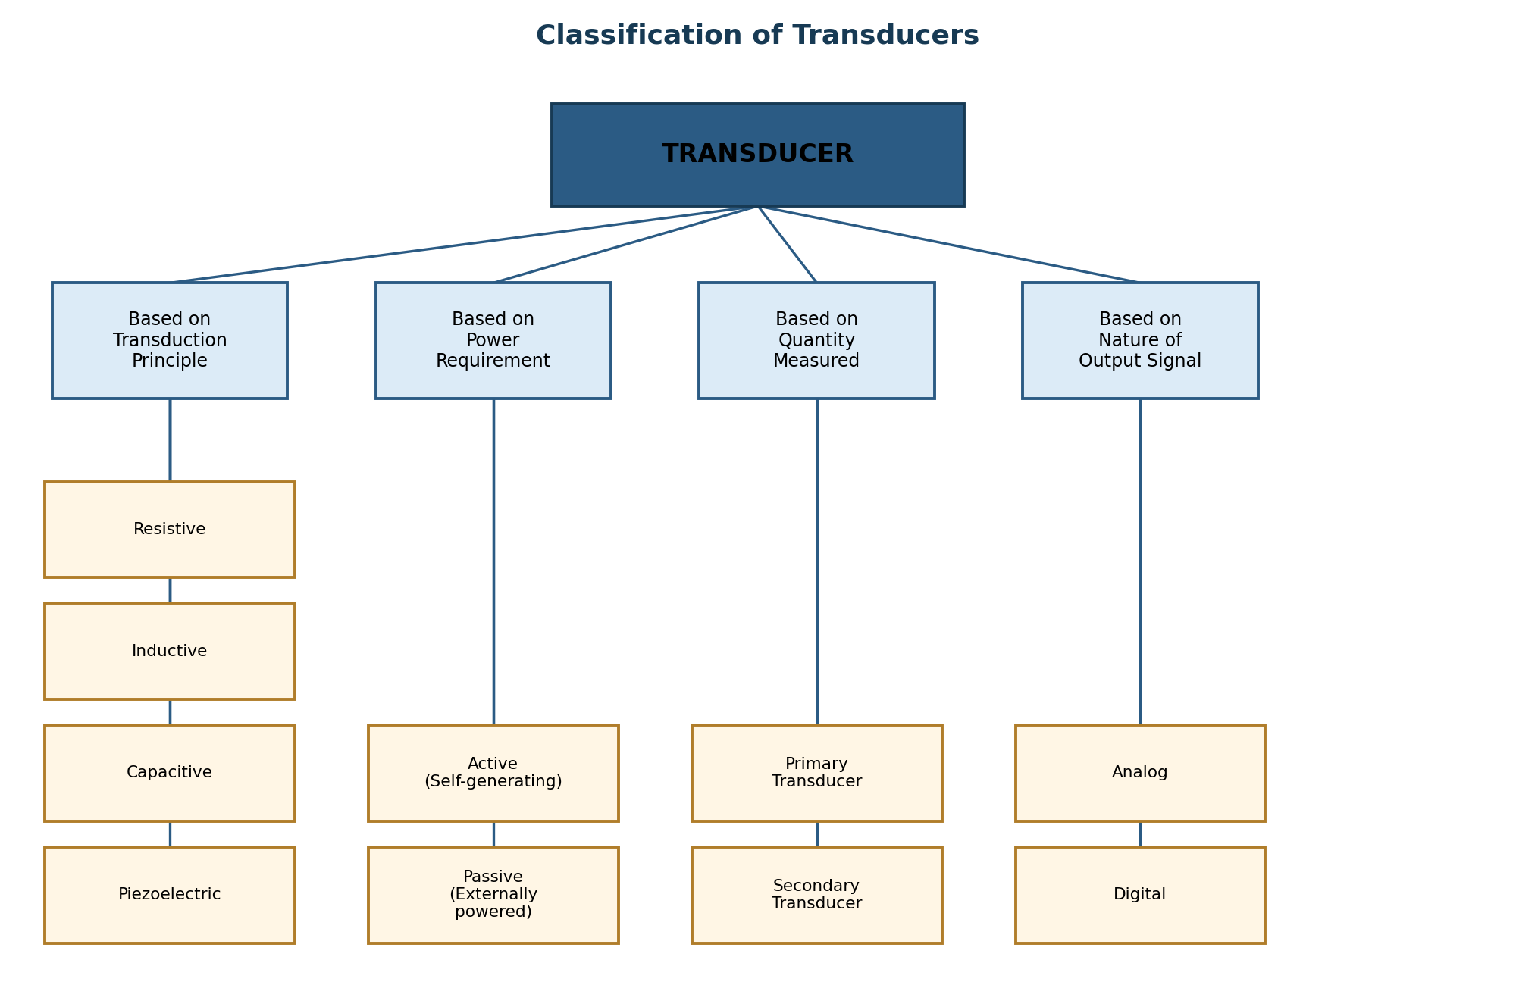
Fig. 2.1 – Classification of transducers

(a) Based on the Transduction Principle
- Resistive: Output changes as electrical resistance (e.g. resistance strain gauge, potentiometer, resistance thermometer).
- Inductive: Output changes as self or mutual inductance (e.g. LVDT, two-coil inductive transducer).
- Capacitive: Output changes as capacitance due to change in plate area, distance, or dielectric (e.g. capacitive pressure sensor).
- Piezoelectric: Output is a voltage generated when mechanical stress is applied to certain crystals (e.g. quartz accelerometer).

(b) Based on Power Requirement
- Active (self-generating) transducers: Generate their own electrical output directly from the measurand without needing an external power supply, e.g. piezoelectric, thermocouple, photovoltaic cell.
- Passive (externally powered) transducers: Require an external power source to produce an output signal; the measurand only modulates a parameter such as resistance, inductance, or capacitance, e.g. strain gauge, LVDT, thermistor.

(c) Based on the Quantity Measured
- Primary transducer: Directly senses the physical quantity using a mechanical phenomenon, e.g. a Bourdon tube sensing pressure.
- Secondary transducer: Converts the output of the primary transducer into an electrical signal, e.g. an LVDT that converts the Bourdon tube's displacement into voltage.

(d) Based on the Nature of Output Signal
- Analog transducers: Produce a continuous output signal that is a function of time, e.g. strain gauge, thermocouple.
- Digital transducers: Produce an output in the form of discrete pulses or digital codes, e.g. digital encoder.

2.4 Two-Coil Self-Inductance Transducer
An inductive transducer works on the principle that the self-inductance of a coil changes when the reluctance of its magnetic circuit changes. This can be achieved by varying the number of turns, the geometric configuration, or — most commonly — by changing the position of a ferromagnetic core (armature) within the coil, which alters the air gap and hence the reluctance of the flux path.
A single-coil inductive transducer suffers from non-linearity and is sensitive to temperature and supply-frequency variations. These drawbacks are overcome by using a two-coil (differential) arrangement, in which two identical coils are placed symmetrically on either side of a common movable ferromagnetic armature.
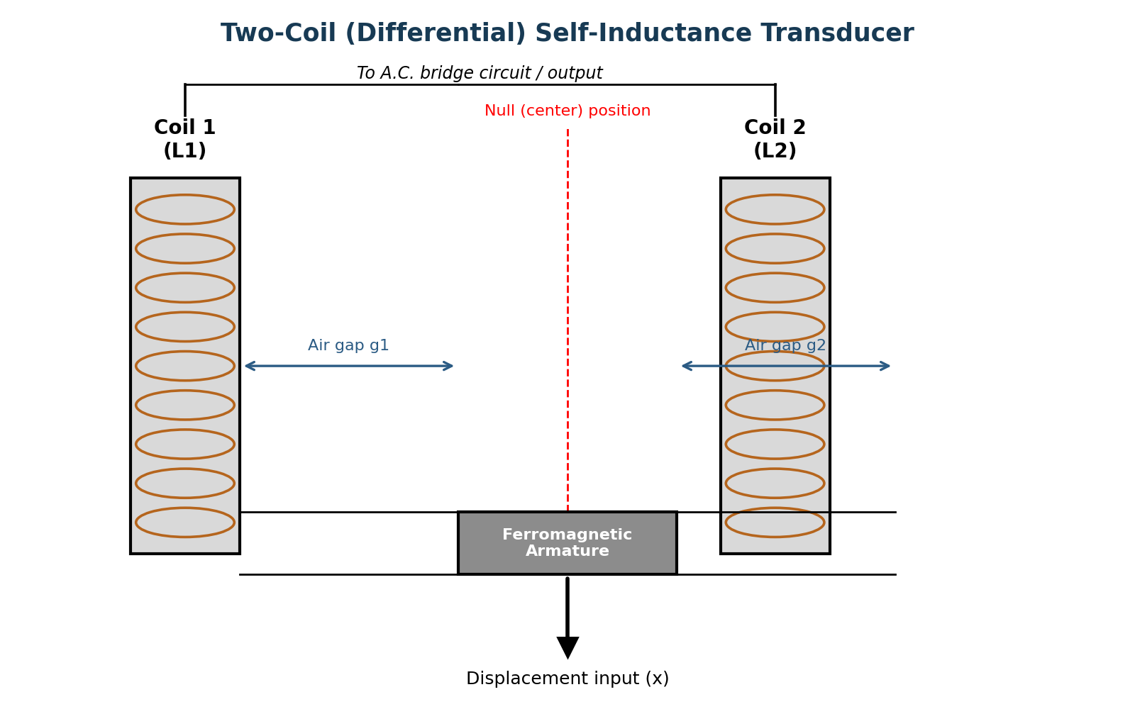
Fig. 2.2 – Two-coil (differential) self-inductance transducer

Construction
- Two identical windings, coil 1 (L₁) and coil 2 (L₂), are wound on separate limbs of a laminated ferromagnetic core / frame.
- A common ferromagnetic armature (plunger) is placed centrally between the two coils and is mechanically coupled to the member whose displacement is to be measured.
- At the null (central) position, the armature creates equal air gaps g₁ and g₂ with both coils, so the self-inductances L₁ and L₂ are equal.
- The two coils are usually connected as two arms of an A.C. bridge circuit (or in a push-pull/differential arrangement) so that their outputs can be compared.

Working Principle
When the armature is displaced from its central (null) position by the input displacement, it moves closer to one coil and farther from the other. This decreases the air gap (and reluctance) on one side while increasing it on the other. Since inductance is inversely proportional to reluctance, L₁ increases while L₂ decreases (or vice-versa) as the armature moves. The differential output, taken as (L₁ − L₂), is a measure of the direction and magnitude of the displacement.
The self-inductance of a coil with an air gap can be approximated as:
L = N² / ℜ where ℜ = reluctance of the magnetic circuit ∝ (air-gap length / area)
Since the two coils are connected differentially in the bridge, the output voltage is approximately proportional to the displacement of the armature, and unwanted effects such as temperature drift and supply-voltage variation — which affect both coils equally — tend to cancel out. This differential action makes the two-coil transducer more linear and more sensitive than a single-coil unit, and it also provides direction sensing (the phase of the output reverses when the armature crosses the null position).

Advantages
- Better linearity than a single-coil transducer.
- Higher sensitivity due to differential (push-pull) action.
- Temperature and supply-voltage effects are largely cancelled out.
- No physical contact (wear-free) between the armature and the coil assembly — long working life.

Disadvantages
- Requires an A.C. excitation supply and bridge/demodulation circuitry.
- Performance can be affected by stray magnetic fields.
- Relatively larger size and mass compared to resistive transducers.

Applications
- Measurement of small linear displacements.
- Pressure, load, and force measurement (through an elastic element that produces displacement).
- Proximity and thickness measurement.

2.5 Piezoelectric Transducer
The piezoelectric effect is the property exhibited by certain crystalline materials (e.g. quartz, Rochelle salt, barium titanate, tourmaline) whereby an electric charge (and hence a voltage) is generated across opposite faces of the crystal when a mechanical force is applied to it. This is called the direct piezoelectric effect, and it forms the basis of the piezoelectric transducer, which is a self-generating (active) transducer — it needs no external power supply to produce an output.
The reverse also holds true: when an electric field is applied across the crystal, it undergoes mechanical deformation. This is called the inverse (reciprocal) piezoelectric effect and is used in ultrasonic generators and piezoelectric actuators.
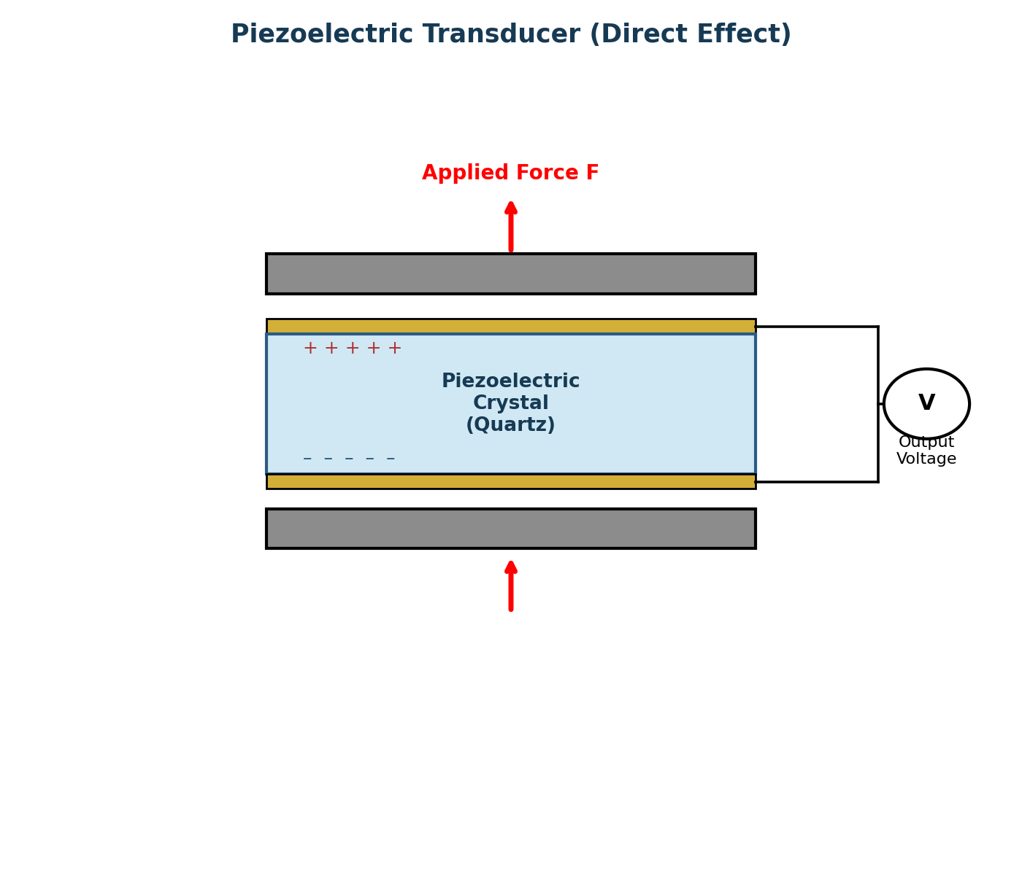
Fig. 2.3 – Piezoelectric transducer (direct effect)

Construction
- A thin slice of piezoelectric crystal (natural, such as quartz and tourmaline, or synthetic, such as barium titanate and lead zirconate titanate – PZT) is cut to a specific crystallographic orientation.
- Thin metal electrodes are deposited or clamped on the two opposite faces of the crystal to collect the generated charge.
- Rigid metal plates are placed above and below the electrode-crystal assembly to apply and distribute the mechanical force uniformly, and the whole assembly is mounted in a protective housing.

Working Principle
When a mechanical force F is applied to the crystal along its sensitive axis, the crystal lattice is deformed. This deformation displaces the positive and negative ionic charge centres within the unit cell, producing a net electric dipole moment and, therefore, an accumulation of opposite charges on the two faces of the crystal. The resulting charge Q is directly proportional to the applied force:
Q = d × F
where d is the piezoelectric (charge) sensitivity constant of the crystal (in coulombs per newton) and F is the applied force. Since the crystal-electrode combination behaves like a capacitor of capacitance C, the open-circuit output voltage developed is:
V = Q / C = (d × F) / C
Because the generated charge tends to leak away through the crystal's own resistance and the input impedance of the measuring circuit, piezoelectric transducers are inherently suited to dynamic (rapidly changing) force, pressure, and vibration measurements rather than static measurements, and they are normally used with a high-input-impedance charge amplifier.

Properties of Piezoelectric Materials
- High output for small deformation – gives usable signal levels even for very small displacements.
- Self-generating – requires no external excitation.
- Wide frequency response – suitable for high-frequency dynamic and vibration measurements.
- High rigidity/stiffness – gives a very high natural frequency and small physical size.

Advantages
- Self-generating; no external power source needed.
- Small, rugged, and has a very high frequency response – ideal for dynamic measurements.
- High sensitivity and a wide operating range of force/pressure.

Disadvantages
- Cannot measure static or slowly varying quantities (charge leaks away over time).
- Output is small and requires a charge amplifier with very high input impedance.
- Output is affected by temperature, and some crystals lose piezoelectric properties above the Curie temperature.

Applications
- Accelerometers and vibration pickups.
- Dynamic force, pressure, and load measurement (e.g. in engine combustion pressure studies).
- Microphones, ultrasonic transducers, and phonograph pickups.

3. Strain Measurement
When a mechanical member is subjected to a load, it deforms. Strain (ε) is defined as the fractional change in the dimension (length) of the member:
ε = ΔL / L (dimensionless, usually expressed in microstrain, με = 10⁻⁶)
Since strain is directly related to stress through the material's modulus of elasticity (σ = Eε, within the elastic limit), measuring strain allows engineers to determine stress, load, torque, and force in structural and mechanical components. The most common and versatile device used for this purpose is the electrical resistance strain gauge.

3.1 Strain Gauge – Principle and Construction
A resistance strain gauge works on the principle that the electrical resistance of a conductor changes when it is mechanically strained. This is described by the relation for the resistance of a wire:
R = ρ L / A
When the wire is stretched, its length L increases and its cross-sectional area A decreases, both of which increase the resistance R. Additionally, the resistivity ρ itself changes slightly with strain (the piezoresistive effect). The fractional change in resistance is related to the strain by the gauge factor (GF), which is the key sensitivity parameter of a strain gauge:
GF = (ΔR / R) / (ΔL / L) = (ΔR / R) / ε
For most metallic strain gauges, the gauge factor is approximately 2.0. A higher gauge factor means a larger, more easily measurable change in resistance for a given strain.
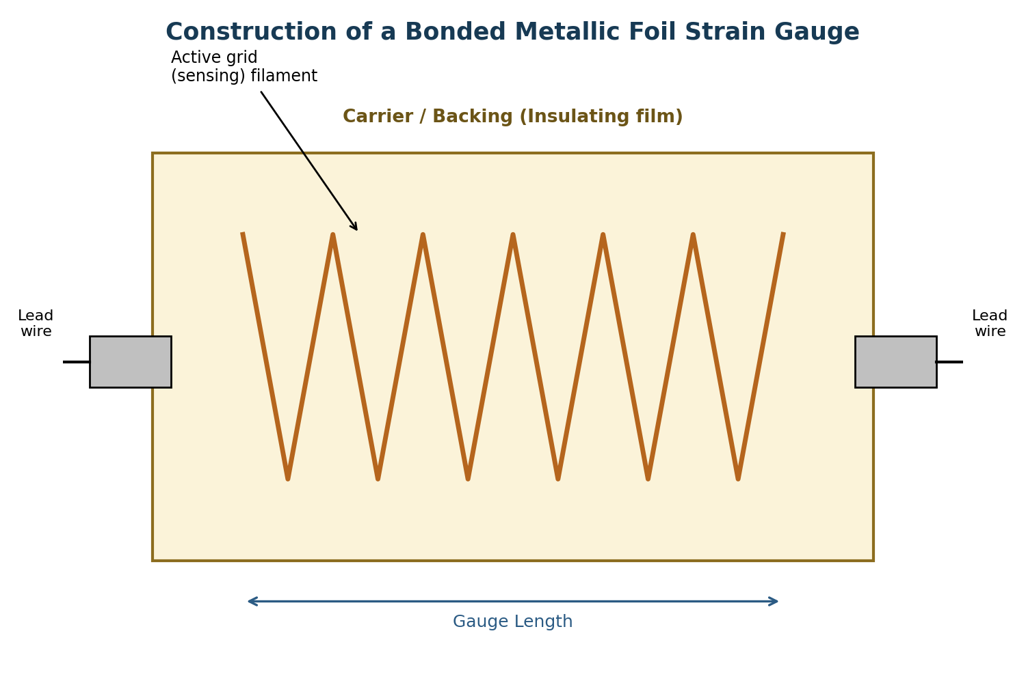
Fig. 3.1 – Construction of a bonded metallic foil strain gauge
A bonded strain gauge consists of a fine resistance wire or a photo-etched metal foil arranged in a zig-zag (grid) pattern to maximise the length of conductor exposed to strain along the sensing axis, while minimising sensitivity to strain in the transverse direction. This grid is mounted on a thin, flexible insulating carrier (backing) such as polyimide or epoxy film, and lead wires are soldered to terminal tabs at the ends of the grid. The carrier is bonded firmly to the test specimen with a suitable adhesive so that the gauge experiences exactly the same strain as the surface of the specimen.

3.2 Classification of Strain Gauges
Strain gauges can be classified in several ways:

(a) Based on Principle of Operation
- Mechanical strain gauges: Use levers and gear trains to mechanically amplify and indicate the deformation (e.g. Huggenberger extensometer). Bulky, and mainly used for calibration.
- Optical strain gauges: Use optical levers or interference of light (e.g. Tuckerman optical strain gauge) to measure deformation with high precision.
- Electrical strain gauges: Convert strain into a change of an electrical parameter. These are the most widely used and include:
  - Resistance strain gauges – change in electrical resistance with strain (most common type).
  - Inductance strain gauges – change in self/mutual inductance with strain.
  - Capacitance strain gauges – change in capacitance with strain.
  - Piezoelectric strain gauges – generate charge/voltage proportional to dynamic strain.

(b) Based on Construction (Electrical Resistance Strain Gauges)
Type | Description
Unbonded wire gauge | Fine resistance wire stretched between insulated pins fixed to a movable and a fixed frame; not bonded directly to the specimen. Used mainly in load cells and pressure transducers.
Bonded wire gauge | Fine wire grid cemented directly onto the specimen surface using an adhesive; wire is looped back and forth to form a grid pattern.
Bonded metallic foil gauge | A thin metal foil (2–5 μm) is photo-etched into a grid pattern on a flexible insulating backing. Offers a larger surface contact area (better heat dissipation), fine control of grid geometry, and is the most commonly used type today.
Semiconductor (piezoresistive) strain gauge | Uses a strip of semiconductor material (silicon/germanium) whose resistivity changes strongly with strain (piezoresistive effect). Gauge factor is 50–100 times higher than metallic gauges, but more temperature-sensitive and less linear.

3.3 Mounting of Strain Gauges
The accuracy of strain measurement depends critically on how well the strain gauge is bonded to the specimen, since the gauge must faithfully follow the surface strain without slipping or introducing mechanical error. The general procedure for mounting a bonded strain gauge is as follows:
- Surface preparation: The mounting surface is cleaned, degreased, and lightly abraded (sanded) to remove rust, paint, and oxide layers, then neutralised with a cleaning solvent to obtain a smooth, contaminant-free surface.
- Layout marking: Reference lines are marked on the specimen to align the gauge accurately along the direction in which strain is to be measured.
- Application of adhesive: A thin, uniform layer of adhesive (e.g. cyanoacrylate cement for room-temperature use, or epoxy resin for high-temperature/long-duration use) is applied to the back of the gauge or to the specimen surface.
- Bonding: The gauge is placed in position, aligned with the marked reference lines, and pressed firmly using a Teflon sheet and roller/thumb pressure to squeeze out excess adhesive and eliminate air bubbles, ensuring a thin, void-free bond line.
- Curing: The adhesive is allowed to cure fully under the specified pressure, temperature, and time (as per the adhesive manufacturer's recommendation).
- Lead-wire connection and protection: Lead wires are soldered to the gauge terminals, and the entire gauge and lead assembly is coated with a protective barrier (wax, silicone rubber, or polyurethane coating) to guard against moisture, dirt, and mechanical damage.
- Circuit connection and balancing: The gauge is connected into a Wheatstone bridge circuit (quarter, half, or full-bridge configuration) and the bridge is balanced before the load is applied.
Correct mounting is essential because a poorly bonded gauge introduces hysteresis, creep, and drift in the readings, so strict cleanliness, correct adhesive selection, and proper curing are essential for reliable, long-term strain data.

3.4 Strain Gauge Rosettes
A single strain gauge can measure strain only along its own axis (uniaxial strain). However, in most real components the state of stress is biaxial, and neither the magnitude nor the direction of the principal strains is known in advance. To fully determine the magnitude and direction of the principal strains at a point on the surface, three independent strain measurements are required at that point, along three different (known) directions. A strain gauge rosette is a cluster of two or three individual strain gauge grids, closely superimposed at a single location and oriented at specific, known angles to each other, so that this multi-directional strain data can be obtained simultaneously from virtually one point.

Two-Element Rosette
A two-element (rectangular) rosette consists of two grids placed at 90° to each other. It is used only when the directions of the principal strains are already known in advance (for example, on a shaft under pure torsion, or a member under simple bending, where the principal axes are evident from the geometry/loading). The two gauges are aligned along these known principal directions, and the principal strains ε₁ and ε₂ are read directly from the two gauges.
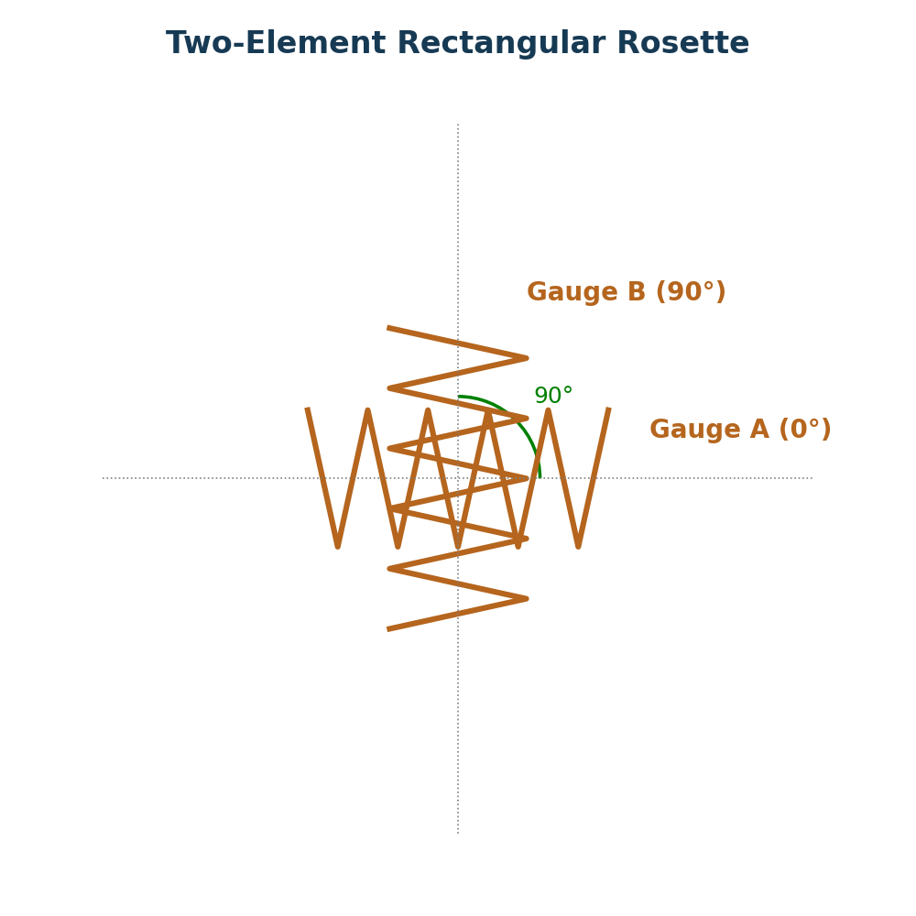
Fig. 3.2 – Two-element (90°) rectangular rosette
Since the principal directions are known, no further calculation of angle is needed — gauge A is aligned with one principal axis and gauge B (at 90°) with the other, and:
ε₁ = εₐ (reading of gauge A) ε₂ = εᵇ (reading of gauge B)

Three-Element Rosette
When the directions of the principal strains are not known, three gauges at three known, different angles are required to fully solve for the magnitude and orientation of the principal strains at that point. Two standard configurations are commonly used:
- Rectangular (45°) rosette: Three grids arranged at 0°, 45°, and 90° to a reference axis.
- Delta (equiangular / 60°) rosette: Three grids arranged at 0°, 60°, and 120° to a reference axis (also drawn as 0°, 60°, 120° in a triangular/delta pattern).
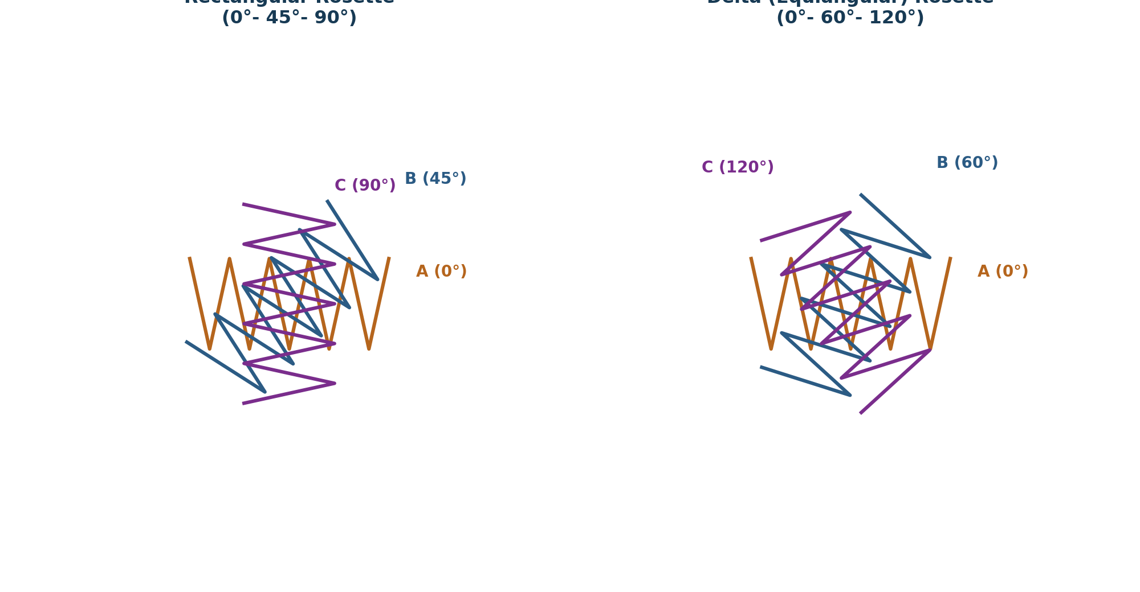
Fig. 3.3 – Three-element rosettes: rectangular (0°–45°–90°) and delta (0°–60°–120°)
With the three measured strains εₐ, εᵇ, εᶜ from gauges A, B, C, the principal strains ε₁, ε₂ and the angle θ that the principal axis makes with gauge A can be computed. For the 45° rectangular rosette (gauges at 0°, 45°, 90°), the standard relations are:
ε₁,₂ = (εₐ + εᶜ)/2 ± (1/√2) √[(εₐ − εᵇ)² + (εᵇ − εᶜ)²]
tan 2θ = (2εᵇ − εₐ − εᶜ) / (εₐ − εᶜ)
For the 60° delta rosette (gauges at 0°, 60°, 120°), the corresponding relations are:
ε₁,₂ = (εₐ + εᵇ + εᶜ)/3 ± (√2/3) √[(εₐ − εᵇ)² + (εᵇ − εᶜ)² + (εᶜ − εₐ)²]
Once the principal strains ε₁ and ε₂ are known, the principal stresses can be obtained using the biaxial stress–strain relations of the material (Hooke's law for plane stress), which allows complete stress analysis of the component at that point.

Comparison: Two-Element vs. Three-Element Rosette
Feature | Two-Element Rosette | Three-Element Rosette
Number of grids | 2 (at 90°) | 3 (at 45° or 60° spacing)
Prior knowledge needed | Directions of principal strains must be known beforehand | No prior knowledge of principal directions needed
Information obtained | Magnitudes of the two known principal strains only | Magnitude AND direction (orientation) of principal strains
Typical use | Shafts in pure torsion, simple beams – known stress state | General biaxial stress state where orientation is unknown

4. Question Bank

4.1 Two-Mark Questions
Q.No. | Question
1 | Define transducer.
2 | What is meant by sensitivity of a transducer?
3 | Define linearity of a transducer.
4 | What is hysteresis in a transducer?
5 | Distinguish between active and passive transducers (one line each).
6 | What is the principle of a two-coil inductive transducer?
7 | Define the piezoelectric effect.
8 | Name any two piezoelectric materials.
9 | Define strain and give its unit.
10 | Define gauge factor of a strain gauge.
11 | What is a bonded strain gauge?
12 | What is a strain gauge rosette?
13 | State the angle between the grids in a two-element rosette.
14 | State the two standard angular configurations of a three-element rosette.
15 | Why is a semiconductor strain gauge more sensitive than a metallic gauge?

4.2 Five-Mark Questions
Q.No. | Question
1 | Explain the static characteristics of a transducer with suitable examples.
2 | Explain the dynamic characteristics of a transducer.
3 | Classify transducers based on transduction principle, power requirement, and nature of output signal.
4 | Explain the working principle of a two-coil self-inductance transducer with a neat diagram.
5 | Describe the construction and working of a piezoelectric transducer.
6 | List the advantages, disadvantages, and applications of piezoelectric transducers.
7 | Explain the construction of a bonded metallic foil strain gauge with a diagram.
8 | Classify strain gauges based on construction and explain each type briefly.
9 | Explain the step-by-step procedure for mounting a bonded strain gauge on a specimen.
10 | Explain the two-element strain gauge rosette with a diagram and state where it is used.
11 | Distinguish between a two-element and a three-element strain gauge rosette.
12 | Derive the relation for the gauge factor of a resistance strain gauge.

4.3 Ten-Mark Questions
Q.No. | Question
1 | Define a transducer and explain in detail the static and dynamic characteristics used to evaluate its performance.
2 | With a neat classification chart, explain the various ways of classifying transducers, giving at least two examples under each category.
3 | Describe the construction and working principle of a two-coil (differential) self-inductance transducer with a neat diagram. Discuss its advantages, disadvantages, and applications.
4 | Explain the piezoelectric effect. Describe the construction, working principle, and derive the expression for the output voltage of a piezoelectric transducer. Also list its properties, advantages, and applications.
5 | What is a strain gauge? Explain its principle of operation and derive the expression for the gauge factor. Describe the construction of a bonded metallic foil strain gauge with a neat sketch.
6 | Explain in detail the classification of strain gauges based on the principle of operation and construction, bringing out the differences between wire, foil, and semiconductor strain gauges.
7 | Explain the complete procedure for mounting a bonded resistance strain gauge on a test specimen, and discuss the precautions to be taken at each stage for accurate strain measurement.
8 | What is a strain gauge rosette? Explain the two-element and three-element rosette configurations with neat diagrams, and derive the expressions for principal strains and their orientation for a 45° rectangular rosette.

Measurement of Force, Torque, and Pressure
Lecture Notes for Diploma Students
Covering: Force Measurement (Spring Balance, Proving Ring, Load Cell) | Torque Measurement (Prony Brake, Eddy Current & Hydraulic Dynamometer) | Pressure Measurement (McLeod Gauge) Includes probable 2, 5, and 10 mark examination questions.

1. Introduction
Measurement is the process of comparing an unknown quantity with a known standard (reference) quantity of the same kind. In mechanical engineering practice, three of the most important mechanical quantities that need to be measured are force, torque, and pressure. Accurate measurement of these quantities is essential for:
- Testing and rating of machines, engines, and prime movers (e.g., determining power output).
- Design verification and quality control of components (e.g., checking that a spring, structure, or machine element performs within safe limits).
- Calibration of testing machines (universal testing machines, hardness testers, etc.).
- Process control in industries — monitoring pressure in boilers, pipelines, vacuum systems, etc.
An instrument used for measurement should be selected based on range, accuracy, sensitivity, repeatability, and the environment in which it is to be used. This unit introduces common mechanical and electro-mechanical instruments used to measure force, torque, and pressure.
2. Force Measurement
Force is a physical quantity that changes or tends to change the state of rest or motion of a body. Force measurement is generally done by allowing the unknown force to act on an elastic member and measuring the resulting deformation (elastic method), or by directly balancing it against a known force (e.g., dead-weight method). The most common instruments used for force measurement are the Spring Balance, the Proving Ring, and the Load Cell.

2.1 Spring Balance
A spring balance is one of the simplest devices for measuring force (or weight). It works on the principle that the extension (or compression) produced in an elastic spring is directly proportional to the force applied, within the elastic limit of the spring material (Hooke's Law).
F = k × x
Where F = applied force, k = stiffness (spring constant) of the spring, and x = extension/deflection produced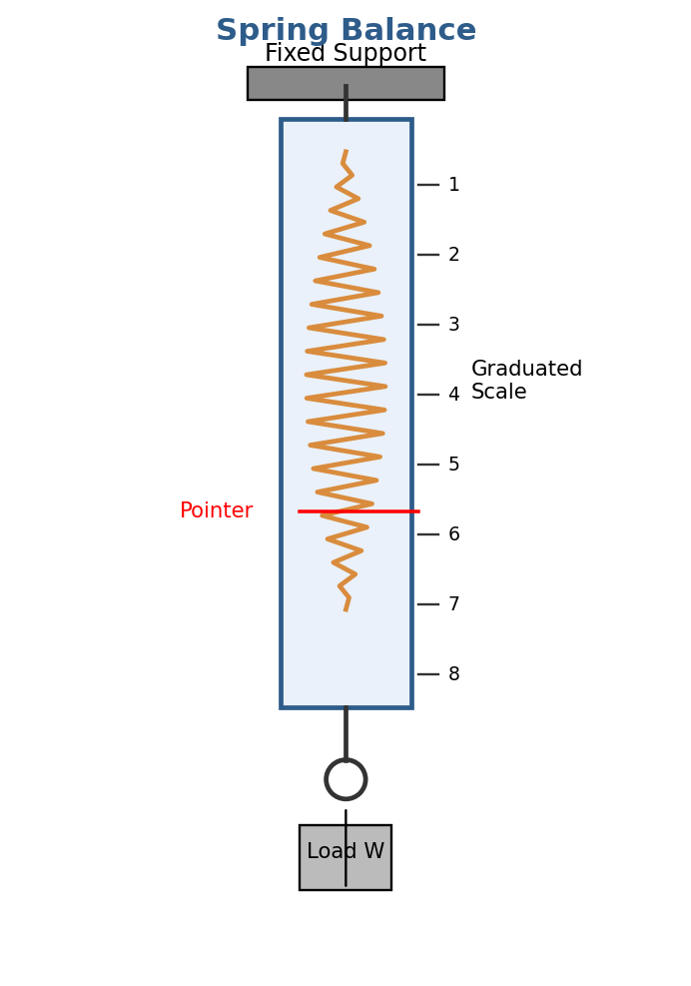
Fig. 2.1 — Construction of a Spring Balance

Construction
- A helical spring is enclosed inside a graduated tubular casing.
- The top end of the spring is fixed to a hook/support, and the bottom end carries a hook to which the load (unknown force) is attached.
- A pointer attached to the moving end of the spring moves over a graduated scale marked directly in units of force (N or kgf).

Working
When the unknown load W is suspended from the bottom hook, the spring stretches. The extension of the spring is proportional to the applied load, and the pointer indicates the corresponding force directly on the calibrated scale.

Applications
- Measuring small to medium forces/weights in laboratories and workshops.
- Quick, portable weight/force measurement where high precision is not critical.

Limitations
- Accuracy is limited by spring hysteresis, temperature effects on stiffness, and wear over repeated use.
- Not suitable for very large forces or highly precise industrial measurement.

2.2 Proving Ring
A proving ring is a precision force-measuring device used mainly for calibrating testing machines (such as universal testing machines and compression testing machines). It consists of an elastic steel ring which deflects when a force is applied along its vertical diameter.
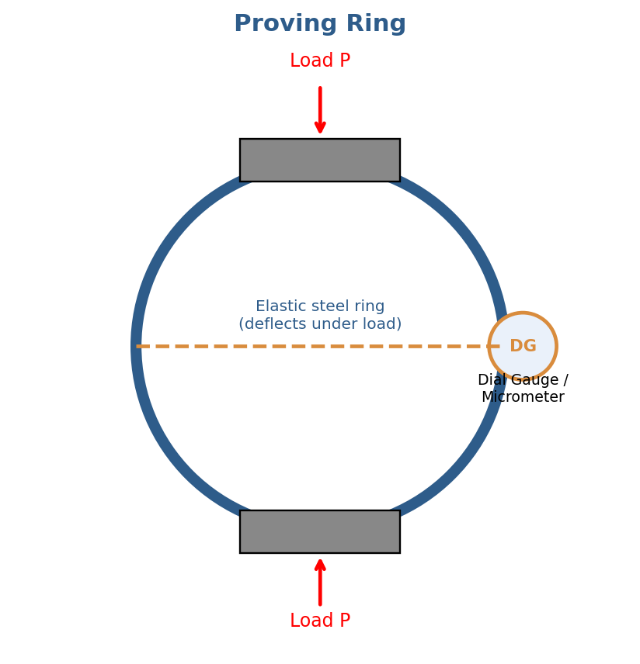
Fig. 2.2 — Proving Ring with Micrometer/Dial Gauge

Construction
- A ring made of a high-grade elastic steel alloy (low hysteresis, high resilience) is machined to a precise circular shape.
- Integral bosses (lugs) are provided at the top and bottom of the ring, along the vertical diameter, through which the load is applied.
- A highly sensitive micrometer (or dial gauge) is fitted horizontally across the inside diameter of the ring to measure the small deflection produced.

Working
When a compressive or tensile force P is applied along the vertical diameter of the ring, the ring deforms slightly — the vertical diameter decreases (or increases) and correspondingly the horizontal diameter increases (or decreases). This change in horizontal diameter is measured very precisely by the micrometer/dial gauge. Since the deflection is proportional to the applied load, the ring can be calibrated to read the applied force directly:
δ = (P × D³) / (E × I) × K
Where δ = deflection of the ring, P = applied load, D = mean diameter of the ring, E = modulus of elasticity of ring material, I = moment of inertia of the ring cross-section, and K = a constant depending on ring geometry.

Applications
- Calibration of tensile/compression testing machines and load cells (as a reference standard).
- Precise force measurement in laboratories, due to its high accuracy and stability.

Advantages
- High accuracy and excellent repeatability; not affected much by temperature.
- Robust and stable over long periods — widely accepted as a reference/calibration standard.

2.3 Load Cell
A load cell is a transducer that converts an applied force (load) into an electrical signal, which can be measured, displayed, or recorded. The most common type used in industry is the strain-gauge load cell.
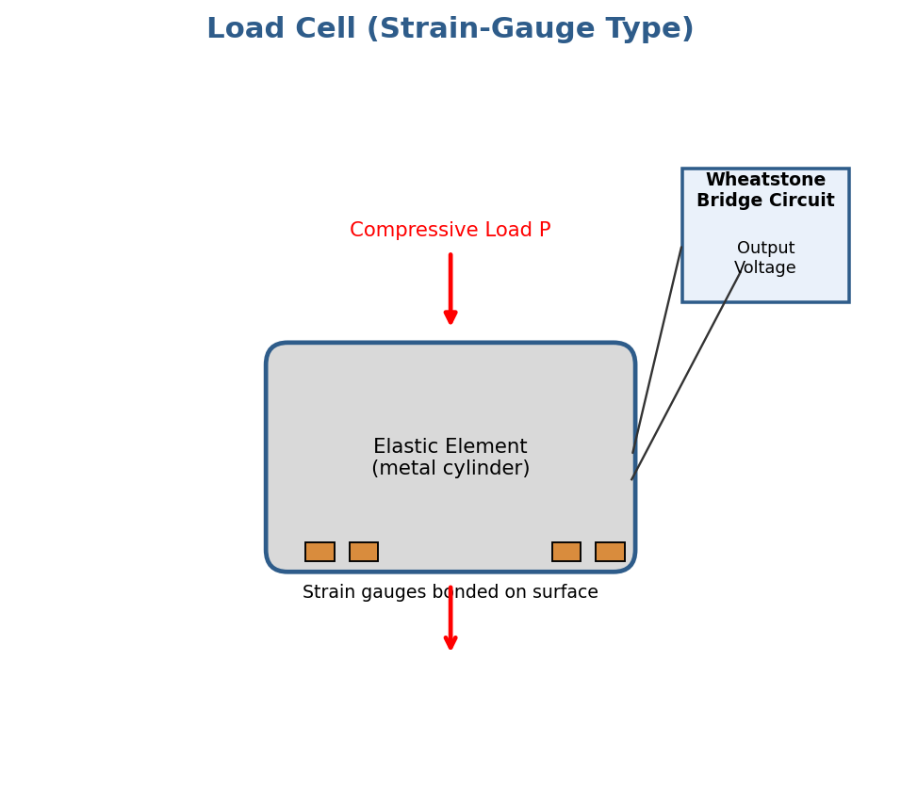
Fig. 2.3 — Strain-Gauge Load Cell with Wheatstone Bridge

Construction
- An elastic element (usually a metal cylinder, column, or beam of high-grade alloy steel) forms the main body of the load cell.
- Electrical resistance strain gauges are firmly bonded onto the surface of the elastic element, usually four gauges arranged to form a Wheatstone bridge circuit — some gauges experience tension, others compression, for temperature compensation and maximum sensitivity.
- The assembly is hermetically sealed against moisture and dust.

Working
When a load is applied to the elastic element, it deforms slightly (well within its elastic limit). This deformation causes a proportional change in the electrical resistance of the strain gauges bonded to it. The Wheatstone bridge circuit converts this small resistance change into a proportional output voltage:
Output ∝ Applied Load (after amplification and calibration)
The output voltage signal is amplified, processed, and displayed as a direct reading of force/weight on a digital indicator, or fed to a data acquisition system/PLC for further processing.

Applications
- Electronic weighing scales and industrial weighbridges.
- Force measurement in testing machines, process control, and material handling systems.
- Structural health monitoring and tension/compression measurement in cranes, hoists, etc.

Advantages
- High accuracy, fast response, and can be interfaced directly with digital/electronic instruments.
- Available in a wide range of capacities, suitable for both very small and very large forces.
Probable Examination Questions — Force Measurement
2-Mark Questions
- Define force measurement and name any two instruments used for it.
- State the working principle of a spring balance.
- What is a proving ring used for?
- Define a load cell.
- Write the formula relating force and spring deflection in a spring balance.
5-Mark Questions
- Explain the construction and working of a spring balance with a neat sketch.
- Describe the construction and working principle of a proving ring with a sketch.
- Explain the working of a strain-gauge load cell with the help of a diagram.
- Compare a proving ring and a load cell on the basis of construction, accuracy, and applications.
10-Mark Questions
- With a neat labeled diagram, explain the construction, working principle, and applications of a proving ring. Also derive/state the relation used to determine the applied force.
- Explain in detail the construction and working of a strain-gauge type load cell, with a neat sketch of the Wheatstone bridge arrangement, and discuss its advantages over a spring balance.
- Discuss any three instruments used for force measurement, explaining their construction, working principle, and applications with neat sketches.
3. Torque Measurement
Torque is the turning or twisting moment of force about an axis of rotation. Torque measurement is important for determining the power developed/absorbed by engines, motors, and machines, since power is directly related to torque and rotational speed:
P = (2π N T) / 60 (Watts), where N = speed in rpm, T = torque in N·m
Instruments used to measure torque (and hence power) are generally called dynamometers. Dynamometers are broadly classified as absorption dynamometers (which absorb and dissipate the power being measured, e.g., Prony brake, hydraulic dynamometer, eddy current dynamometer) and transmission dynamometers (which transmit the power while measuring torque).

3.1 Prony Brake Dynamometer
The Prony brake is one of the simplest and oldest forms of absorption dynamometer, used to measure the torque/power output of an engine or motor by absorbing the power through mechanical friction.
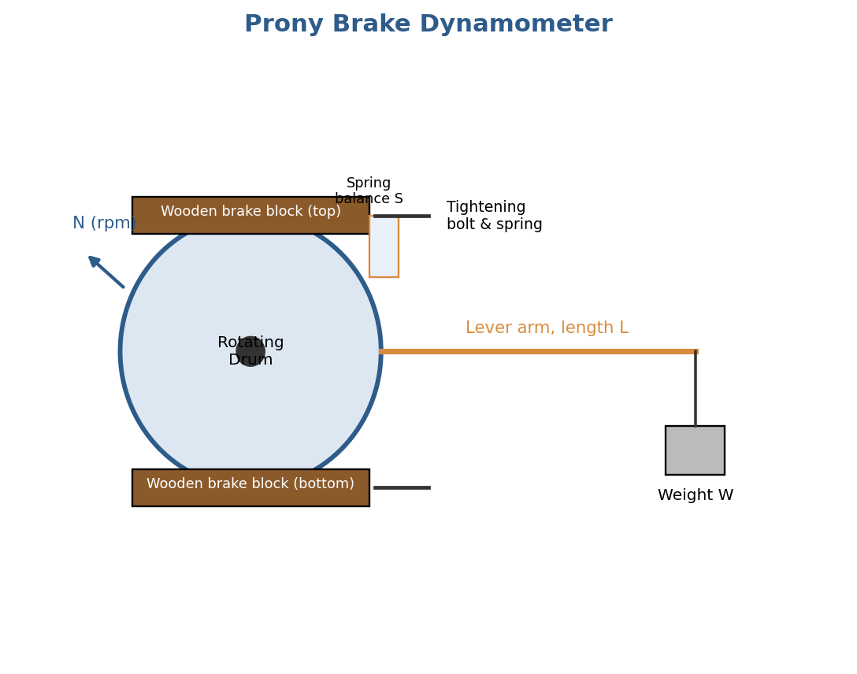
Fig. 3.1 — Prony Brake Dynamometer

Construction
- A rotating drum (flywheel) is mounted on the output shaft of the engine/motor whose power is to be measured.
- Two wooden brake blocks are clamped around the drum, held together by bolts fitted with springs, so that the clamping (and hence frictional) force can be adjusted.
- A lever arm of known length L is rigidly attached to one of the brake blocks and extends outward, carrying a weight pan (or resting on a weighing/spring balance) at its free end.

Working
As the drum rotates, friction between the brake blocks and the drum tends to rotate the lever arm in the direction of rotation. This tendency is balanced by adding weights W at the end of the lever arm until the arm is held stationary (horizontal) — the frictional torque exactly balances the torque due to the weight.
T = W × L
Where T = torque absorbed (N·m), W = balancing weight/force at the end of the lever (N), and L = effective length of the lever arm (m). The power absorbed is then calculated as P = 2πNT/60.

Applications
- Simple laboratory testing of small engines and motors for torque/power measurement.

Limitations
- Considerable heat is generated at the friction surface (drum/brake block), requiring cooling (often water-cooled drum) for higher power.
- Not suitable for high-power, high-speed testing due to wear and heat dissipation limitations; less accurate than modern dynamometers.

3.2 Eddy Current Dynamometer
An eddy current dynamometer is an absorption-type dynamometer that measures torque by making use of the eddy currents induced in a rotating metal disc when it passes through a magnetic field. It is widely used for testing medium and high-power engines because of its smooth operation and good control over loading.
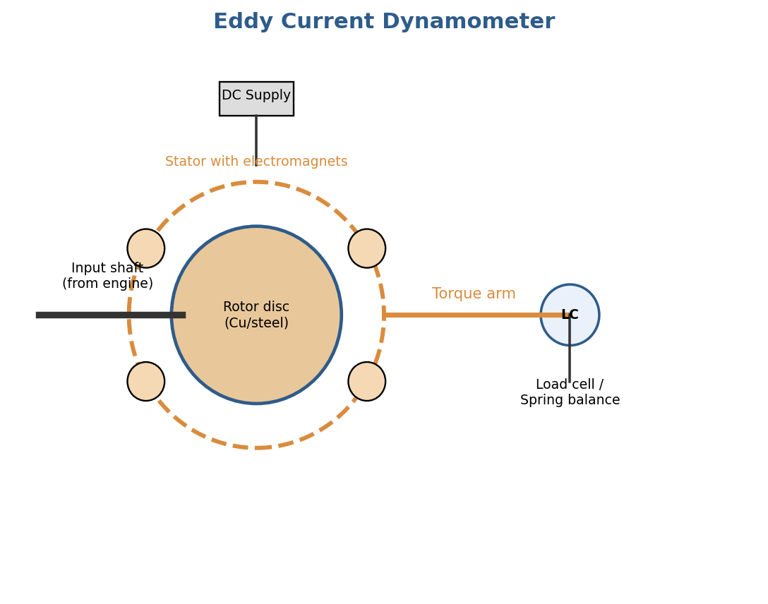
Fig. 3.2 — Eddy Current Dynamometer

Construction
- A rotor disc (usually of copper or steel) is keyed to the input shaft, which is connected to the engine/motor under test.
- The rotor rotates within a stator that carries a number of electromagnetic coils (excited by a DC supply) arranged around the periphery of the rotor, without any physical (mechanical) contact between rotor and stator.
- The stator housing is mounted on trunnion bearings, free to rotate slightly, and is restrained by a torque arm connected to a load cell or spring balance that measures the reaction torque.

Working
When the DC supply energizes the stator coils, a magnetic field is set up. As the rotor disc rotates within this magnetic field, eddy currents are induced in the disc (as per Faraday's law of electromagnetic induction). These eddy currents interact with the magnetic field, producing a retarding (braking) torque on the rotor — and an equal and opposite reaction torque on the stator casing, which tends to rotate the stator casing in the same direction as the rotor.
This reaction torque is prevented from rotating the stator by the torque arm, which is measured by a load cell/spring balance at a known radius:
T = F × R
Where F = force recorded on the load cell/spring balance, and R = length of the torque arm. The eddy current losses (and hence the braking torque) increase with the strength of the magnetic field (which can be varied by adjusting the DC excitation current), allowing the load to be smoothly and precisely controlled.

Applications
- Testing of automobile engines, industrial motors, and other prime movers over a wide range of speed and power.

Advantages
- Smooth, stepless control of loading; no mechanical wear/friction between rotor and stator; suitable for high-speed and high-power testing.
- Good accuracy and quick response, widely used in modern engine test beds.

3.3 Hydraulic Dynamometer
A hydraulic (or water-brake) dynamometer is an absorption dynamometer that absorbs the power of the engine/motor under test by churning water (or oil) between a rotor and a stator, dissipating the energy as heat.
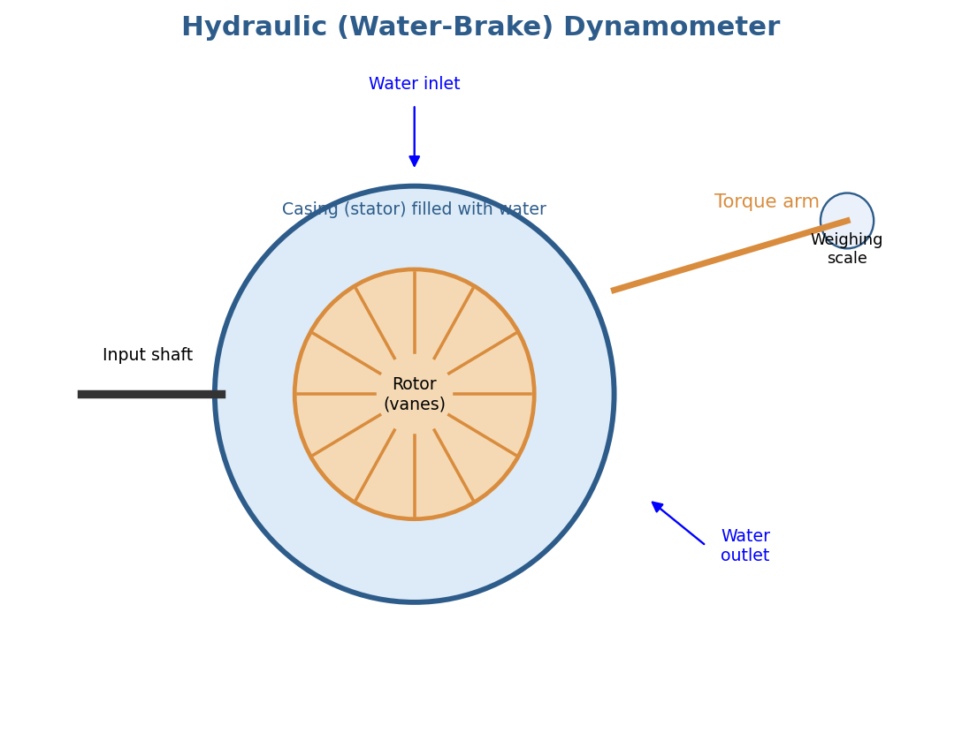
Fig. 3.3 — Hydraulic (Water-Brake) Dynamometer

Construction
- It consists of a rotor (with radial vanes/pockets) mounted on the input shaft connected to the engine/motor under test, enclosed within a casing (stator) which also has corresponding vanes/pockets, and is free to rotate slightly on trunnion bearings.
- The casing is filled with water (or oil) through an inlet, with an outlet to drain/circulate the water and carry away the heat generated.
- A torque arm is attached to the casing, resting on a weighing scale/load cell, to measure the reaction torque, similar to the eddy current dynamometer.

Working
As the rotor rotates within the water-filled casing, the rotor vanes fling the water outward into the stator pockets, setting up violent turbulence (churning action). This churning resists the rotation of the rotor, absorbing the input power and converting it into heat, which is carried away by the continuous flow of water through the casing.
The reactive torque exerted on the casing (equal in magnitude to the torque absorbed from the rotor) is measured by the torque arm and weighing scale/load cell, exactly as in the Prony brake and eddy current dynamometer:
T = F × R, P = 2π N T / 60
The amount of power absorbed can be controlled by varying the quantity of water in the casing (using a sluice gate/control valve) — more water gives greater braking torque.

Applications
- Testing of medium and large engines, especially where large amounts of power must be absorbed and dissipated (e.g., testing of automotive and marine engines).

Advantages and Limitations
- Advantage: Can absorb very large amounts of power continuously since heat is carried away by circulating water.
- Limitation: Requires a continuous water supply and drainage system; torque control response is comparatively slower than an eddy current dynamometer.
Probable Examination Questions — Torque Measurement
2-Mark Questions
- Define torque and state its relation with power.
- What is a dynamometer ? Name its two main types.
- State the principle of a Prony brake dynamometer.
- Name the source of braking torque in an eddy current dynamometer.
- What is the function of water in a hydraulic dynamometer?
5-Mark Questions
- Explain the construction and working of a Prony brake dynamometer with a neat sketch.
- Describe the working principle of an eddy current dynamometer with a diagram.
- Explain the construction and working of a hydraulic (water-brake) dynamometer with a sketch.
- Derive the expression for torque and power measured using a Prony brake dynamometer.
10-Mark Questions
- With a neat labeled diagram, explain the construction, working, and applications of an eddy current dynamometer. State its advantages over a Prony brake.
- Explain in detail the construction and working principle of a hydraulic dynamometer with a neat sketch, and discuss how the load can be varied and controlled.
- Compare the Prony brake, eddy current dynamometer, and hydraulic dynamometer on the basis of construction, working principle, accuracy, and suitability for high-power engine testing.
4. Pressure Measurement
Pressure is the force exerted per unit area by a fluid (liquid or gas) on the walls of its container or on any surface in contact with it. While common pressure gauges (Bourdon tube, diaphragm, etc.) are used for measuring moderate to high pressures, special instruments are required for measuring very low pressures (high vacuum), such as the McLeod gauge.

4.1 McLeod Gauge
The McLeod gauge is a manometric type instrument used for the accurate measurement of very low (vacuum) pressures — typically in the range of 10⁻¹ to 10⁻⁴ mm of Hg — that are too small to be measured by ordinary manometers or Bourdon gauges. It works on the principle of compressing a known volume of the low-pressure gas to a much smaller volume, so that the resulting (much higher) pressure can be measured using a simple mercury manometer, and the original low pressure calculated by applying Boyle's Law.
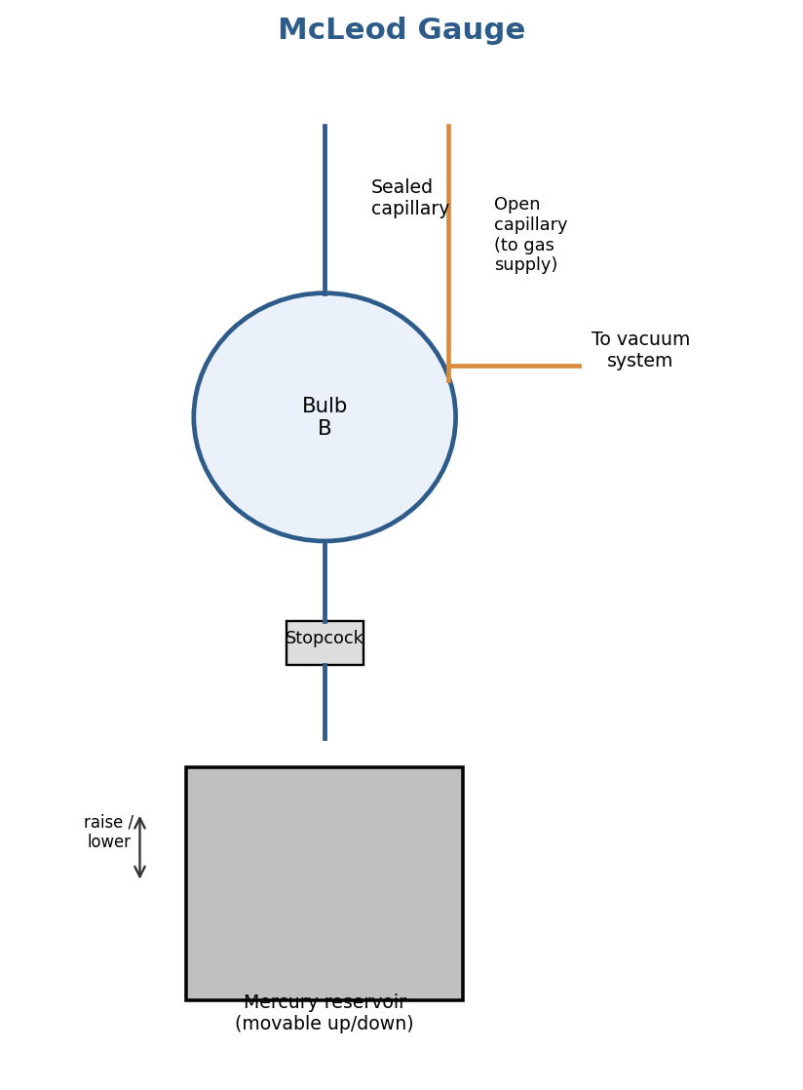
Fig. 4.1 — McLeod Gauge

Construction
- A glass bulb B of known volume V is connected to a sealed capillary tube of known, uniform bore (cross-sectional area a) at the top.
- The bulb is also connected, via a three-way stopcock, to a mercury reservoir at the bottom, and to an open (reference) capillary tube alongside the sealed one, which connects to the vacuum system whose pressure is to be measured.
- The mercury reservoir can be raised or lowered (manually or using a plunger/screw mechanism) to force mercury up into the bulb and capillary.

Working Principle (Boyle's Law Application)
Initially, the stopcock is opened so that the gas (at the unknown low pressure P, to be measured) fills the bulb and the connected system. The stopcock is then closed, trapping a known volume V of gas (at pressure P) inside the bulb and sealed capillary.
The mercury reservoir is then raised, forcing mercury up into the bulb. This compresses the trapped gas into the sealed capillary tube. Mercury continues to rise until the level in the open (reference) capillary reaches a fixed reference (zero) mark. At this point, the trapped gas is confined to a small column of length h in the sealed capillary tube, of cross-sectional area a, so the compressed volume is:
v = a × h
The difference in mercury levels between the sealed and open capillary at this stage gives the pressure of the compressed gas, which (since the reference capillary is open to the original low pressure P, considered negligible compared to the compressed pressure) is approximately equal to h itself (expressed as a column of mercury):
Compressed gas pressure ≈ h (mm of Hg)
Applying Boyle's Law (P·V = p·v, at constant temperature) to the gas before and after compression:
P × V = h × (a × h) = a h²
P = (a h²) / V
Since a and V are constants for a given gauge, the original (unknown) low pressure P can be calculated simply by measuring h, the length of the compressed gas column. The scale next to the sealed capillary can even be graduated directly in units of pressure for direct reading.

Applications
- Measurement and calibration of high vacuum in vacuum systems, vacuum furnaces, and vacuum-based industrial processes.
- Used as a standard/reference instrument for calibrating other low-pressure (vacuum) gauges.

Advantages and Limitations
- Advantage: Very high accuracy for measuring very low pressures; does not require any external power or electrical supply.
- Limitation: Cannot be used for continuous/online monitoring (it gives an intermittent reading each time it is operated); not suitable for measuring the pressure of vapors that may condense during compression (e.g., water vapor); fragile (glass construction) and requires careful handling of mercury

Probable Examination Questions — Pressure Measurement
2-Mark Questions
- Define vacuum pressure measurement and give one example of an instrument used for it.
- State the range of pressure measurable by a McLeod gauge.
- Name the law used in the working of a McLeod gauge.
- What is the function of the mercury reservoir in a McLeod gauge?
5-Mark Questions
- Explain the construction of a McLeod gauge with a neat sketch.
- Explain how Boyle's Law is applied in the working of a McLeod gauge.
- State the limitations and applications of a McLeod gauge.
10-Mark Questions
- With a neat labeled diagram, explain the construction and working of a McLeod gauge. Derive the expression used to determine the unknown low pressure P in terms of the compressed gas column length h.
- Discuss the McLeod gauge in detail — construction, working principle, derivation of the pressure measurement formula, applications, advantages, and limitations.

Quick Revision Summary

Quantity | Instrument | Principle
Force | Spring Balance | Extension of spring ∝ applied force (Hooke's Law)
Force | Proving Ring | Deflection of elastic steel ring ∝ applied force
Force | Load Cell | Strain in elastic element → resistance change in strain gauge → electrical output
Torque | Prony Brake | Frictional torque on rotating drum balanced by weight on lever arm
Torque | Eddy Current Dynamometer | Eddy currents induced in rotating disc by magnetic field create braking torque
Torque | Hydraulic Dynamometer | Churning of water between rotor & stator absorbs and dissipates power as heat
Pressure (vacuum) | McLeod Gauge | Compression of known gas volume; pressure found by Boyle's Law

— End of Notes —
Applied Mechanical Measurements
Lecture Notes — Speed, Displacement, Flow, Temperature & Miscellaneous Measurements, with diagrams and question bank (2 / 5 / 10 marks)

1. Speed Measurement

1.1 Classification of Tachometers
A tachometer is an instrument used to measure the rotational speed (angular velocity) of a shaft, usually expressed in revolutions per minute (RPM). Tachometers are broadly classified as follows:
(A) Based on contact with the shaft
- Contact type — the tachometer tip physically touches the rotating shaft (e.g., mechanical/centrifugal tachometer).
- Non-contact type — speed is sensed without touching the shaft (e.g., stroboscope, eddy current, photoelectric tachometer).
(B) Based on principle of operation
Type | Principle | Example
Mechanical tachometer | Centrifugal force of rotating flyweights | Fly-ball / Hartnell governor type
Electrical tachometer | EMF generated proportional to speed | DC / AC tachogenerator
Vibrating reed tachometer | Resonance of calibrated reeds | Frahm tachometer
Stroboscopic tachometer | Persistence of vision, flashing light | Strobe lamp tachometer
Eddy current tachometer | Eddy currents drag a disc | Drag-cup / vehicle speedometer
Digital/Photoelectric | Counting reflected light pulses | Photo tachometer

(C) Based on output
- Indicating type — gives instantaneous speed reading (pointer/digital display).
- Integrating type (revolution counter) — records the total number of revolutions over a period.
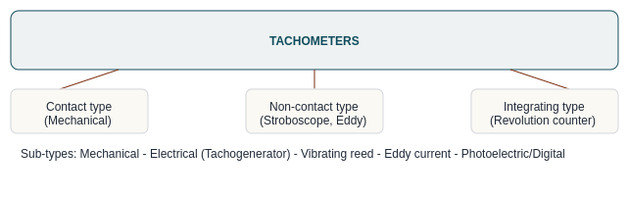
Fig 1.1 — Classification chart of tachometers

1.2 Revolution Counter
A revolution counter (mechanical counter) is an integrating-type speed measuring instrument. It counts the total number of revolutions made by a rotating shaft over a known interval of time; the speed is then obtained by dividing the count by the time using a stopwatch:
N (RPM) = (Number of revolutions counted) / (Time in minutes)
Construction & Working
- The counter spindle is pressed against the rotating shaft (or coupled through a rubber-tipped cone).
- A worm-and-gear train reduces the shaft speed and drives a set of dial pointers (units, tens, hundreds, thousands) similar to an odometer.
- The operator starts a stopwatch simultaneously with engaging the counter, notes initial and final readings after a fixed time, and computes the RPM.
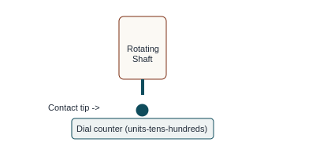
Fig 1.2 — Revolution counter (contact type) schematic

1.3 Eddy Current Tachometer (Drag-cup Tachometer)
The eddy current tachometer is a non-contact, indicating-type instrument widely used in automobile speedometers. Its working is based on electromagnetic induction and eddy current drag.
Construction
- A permanent magnet is coupled to the shaft whose speed is to be measured, so it rotates with the shaft.
- A light aluminium/copper cup (drag cup) surrounds the magnet, free to rotate on its own spindle, restrained by a hair-spring (control spring).
- A pointer is fixed to the spindle of the drag cup, moving over a calibrated scale.
Working Principle
- As the magnet rotates, its rotating magnetic field cuts through the drag cup and induces eddy currents in it (Faraday's law).
- These eddy currents produce their own magnetic field, which interacts with the magnet's field, producing a torque that tends to drag the cup in the same direction as the magnet (Lenz's law).
- The cup rotates until the deflecting (drag) torque is balanced by the restoring torque of the control spring.
- The steady deflection of the cup/pointer is proportional to the speed of rotation of the magnet (shaft speed); the scale is calibrated directly in RPM.
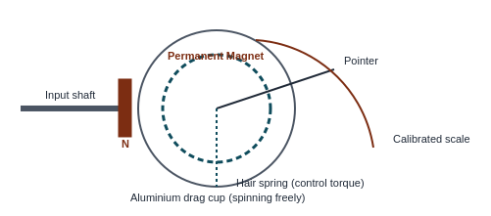
Fig 1.3 — Eddy current (drag-cup) tachometer
Advantages
- Simple, robust, no electrical supply needed; direct reading; low cost — ideal for vehicle speedometers.
Limitations
- Accuracy affected by temperature (changes magnet strength and cup resistivity); needs periodic calibration.

2. Displacement Measurement

2.1 Linear Variable Differential Transformer (LVDT)
The LVDT is the most widely used inductive-type transducer for measuring linear displacement. It converts a linear mechanical displacement into a proportional electrical (AC voltage) output.
Construction
- Consists of one primary winding at the centre and two identical secondary windings (S1 and S2), symmetrically wound on either side of the primary, on a cylindrical former.
- A movable soft-iron core (plunger) slides inside the former and is mechanically connected to the object whose displacement is to be measured.
- The primary is excited by an AC supply (typically 1–10 kHz).
- The two secondaries are connected in series opposition, so the output is the differential voltage e0 = e1 − e2.
Working Principle
- Null position: When the core is at the centre, flux linkage with both secondaries is equal, so induced EMFs e1 = e2, giving output e0 = 0.
- Core displaced above null: More flux links S1, so e1 > e2; output is in phase with primary voltage.
- Core displaced below null: More flux links S2, so e2 > e1; output is 180° out of phase with primary voltage.
- The magnitude of e0 is proportional to the amount of core displacement, and the phase indicates the direction.
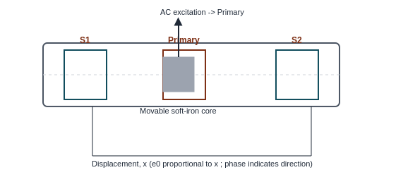
Fig 2.1 — Construction of LVDT (core at null / displaced positions)
Advantages
- Frictionless (no physical contact between core and winding), infinite resolution, high sensitivity, good linearity over the working range, rugged and reliable.
Limitations
- Sensitive to stray magnetic fields and temperature; needs AC excitation and demodulation circuitry; dynamic response limited by core mass.
Applications
- Displacement/position sensing, load cells, pressure gauges (via diaphragm), thickness gauging.

3. Flow Measurement

3.1 Rotameter (Variable Area Flow Meter)
A rotameter is a variable-area type flow meter used for measuring the flow rate of liquids and gases.
Construction
- A vertical, transparent, tapered glass tube (small diameter at bottom, larger at top) mounted with the wide end up.
- A float (bob) of specific shape and density is placed inside the tube, free to move up and down.
- The tube is graduated (directly in flow units or with a percentage scale).
Working Principle
- Fluid enters from the bottom and flows upward past the float, lifted by the dynamic force of the flowing fluid.
- As the float rises, the annular area between the float and the tapered tube wall increases, reducing flow velocity around the float until the upward fluid (drag) force just balances the float's weight (less buoyancy).
- Equilibrium: Weight of float = Buoyant force + Drag force. The float settles at a height proportional to the flow rate — higher flow rate pushes the float higher.
- The flow rate is read directly from the graduated scale at the float's upper edge (or maximum diameter).
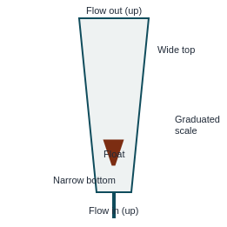
Fig 3.1 — Rotameter (variable area flow meter)
Advantages
- Simple, low cost, direct visual reading, good for low flow rates, constant pressure-drop device.
Limitations
- Must be mounted vertically; limited accuracy; glass tube can break; unsuitable for opaque or very high-pressure fluids.

3.2 Turbine Flow Meter
A turbine meter is a velocity-type flow meter that gives an electrical pulse output proportional to volumetric flow rate — widely used for accurate, high-range flow measurement of clean liquids and gases.
Construction
- A multi-bladed rotor (turbine wheel), made of a magnetic material, is mounted centrally in the flow line on a low-friction bearing/shaft, free to rotate.
- A magnetic pickup coil (reluctance pickup) is mounted on the outside of the pipe housing, close to the blade tips.
- Straightening vanes are provided upstream to remove flow swirl before it reaches the rotor.
Working Principle
- The fluid flowing through the meter strikes the angled turbine blades and causes the rotor to spin at a speed proportional to the fluid velocity (and hence volumetric flow rate).
- As each blade passes the magnetic pickup coil, it disturbs the magnetic field and induces a small voltage pulse in the coil.
- The frequency of these pulses is directly proportional to the flow rate: Q = f / K, where f = pulse frequency and K = meter (calibration) constant.
- The pulse train is fed to an electronic counter/totalizer to display flow rate and total flow.
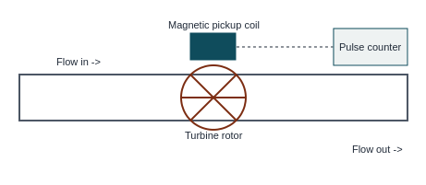
Fig 3.2 — Turbine flow meter
Advantages
- High accuracy, wide range, fast response, digital (pulse) output suited to totalizing.
Limitations
- Needs clean fluid (bearing wear from suspended particles); requires straight upstream/downstream pipe runs; not suitable for very viscous fluids.

4. Temperature Measurement

4.1 Resistance Thermometer (RTD)
A resistance thermometer works on the principle that the electrical resistance of a pure metal increases almost linearly with temperature.
Rt = R0 (1 + α·ΔT)
where R0 = resistance at reference temperature (0°C), α = temperature coefficient of resistance, ΔT = temperature rise.
Construction
- A fine resistance wire (platinum, nickel, or copper) is wound non-inductively (bifilar winding, to cancel self-inductance) on a mica or ceramic former.
- The winding is protected inside a metal sheath / protective thermowell.
- Lead wires connect the sensing element to a measuring bridge (usually a Wheatstone bridge) placed outside.
Working
- The RTD element is placed in the medium whose temperature is to be measured.
- As temperature changes, the resistance of the element changes proportionally.
- This change in resistance unbalances the Wheatstone bridge; the bridge output (or resistance needed to rebalance it) is calibrated directly in terms of temperature.
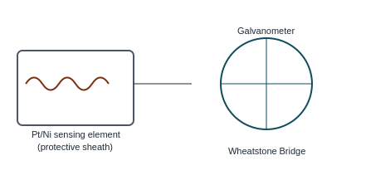
Fig 4.1 — Resistance thermometer with Wheatstone bridge
Advantages
- High accuracy and stability, good repeatability, suitable for remote indication, wide usable range (platinum RTD: −200°C to 850°C).
Limitations
- Costlier than thermocouples; slower response; self-heating error due to sensing current; fragile winding.

4.2 Optical Pyrometer
An optical pyrometer is a non-contact type temperature measuring instrument used for very high temperatures (600°C to 3000°C+), based on comparing the brightness (intensity) of radiation emitted by the hot body with that of a reference (calibrated) filament lamp.
Construction
- Objective lens — focuses the image of the hot object.
- A reference lamp (pyrometer lamp) with a filament whose brightness can be varied using a rheostat, placed at the focal plane.
- A red filter — allows only a narrow (monochromatic) band of wavelength (~0.65 μm) to pass, for consistent comparison.
- An eyepiece for viewing, and a milliammeter (calibrated directly in temperature) in series with the lamp circuit.
Working Principle
- The image of the hot object (source) is focused, through the objective lens, onto the plane of the reference filament.
- The observer views the filament superimposed on the image of the hot source through the red filter and eyepiece.
- The current through the reference lamp is adjusted (rheostat) until the filament brightness exactly matches the object's brightness — the filament tip 'disappears' against the background (disappearing filament method).
- The milliammeter reading, pre-calibrated against known temperatures, is then read directly as the object's temperature.
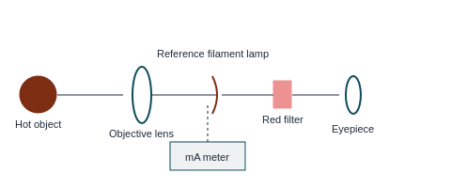
Fig 4.2 — Optical pyrometer (disappearing filament type)
Advantages
- Non-contact — suitable for very high temperatures / moving or inaccessible objects; wide range; portable.
Limitations
- Manual operation (observer judgement) → possible human error; needs the object to be visible/luminous; less accurate at lower temperatures; affected by smoke/absorbing medium between object and instrument.

5. Miscellaneous Measurements

5.1 Humidity Measurement — Hair Hygrometer
A hair hygrometer measures relative humidity using the principle that human hair (or certain organic fibres) changes length with change in relative humidity — hair expands as humidity increases and contracts as humidity decreases.
Construction & Working
- A bundle of specially treated (degreased) human hair is stretched between a fixed frame at one end and a spring-loaded tensioning arrangement at the other.
- The other end of the hair bundle is connected, through a lever and pulley/rack-and-pinion mechanism, to a pointer moving over a calibrated scale (0–100% RH).
- As relative humidity increases, the hair elongates, moving the linkage and pointer; as humidity decreases, the hair contracts, moving the pointer in the opposite direction.
- The scale is calibrated by comparison with a standard (e.g., psychrometer) at known humidity levels.
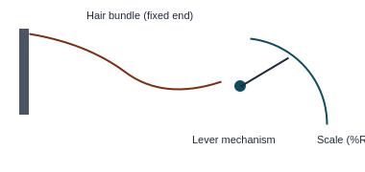
Fig 5.1 — Hair hygrometer
Advantages / Limitations
- Simple, inexpensive, portable, direct reading. However: slow response, hair ages/degrades with time and pollution, needs periodic recalibration, poor accuracy at very high/low humidity.

5.2 Density Measurement — Hydrometer
A hydrometer measures the specific gravity (relative density) of a liquid using Archimedes' principle of floatation: a floating body displaces its own weight of liquid.
Construction
- A sealed glass tube with a bulb at the bottom weighted with lead shot / mercury (to keep it upright and floating vertically).
- A narrow graduated stem extends above the bulb, calibrated directly in specific gravity units.
Working Principle
- The hydrometer is floated freely in the liquid under test.
- In a denser liquid, a smaller volume needs to be displaced to support the hydrometer's weight, so it floats higher (less of the stem submerged).
- In a less dense liquid, a larger volume must be displaced, so the hydrometer sinks lower.
- The specific gravity is read directly at the point where the liquid surface cuts the graduated stem.
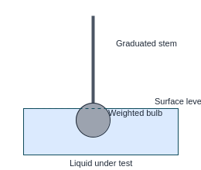
Fig 5.2 — Hydrometer floating in liquid
Applications
- Battery acid testing (specific gravity of electrolyte), milk testing (lactometer), alcohol content testing, sugar solution testing (Brix hydrometer).

5.3 Liquid Level Measurement — Sight Glass and Float Gauge
(a) Sight Glass (Gauge Glass)
- The simplest direct-reading level indicator: a transparent glass (or plastic) tube is connected to the vessel/tank at the top and bottom through shut-off valves.
- By the principle of communicating vessels, the liquid level in the sight tube is always the same as the level inside the tank.
- The level is read visually against a graduated scale mounted alongside the glass tube.
(b) Float Gauge (Float-type Level Indicator)
- A float (hollow ball/disc, less dense than the liquid) rests on the liquid surface inside the tank.
- The float is connected via a flexible cable/tape over a pulley to a counterweight and a pointer/dial outside the tank, or through a rigid arm and lever to an external indicator.
- As the liquid level rises or falls, the float moves up/down correspondingly, and this motion is transmitted to the pointer, which indicates the level on a calibrated scale.
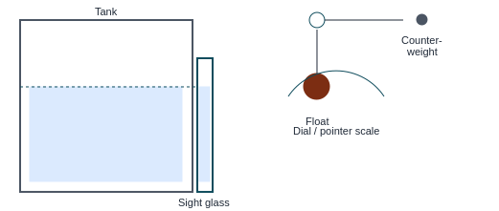
Fig 5.3 — Sight glass (left) and float-type level gauge with pulley & counterweight (right)

5.4 Biomedical Measurement — Sphygmomanometer
A sphygmomanometer is used to measure arterial blood pressure (systolic and diastolic) indirectly, non-invasively.
Construction
- An inflatable rubber cuff (bladder) wrapped around the upper arm, connected to a rubber hand-bulb (pump) with a release valve, and a pressure indicator — either a mercury column manometer or an aneroid (dial) gauge.
- A stethoscope is used along with the cuff (auscultatory method) to listen to Korotkoff sounds over the brachial artery.
Working Principle (Auscultatory Method)
- The cuff is wrapped around the upper arm and inflated (using the hand bulb) to a pressure above the expected systolic pressure — this fully occludes (collapses) the brachial artery, stopping blood flow.
- The cuff pressure is then released slowly and steadily via the control valve, while a stethoscope placed over the brachial artery (at the elbow) is used to listen for sounds.
- The pressure at which the first tapping (Korotkoff) sound is heard, as blood just begins to spurt through the artery, is recorded as the systolic pressure.
- As the cuff pressure continues to fall, the sounds change and finally disappear; the pressure at which the sound disappears (artery fully open, unobstructed flow) is recorded as the diastolic pressure.
- Readings are expressed in mm of Hg, e.g., 120/80 mmHg.
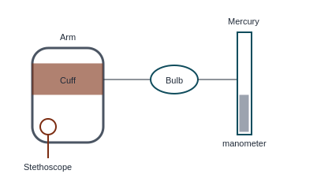
Fig 5.4 — Sphygmomanometer (auscultatory method) setup
Types
- Mercury sphygmomanometer — most accurate, uses a mercury column.
- Aneroid sphygmomanometer — uses a bourdon-tube/diaphragm dial gauge, portable.
- Digital (electronic) sphygmomanometer — uses an oscillometric method with an automatic pressure sensor, no stethoscope needed.

6. Probable Question Bank

Speed Measurement
2 Marks
- Define a tachometer.
- What is a revolution counter?
- State the principle of an eddy current tachometer.
- List any two types of contact-type tachometers.
5 Marks
- Classify tachometers with suitable examples of each type.
- Explain the construction and working of a revolution counter with a neat sketch.
- Differentiate between contact-type and non-contact-type tachometers.
10 Marks
- With a neat sketch, explain the construction and working principle of an eddy current tachometer. State its advantages and limitations.
- Describe in detail the classification of tachometers and explain any two types with diagrams.

Displacement Measurement (LVDT)
2 Marks
- Expand LVDT and state its use.
- What is meant by the 'null position' of an LVDT?
5 Marks
- Explain the construction of an LVDT with a labelled diagram.
- State the advantages and limitations of an LVDT.
10 Marks
- With a neat sketch, explain the construction and working principle of LVDT, and explain how output voltage varies with core displacement on either side of the null position.

Flow Measurement
2 Marks
- What is a rotameter?
- State the principle of a turbine flow meter.
5 Marks
- Explain the construction and working of a rotameter with a diagram.
- Explain the working principle of a turbine flow meter with a sketch.
10 Marks
- With neat diagrams, compare the construction, working, advantages and limitations of a rotameter and a turbine flow meter.

Temperature Measurement
2 Marks
- State the principle of a resistance thermometer.
- What is an optical pyrometer used for?
5 Marks
- Explain the construction and working of a resistance thermometer with a diagram.
- Explain the 'disappearing filament' principle used in an optical pyrometer.
10 Marks
- With a neat sketch, explain the construction and working of an optical pyrometer. State its advantages, limitations and applications.
- Explain the working of a resistance thermometer along with a Wheatstone bridge circuit for measuring the change in resistance.

Miscellaneous Measurements
2 Marks
- State the principle of a hair hygrometer.
- Define specific gravity and name the instrument used to measure it.
- What is a sight glass?
- What does a sphygmomanometer measure?
5 Marks
- Explain the construction and working of a hydrometer with a neat sketch.
- Explain the working of a float-type liquid level gauge.
- Explain the auscultatory method of blood pressure measurement using a sphygmomanometer.
10 Marks
- Explain, with neat sketches, the construction and working of (a) a hair hygrometer and (b) a hydrometer.
- Describe with a diagram the working of a sphygmomanometer for measuring systolic and diastolic blood pressure. Mention its types.
- Compare sight glass and float gauge methods of liquid level measurement with neat diagrams, stating advantages and limitations of each.
Tip: For 10-mark answers, always structure as — Definition → Principle → Neat labelled diagram → Construction → Working → Advantages/Limitations/Applications — this covers the full expected marking scheme.
DIPLOMA ENGINEERING
METROLOGY & QUALITY CONTROL
LECTURE NOTES – UNIT IV
Limits, Fits & Tolerances
Angular Measurement
Screw Thread Measurement
With diagrams, worked numerical examples, real-world applications
and a complete 2-mark / 5-mark / 10-mark question bank
Part | Topics covered
A | Limits, Fits & Tolerances – concept, principle, IS 919-1993, plug & ring gauges (Taylor's principle, gauge design), IS 3477-1973, multi-gauging and inspection
B | Angular Measurement – universal bevel protractor, sine bar, spirit level, clinometer, angle gauges (with numericals on setting angle gauges)
C | Screw Thread Measurement – ISO grades & fits, thread errors, pitch errors, measurement of major / minor / effective diameter and pitch, two-wire method, thread gauge micrometer, floating carriage dial micrometer
D | Question Bank – 2 marks, 5 marks, 10 marks, and a formula sheet

PART A – LIMITS, FITS AND TOLERANCES

A1. Why do we need limits, fits and tolerances?
No manufacturing process can produce a part to an exact size. A shaft that is ordered as Ø25 mm will come out as 24.98 mm, 25.01 mm and so on, because of machine vibration, tool wear, temperature, operator skill and measuring error. Instead of chasing an impossible "exact" size, the designer states how much variation is acceptable – the part will still work if its size lies between two permitted limits.
This idea is the basis of interchangeability: any bolt taken from a box must fit any nut from another box, and a spare piston bought from a shop must fit an engine made years earlier. Limits and fits make mass production, spare-part supply and assembly-line work possible, and they keep cost down – a tighter tolerance means a costlier process, so the designer gives the widest tolerance that still allows proper function.

A2. Basic terminology
Term | Meaning
Basic (nominal) size | The theoretical size from which limits are measured; same for hole and shaft of a fit (e.g. 25 mm).
Actual size | The size obtained by measurement of the finished part.
Limits of size | The two extreme permissible sizes: Maximum limit (upper) and Minimum limit (lower).
Deviation | Algebraic difference between a size and the basic size. Upper deviation = max limit − basic size (ES for hole, es for shaft). Lower deviation = min limit − basic size (EI for hole, ei for shaft).
Fundamental deviation | The deviation (upper or lower) that is closest to the zero line; it fixes the position of the tolerance zone.
Tolerance | Difference between the maximum and minimum limits = upper deviation − lower deviation. It fixes the size of the tolerance zone.
Zero line | The line representing the basic size; deviations are drawn above (+) or below (−) it.
Allowance | Intentional difference between the maximum material limits of mating parts (= minimum clearance or maximum interference). It is a *prescribed* difference, while tolerance is a *permitted variation*.
MML / LML | Maximum Material Limit – the limit that leaves most metal (largest shaft, smallest hole). Least Material Limit – the opposite.
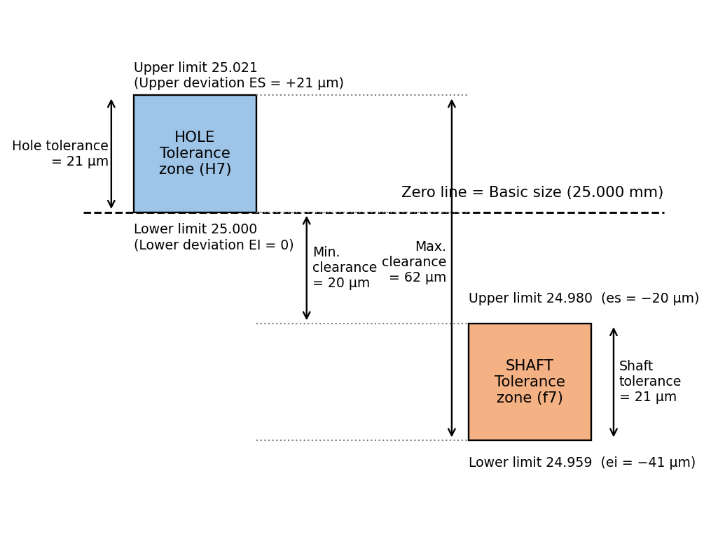
Fig. 1: Limits, deviations and tolerance zones for a Ø25 H7/f7 fit
In Fig. 1, the hole zone sits entirely above the zero line and the shaft zone entirely below it, so the shaft is always smaller than the hole – a clearance fit.

Types of tolerance
- Unilateral tolerance – the variation is permitted in only one direction from the basic size, e.g. 25 +0.021 / −0.000. Preferred in the hole-basis system because the datum (basic size) stays fixed and a single tool setting can be used.
- Bilateral tolerance – variation permitted on both sides, e.g. 25 ± 0.02 (or +0.03/−0.01). Used where the size must be controlled around a mean, such as hole centre distances.
- Geometrical tolerances – limit form and position errors (flatness, roundness, parallelism, etc.). They are outside this unit but work together with size tolerances.

A3. Fits
A fit is the relationship between a hole and a shaft that are to be assembled, determined by the difference in their sizes before assembly. There are three families:
Type | Condition | Result | Examples / use
Clearance fit | Max. shaft < Min. hole (tolerance zones do not touch; shaft zone is below) | Always some gap; parts rotate or slide freely | Bearings and journals, sliding gears, machine-tool slides, piston in cylinder, door hinge pin
Interference fit | Min. shaft > Max. hole (shaft zone above hole zone) | Always overlap of metal; assembly needs press, heating or cooling; permanent joint | Bush in housing, wheel on axle, gear rim on hub, bearing race on shaft
Transition fit | Zones overlap | Result may be small clearance or small interference depending on actual sizes | Location of gears, pulleys, couplings with key; dowel pins; precise location with easy dismantling
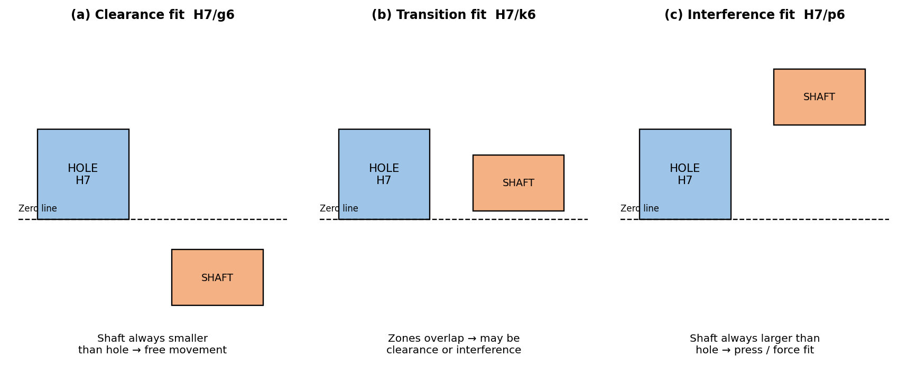
Fig. 2: Clearance, transition and interference fits (hole-basis system)

Terms used in fits
- Maximum clearance = Max. hole size − Min. shaft size
- Minimum clearance = Min. hole size − Max. shaft size (if positive, this equals the allowance)
- Maximum interference = Max. shaft size − Min. hole size
- Minimum interference = Min. shaft size − Max. hole size

Hole-basis and shaft-basis systems
 | Hole-basis system | Shaft-basis system
Principle | Hole is kept constant (H: lower deviation = 0); different fits are obtained by changing the shaft limits | Shaft is kept constant (h: upper deviation = 0); different fits are obtained by changing the hole limits
Preferred? | Yes – holes are made with standard-size tools (drills, reamers, broaches) which are costly, whereas shafts can be turned or ground to any size easily | Used only where one long shaft carries many parts with different fits (e.g. line shafting, drawn bright bars)
Example | H7/g6, H7/k6, H7/p6 | G7/h6, K7/h6, P7/h6

A4. The ISO / IS 919-1993 system of limits and fits
IS 919-1993 (equivalent to ISO 286) is the Indian Standard that lays down the system of limits and fits for sizes up to 500 mm. It specifies two things for every hole or shaft: how wide the tolerance zone is (tolerance grade) and where it lies relative to the zero line (fundamental deviation letter).

Tolerance grades (IT grades)
There are 18 standard grades: IT01, IT0, IT1, IT2 … IT16. The smaller the number, the finer (and costlier) the tolerance. Roughly: IT01–IT4 for gauges and precision instruments; IT5–IT12 for parts that mate (fits); IT12–IT16 for non-mating, rough work (castings, forgings, rolled sections).
For grades IT5 to IT16 the tolerance is a multiple of the standard tolerance unit i:
i (µm) = 0.45 ∛D + 0.001 D (D = geometric mean of the diameter step, mm)
Grade | IT5 | IT6 | IT7 | IT8 | IT9 | IT10 | IT11 | IT12 | IT13 | IT14 | IT15 | IT16
Multiple of i | 7 | 10 | 16 | 25 | 40 | 64 | 100 | 160 | 250 | 400 | 640 | 1000

Fundamental deviations (position letters)
- Holes use capital letters A to ZC (28 positions); shafts use small letters a to zc.
- Hole H has a lower deviation of zero (zone starts at the zero line and goes upward). Shaft h has an upper deviation of zero (zone goes downward from the zero line).
- Shafts a–g lie below the zero line → clearance fits with H holes; j–n straddle or just touch it → transition fits; p–zc lie above it → interference fits. (The reverse applies for holes A–G, J–N, P–ZC.)
- Designation: Ø25 H7/g6 – basic size 25 mm, hole grade IT7 with position H, shaft grade IT6 with position g. The other limit of each zone follows from the tolerance grade.

Commonly used fits (hole-basis)
Fit | Type | Typical application
H11/c11 | Loose running | Wide commercial tolerances; hinges, farm machinery, rough bearings
H8/f7, H7/f7 | Normal running | Machine-tool spindle bearings, pump shafts, gearbox bearings
H7/g6 | Sliding (close running) | Precision slides, spool valves, sliding gear on shaft
H7/h6 | Location clearance | Spigots, tailstock sleeves, parts to be assembled by hand and located accurately
H7/k6 | Transition (light drive) | Gears, pulleys and couplings with key, location with possible light press
H7/n6 | Transition (tight) | Gears and bushes needing accurate location with rigid joint
H7/p6 | Light press (interference) | Bearing bush in housing, dowel in permanent fixture
H7/s6 | Medium drive | Bronze rim on gear hub, steel bush in cast-iron housing

Worked example A-1: Finding tolerance from the IT system
Q. Find the IT7 and IT6 tolerance for the diameter step 30–50 mm.
D = √(30 × 50) = 38.73 mm. i = 0.45 × ∛38.73 + 0.001 × 38.73 = 0.45 × 3.384 + 0.0387 = 1.562 µm
IT7 = 16 i = 16 × 1.562 = 25 µm = 0.025 mm; IT6 = 10 i = 15.6 ≈ 16 µm = 0.016 mm.

Worked example A-2: Clearance fit
Q. Hole Ø40 +0.025/−0.000, shaft Ø40 −0.025/−0.050. Find hole & shaft limits, tolerances, maximum and minimum clearance, and type of fit.
Hole: max 40.025, min 40.000, tolerance = 0.025 mm. Shaft: max 39.975, min 39.950, tolerance = 0.025 mm.
Max. clearance = 40.025 − 39.950 = 0.075 mm; Min. clearance = 40.000 − 39.975 = 0.025 mm (= allowance).
Both clearances are positive → clearance fit.

Worked example A-3: Comparing three fits of Ø25 mm (hole 25 H7 = +0.021/0)
(i) H7/g6 – shaft −0.007/−0.020: max clearance = 21 − (−20) = 41 µm; min clearance = 0 − (−7) = 7 µm → clearance.
(ii) H7/k6 – shaft +0.015/+0.002: max clearance = 21 − 2 = 19 µm; max interference = 15 − 0 = 15 µm → transition.
(iii) H7/p6 – shaft +0.035/+0.022: max interference = 35 − 0 = 35 µm; min interference = 22 − 21 = 1 µm → interference.

Real-world applications
• Automobile engine – piston in cylinder (clearance fit), valve guide in head (interference), gudgeon pin in piston boss (transition).
• Bicycle / motor-cycle – wheel bearing races pressed on the hub (interference), axle in bearing (clearance or light transition).
• Electric motor – rotor shaft with bearing inner race (transition/interference) and bearing outer race in housing (transition), allowing replacement of worn bearings.
• Spare-part industry – a replacement bearing with the same designation always fits because the standard limits are the same worldwide.

A5. Limit gauges – concept and Taylor's principle
Measuring each of thousands of components with a micrometer is slow and needs a skilled operator. A limit gauge is a fixed-size tool that does not measure the size but only tells whether the part is within the limits or not. Every limit gauge has two ends:
- GO end – corresponds to the maximum-material limit (smallest hole / largest shaft). A good part must pass through (or enter) it.
- NO GO (NOT GO) end – corresponds to the least-material limit (largest hole / smallest shaft). A good part must not pass through it.
If the part accepts the GO gauge and rejects the NO GO gauge, its size lies between the limits and it is accepted.

Taylor's principle
Taylor's principle (1905) states: "The GO gauge should check all the features of the mating part at once (size, shape, length of engagement), while the NO GO gauge should check only one feature (one dimension) at a time."
- GO gauge – has the full form of the mating part and full length of engagement (a long cylindrical plug for a hole; a full ring for a shaft). So it checks diameter, roundness, straightness and taper together.
- NO GO gauge – has a short length and point contact (a short plug, or a snap/ring with two-point contact) so that a bell-mouthed, oval or tapered hole is not wrongly accepted and a single oversize dimension is detected.
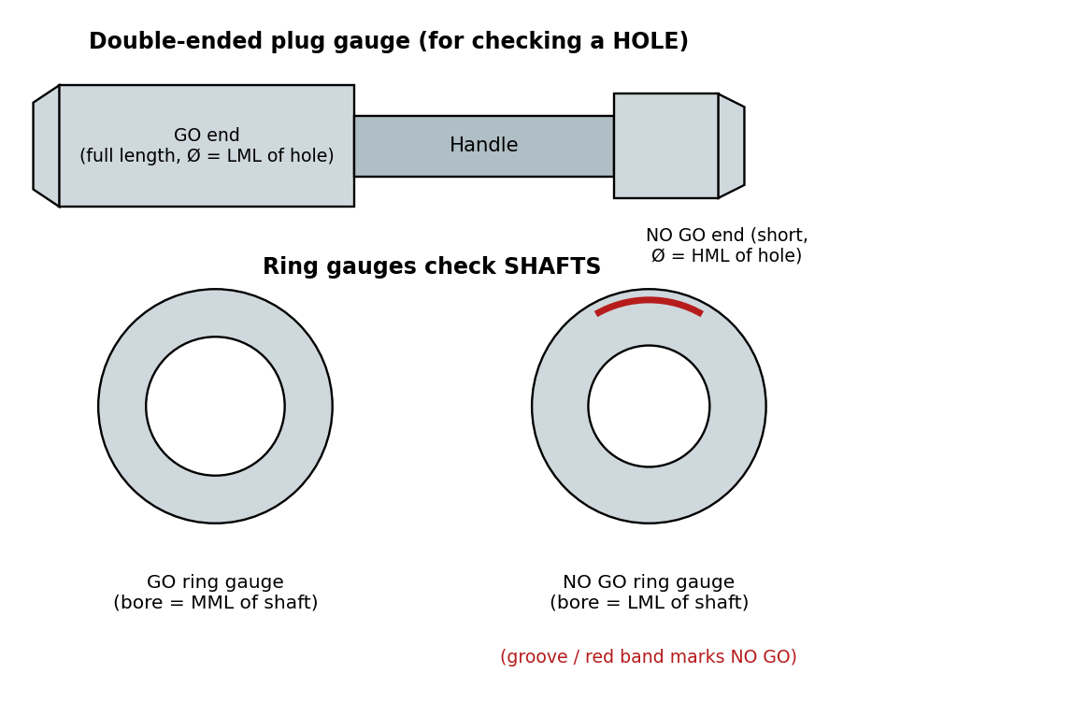
Fig. 3: Double-ended plug gauge and ring gauges

Plug gauges and ring gauges
 | Plug gauge | Ring gauge
Checks | Holes (bores) | Shafts (external diameters)
GO member | Long cylindrical plug, size = LML of hole (min. hole size) | Ring whose bore = MML of shaft (max. shaft size)
NO GO member | Short plug, size = HML of hole (max. hole size) | Ring whose bore = LML of shaft (min. shaft size); marked by a groove or red band
Forms | Double-ended (small sizes), single-ended with handle, progressive plug (GO and NO GO on one end), taper plug for taper holes | Plain rings; for larger shafts snap (gap) gauges (adjustable or fixed) are preferred because rings are heavy and cannot be used on long shafts
Material | Hardened & ground tool steel, alloy steel or chrome-plated / carbide-tipped for long life; made to very close tolerance and stabilised by ageing

Gauge design – gauge tolerance and wear allowance
Gauges are also manufactured parts and therefore need their own tolerance. If the gauge tolerance zone were placed outside the work tolerance zone, good parts could be rejected or bad parts accepted. Hence, by the usual (Indian) practice:
- Gauge tolerance ≈ 10 % of the work tolerance, and the gauge tolerance zone lies inside the work tolerance zone. A few borderline good parts may be rejected, but no bad part can ever be accepted.
- Wear allowance ≈ 10 % of the gauge tolerance, given only on the GO gauge (the GO end wears because it enters every part; the NO GO end seldom touches material). It is added inside the work zone so that the GO gauge can be used until it wears down to the limit of the work.
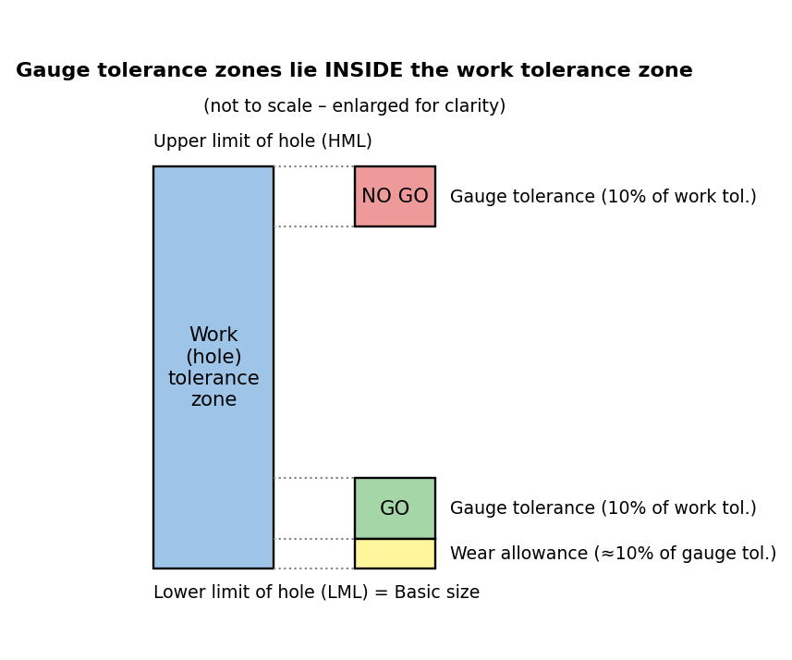
Fig. 4: Gauge tolerance and wear allowance relative to the work tolerance zone
IS 3477-1973 (named in your syllabus) is the Indian Standard for plain ring gauges, and is used together with the other gauge standards for plug and snap gauges. Always refer to the latest edition of the standard when preparing a gauge drawing.
Worked example A-4: Design of a plug gauge for a hole Ø25 H7 (25.000 to 25.021)
Work tolerance = 25.021 − 25.000 = 0.021 mm. Gauge tolerance = 10 % × 0.021 = 0.0021 mm. Wear allowance = 10 % × 0.0021 = 0.00021 ≈ 0.0002 mm.
GO plug: lower limit = 25.000 + 0.0002 = 25.0002; upper limit = 25.0002 + 0.0021 = 25.0023 → Ø25.0002 +0.0021/0
NO GO plug: upper limit = 25.021; lower limit = 25.021 − 0.0021 = 25.0189 → Ø25.0210 −0.0021/0

Worked example A-5: Design of a ring gauge for a shaft Ø25 f7 (24.980 to 24.959)
Work tolerance = 24.980 − 24.959 = 0.021 mm. Gauge tolerance = 0.0021 mm; wear allowance = 0.0002 mm.
GO ring: (wear makes a ring bore larger, so the allowance is applied inwards): upper limit = 24.980 − 0.0002 = 24.9798; lower limit = 24.9798 − 0.0021 = 24.9777.
NO GO ring: lower limit = 24.959; upper limit = 24.959 + 0.0021 = 24.9611.

Advantages and limitations of limit gauges
Advantages | Limitations
• Very fast – semi-skilled operator can inspect  • No reading or calculation, reducing human error  • Low cost per inspection for large batches  • Checks form and size together (GO gauge) | • Do not show the actual size, so no trend/SPC information  • A separate gauge is required for every size and every tolerance  • Gauges wear and must be calibrated periodically  • Not economical for small batches or single parts

Real-world applications
• Mass production of nuts, bolts and bearings – every operator on the line uses GO/NO GO plug and snap gauges instead of micrometers.
• Engine cylinder liners, hydraulic cylinders, gear-box housings – plug gauges for bore diameter; ring gauges for crank-pin, valve-stem and piston-pin diameters.
• Defence ammunition and aerospace fasteners – gauges are the final acceptance tool and are in turn verified against master gauges in the metrology lab.

A6. Concept of multi-gauging and inspection
Inspection is the process of examining a product to decide whether it conforms to the specified size, shape and finish. It may be 100 % inspection (every piece – used for safety-critical parts) or sampling inspection (a statistically chosen sample from a lot – used for large-volume, lower-risk parts). Inspection can take place at the receipt of raw material, between operations (in-process), at the end (final) or even on the machine (in-process gauging with feedback to the machine).
Multi-gauging (also called *multiple gauging* or *composite gauging*) is the technique of measuring several dimensions of a component simultaneously in one loading and one operation, with a separate gauging head (probe) for each dimension. The heads may be dial indicators, LVDT electronic probes, air-gauge jets, or limit switches. Their outputs are collected on one display or fed to a computer which shows each dimension, decides OK / REJECT, and can automatically sort the part.
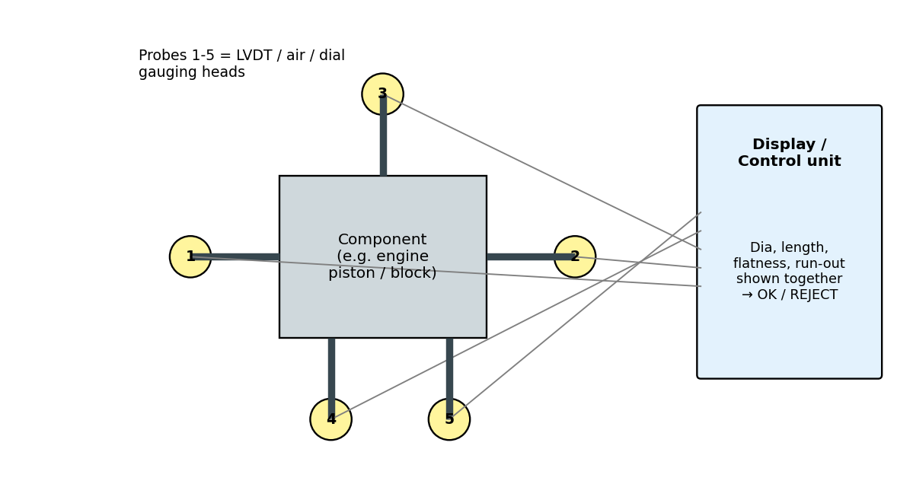
Fig. 5: Layout of a multi-gauging station
Advantages | Limitations
• Large saving in inspection time (one loading, many readings)  • Reduces operator error and fatigue  • Consistent and repeatable results; ideal for automation and SPC data collection  • Can give feedback to machine tool to correct tool wear automatically | • High initial cost of the fixture and heads  • Fixture is specific to one component (low flexibility)  • Needs regular calibration with a master  • Economical only for high-volume production

Real-world applications
• Automobile industry – engine block and crankshaft stations check bore diameters, journal diameters, length and run-out in a few seconds.
• Bearing and piston-ring factories – multi-gauging machines sort parts into size groups (selective assembly).
• Gearbox shafts, valve bodies, fuel-injector parts – in-process gauging with feedback to CNC grinders.
Quick revision – Part A
Tolerance = max limit − min limit. Allowance = min clearance (or max interference). Hole-basis: H hole (lower deviation 0).
GO gauge = full form, long; NO GO gauge = short, one feature (Taylor). Gauge tolerance 10 % of work tolerance; wear allowance 10 % of gauge tolerance (GO only).

PART B – ANGULAR MEASUREMENT

B1. Concept of angular measurement
An angle is the opening between two intersecting lines or surfaces. Unlike length, angle has no physical "standard" that must be kept – a full circle is by definition 360°, so the standard is built into geometry. Angular units:
- Degree (°), minute (′), second (″): 1° = 60′, 1′ = 60″, and a full circle = 360°.
- Radian: the angle subtended at the centre by an arc equal to the radius; 2π rad = 360°, 1 rad = 57.2958°.
- Gradian / grade: 1 right angle = 100 grades (rare).
Angular measurement is needed wherever a surface is inclined to another: tapers, chamfers, cutting-tool angles, V-blocks, dovetails, gear teeth, cams and the levelling of machine beds. Instruments are divided into three groups:
Group | Instruments | Principle
Direct (angle-reading) | Protractor, universal bevel protractor, optical protractor, clinometer | Angle is read directly on a graduated scale / vernier
Comparison (reference angle) | Angle gauges, combination set, taper gauges, try-squares | Work angle is compared with a known fixed angle or a combination of fixed angles
Indirect (trigonometric) | Sine bar, sine centre, sine table, rollers & balls, taper-measuring slip gauges | Angle is calculated from linear measurements using sin, tan or cos
Reference of level | Spirit level, autocollimator, clinometer | Uses gravity or light as a datum

B2. Universal bevel protractor
This is the most common workshop instrument for measuring angles directly. It consists of a stock (base) with a flat reference face, a graduated circular dial (turret) that can be rotated and locked, a blade (a long steel rule) that slides in a slot in the dial and can be locked at any length, and a vernier scale fixed to the stock. An acute-angle attachment can be clamped on the stock to measure angles below 90° more conveniently.
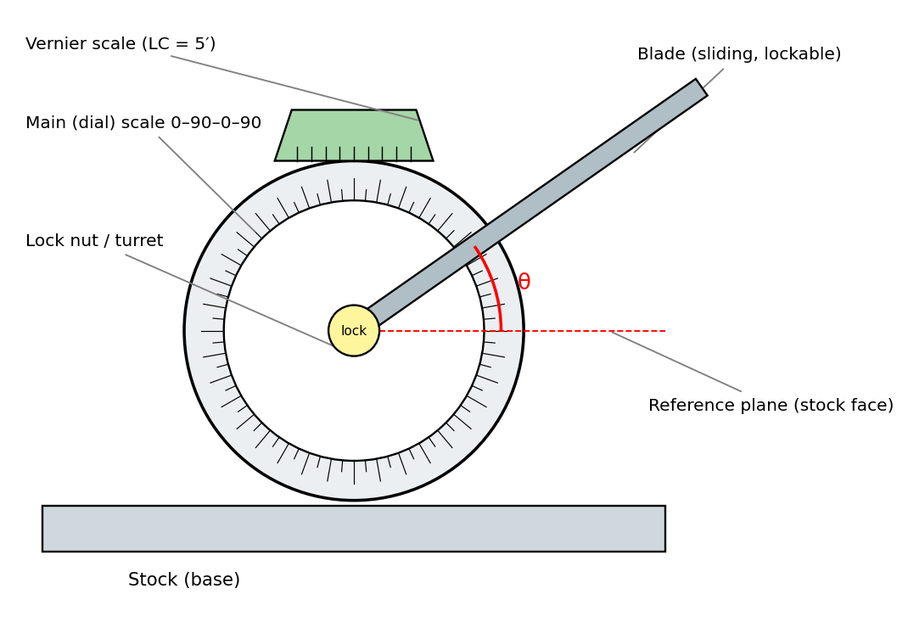
Fig. 6: Universal bevel protractor

Vernier principle and least count
The main dial is divided into degrees and numbered 0–90–0–90 in four quadrants. The vernier plate has 12 divisions on each side of zero which together cover 23 main-scale divisions (23°). Thus:
1 VSD = 23°/12 ; Least count = 2 MSD − 1 VSD = 2° − 23°/12 = 1°/12 = 5′
(One vernier division spans 2° of the main scale less 1/12 degree, so the vernier reads to 5 minutes of arc.)
Worked example B-1: Reading the protractor
The zero of the vernier is just past the 42° line of the main scale and the 7th vernier division coincides with a main-scale line.
Reading = 42° + 7 × 5′ = 42° + 35′ = 42° 35′.

Procedure and use
- Clean the stock and blade, and check the zero by bringing the blade into full contact with the stock face.
- Loosen the dial lock, rotate the blade so that the stock face and blade touch the two surfaces forming the angle, and lock the dial.
- Read degrees on the main scale and minutes on the vernier (note that the vernier scale is read in the same direction as the dial moved).
- Angles above 90° are read as (180° − reading) when the acute-angle attachment is fitted – use the correct dial quadrant.
Real-world applications
• Checking cutting-tool angles (rake, clearance) in a tool room; checking chamfers and bevels on shafts and plates.
• Setting milling-machine head or table to an angle; marking out in fitter and fabrication shops; checking the angle of V-blocks and dovetail slides.

B3. Sine bar
A sine bar is a precision-ground hardened steel bar with two cylindrical rollers of equal diameter fixed at an exact distance L (the centre distance, usually 100, 200 or 300 mm) with their axes parallel to each other and to the top face of the bar. It is an indirect, trigonometric method – the bar is raised on slip gauges to the angle required and the angle is found from the height of the slip-gauge stack.
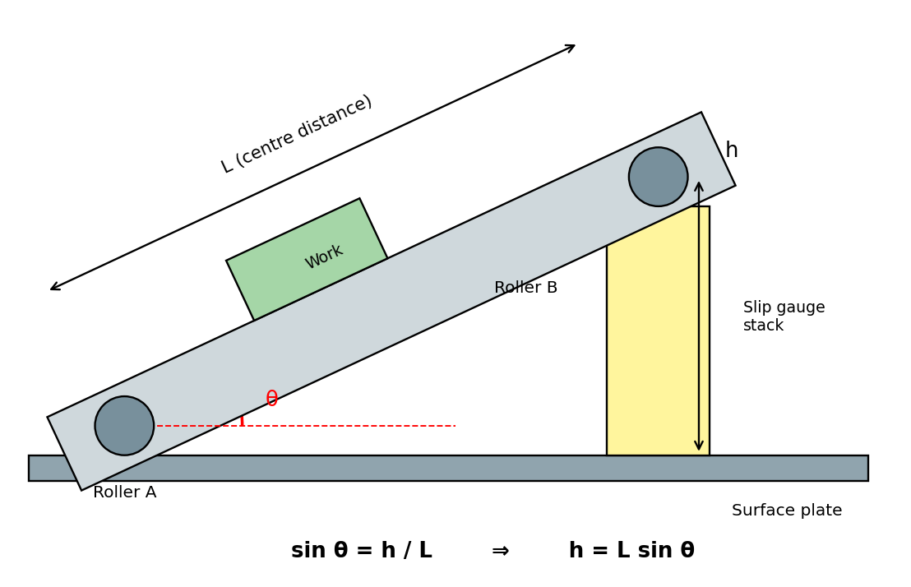
Fig. 7: Sine bar set to angle θ using slip gauges

Principle
Roller A rests on the surface plate and roller B on a stack of slip gauges of height h. The triangle formed by the bar, the surface plate and the vertical gives:
sin θ = h / L ⇒ h = L sin θ

Two uses
- Setting a given angle: calculate h = L sin θ, build that height from slip gauges, raise one roller. The top face is now at the desired angle to the surface plate (used to machine or grind an inclined face).
- Measuring an unknown angle: rest the work on the bar, adjust the slip gauges until the work surface is parallel to the surface plate (dial indicator shows no reading when moved along the work). Then sin θ = h / L gives θ.

Types and limitations
- Types: sine bar, sine block / sine plate (with a base), compound sine plate (for two angles in different planes), sine centre (for tapered work between centres).
- Not suitable for angles above 45° – near 90° the value of sin θ changes slowly, so a small error in h gives a large error in θ (error ≈ δh /(L cos θ)). For large angles use the complement or a sine plate with a different arrangement.
- Accuracy depends on the roller size, centre distance, parallelism and the slip-gauge accuracy. Surfaces must be clean, and temperature of the setup should be steady.
Worked example B-2: Setting a sine bar
Q1. A 200 mm sine bar is to be set to 30°. Find the height of the slip gauge stack.
h = L sin θ = 200 × sin 30° = 200 × 0.5 = 100 mm.
Q2. A 300 mm sine bar is set at 12°. h = 300 × sin 12° = 300 × 0.20791 = 62.37 mm.
Q3. A 100 mm sine bar uses a slip gauge stack of 28.2 mm to bring a taper face parallel to the surface plate. Find the angle.
sin θ = 28.2/100 = 0.282 ⇒ θ = 16.38° ≈ 16° 23′.

Real-world applications
• Grinding and milling tapered work such as tool angles, die and punch faces and dovetail slides (the sine plate is clamped on the magnetic chuck of a surface grinder).
• Inspection of taper gauges, taper shank tools (Morse taper) and gear/cam blanks; calibrating bevel protractors.

B4. Spirit level
A spirit level is an instrument that measures small deviations of a surface from the horizontal (or vertical) using gravity. It has a sealed, slightly curved glass vial filled with alcohol or ether, leaving a bubble. The vial is mounted in a rigid, machined base (flat or V-grooved). The bubble always rises to the highest point, so if the surface is horizontal the bubble stays in the centre between two reference marks; if one end is higher the bubble moves toward it.
- Sensitivity is the angle (or the rise per metre) that moves the bubble by one division – e.g. 0.02 mm per metre per division ≈ 4 arc-seconds. A vial of larger radius of curvature is more sensitive.
- Types: engineer's / machinist's level, precision (micrometer) level with an adjustable vial, frame (block) level with two faces at 90° (for vertical checks), and circular (bull's-eye) level for general levelling in two directions.
- Before use, check the level by reversing it end-to-end on the same surface; the reading should not change.
Real-world applications
• Levelling machine-tool beds, lathe and milling-machine tables before alignment tests; installing heavy machines and presses.
• Building construction (masons, carpenters), levelling of surface plates, and levelling of tripods for surveying instruments.

B5. Clinometer – principle of working
A clinometer is a spirit level mounted on a rotatable graduated circular dial. It measures the angle of an inclined surface relative to the horizontal (gravity datum). The base is placed on the inclined surface; the dial is rotated until the bubble in the vial is centred; the dial then shows the angle through which the vial had to be turned from its original (zero) position – that angle equals the inclination of the surface. A vernier or micrometer-type adjustment gives reading to 1 minute or better. Types include the dial clinometer, the Brunton / hand-held clinometer and the electronic inclinometer.
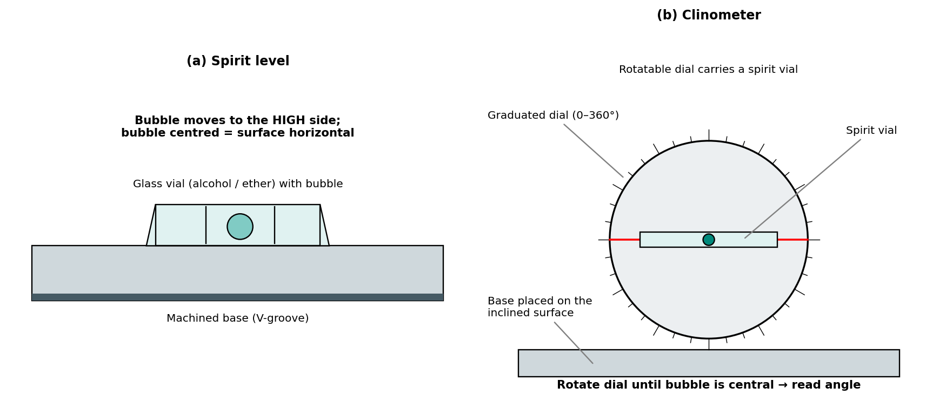
Fig. 8: Spirit level and clinometer
Real-world applications
• Checking the inclination of machine slides, guide ways, and the angular setting of milling heads and grinding wheels.
• Surveying and forestry (slope and tree height), checking of roof pitch, angle of ramps, wheel-chair slope and mining/rock-face dip.
• Aircraft and vehicle testing – measuring tilt of wings, loading ramps and tilt tables.

B6. Angle gauges
Angle gauges are hardened and lapped wedge-shaped steel blocks (the Tomlinson / Taylor-Hobson angle-gauge system, similar to slip gauges for length). They work by comparison and by wringing: several gauges are wrung together, added or subtracted, to build any angle between 0° and 360° (with a square block). They are accurate to about ±1 second.
A standard set has 13 gauges plus one square block:
Group | Angles in the set
Degrees (5) | 1°, 3°, 9°, 27°, 41°
Minutes (4) | 1′, 3′, 9′, 27′
Seconds (4) | 3″, 6″, 18″, 30″
Extra | Square block (90°) – used for angles above 90° and for checking squareness
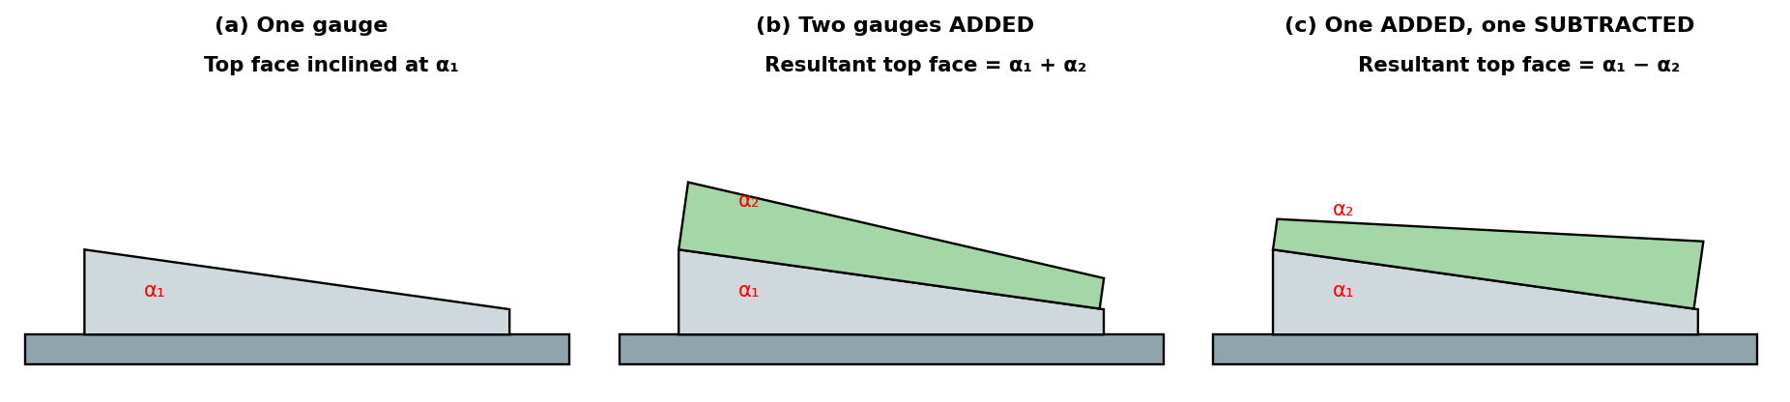
Fig. 9: Angle gauges: (a) a single gauge, (b) angles added, (c) one gauge reversed to subtract
Rules for combination: To add an angle, the gauge is placed with its thick end on the same side as the previous gauge; to subtract, it is reversed so that the thick end is on the opposite side. The gauges are wrung together and held in a holder (the combination is then clamped to the work or used as a master).
Worked example B-3: Setting angle gauges for 32° 25′ 33″
Degrees: 32° = 41° − 9° (use the 41° and 9° gauges, 9° reversed).
Minutes: 25′ = 27′ − 3′ + 1′. Seconds: 33″ = 30″ + 3″.
Combination: (41° − 9°) + (27′ − 3′ + 1′) + (30″ + 3″) = 32° 25′ 33″. (Check: 41 − 9 = 32°; 27 − 3 + 1 = 25′; 30 + 3 = 33″ ✓.)

Worked example B-4: Setting angle gauges for 47° 12′ 9″
Degrees: 47° = 41° + 9° − 3°. Minutes: 12′ = 9′ + 3′. Seconds: 9″ = 6″ + 3″.
Combination: (41° + 9° − 3°) + (9′ + 3′) + (6″ + 3″) = 47° 12′ 9″ ✓. Use a square block together with the gauges to build angles beyond the set's range (e.g. 90° + 20° = 110°).

Real-world applications
• Calibration of bevel protractors and sine bars, and as master reference in inspection departments.
• Checking angles on tool-and-die work, gauge making, cutter grinding; setting precision machine fixtures where a very exact angle is required.
Quick revision – Part B
Bevel protractor LC = 5′. Sine bar: sin θ = h/L, use below 45°. Angle gauge set = 13 pieces (1°,3°,9°,27°,41°;1′,3′,9′,27′;3″,6″,18″,30″).
Spirit level and clinometer use gravity as datum.

PART C – SCREW THREAD MEASUREMENT

C1. Screw thread terminology
Screw threads are used for fastening (bolts, nuts), power transmission (lead screws, jack screws) and for measuring (micrometer screws). The following terms define the geometry of a thread:
Term | Meaning
Major (outside) diameter, d | The largest diameter of the thread – measured over the crests of an external thread (nominal size of the screw).
Minor (core / root) diameter, d₁ | The smallest diameter – measured at the roots of an external thread.
Effective (pitch) diameter, d₂ | Diameter of an imaginary co-axial cylinder that cuts the thread so that the width of the groove equals the width of the tooth (= P/2). It controls how bolt and nut fit and is the most important diameter.
Pitch, P | Axial distance between corresponding points on adjacent threads.
Lead | Axial distance moved by the nut in one revolution; lead = pitch × number of starts.
Flank angle / thread angle | Angle between the two flanks (60° for ISO metric); half-angle = 30°.
Crest / root / flank | Crest – top of the tooth; root – bottom of the groove; flank – the sloping surface joining them.
Thread depth (height) | Radial distance between crest and root = (d − d₁)/2.
Helix angle | tan λ = lead / (π d₂).
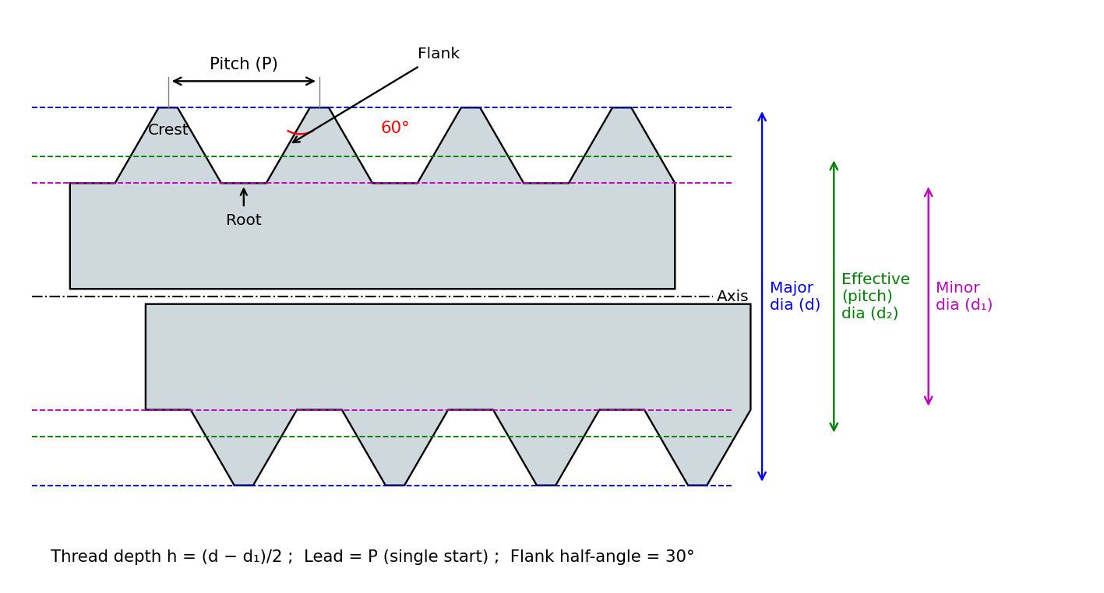
Fig. 10: Screw thread terminology (axial section, ISO metric 60° thread)
For the ISO metric thread with pitch P: basic height H = 0.866 P, d₂ = d − 0.6495 P, d₁ = d − 1.0825 P.
Thread form | Angle | Application
ISO metric (IS 4218) | 60° | General fastening – bolts, nuts, studs
Unified (UNC/UNF) | 60° | American and aerospace fasteners
British Standard Whitworth (BSW) | 55° | Older British fasteners, pipe threads (BSP)
Acme | 29° | Lead screws, vices, machine-tool feed screws
Square | 0° (flanks perpendicular) | Heavy power transmission, presses, screw jacks
Buttress | 45° / 7° | One-direction heavy loads – vices, jacks, hydraulic presses

C2. ISO grades and fits of threads
For interchangeability, the tolerances and fits of metric threads are standardised in ISO 965 / IS 14962 (with IS 4218). Like plain fits, the tolerance on a thread is described by a tolerance grade (a number – its size) and a tolerance position (a letter – its location relative to the basic profile):
 | External thread (bolt) | Internal thread (nut)
Tolerance position (letter) | Small letters e, f, g, h (e: large allowance, h: zero fundamental deviation) | Capital letters G, H (H: zero fundamental deviation)
Grades for pitch (effective) diameter | 3, 4, 5, 6, 7, 8, 9 | 4, 5, 6, 7, 8
Grades for major diameter (bolt) / minor diameter (nut) | 4, 6, 8 | 4, 5, 6, 7, 8
Length of engagement | S – short, N – normal, L – long | S – short, N – normal, L – long

- A tolerance class has the grade first, then the position letter: e.g. 6g (bolt) and 6H (nut). The full designation is M20 × 2.5 – 6H/6g (metric thread of 20 mm major dia, 2.5 mm pitch, nut class 6H, bolt class 6g).
- Fine, medium and coarse quality: 5H/4h (fine), 6H/6g (medium – most common general-purpose fit), 7H/8g (coarse; for hot-rolled or dirty conditions).
- The H nut with h bolt gives zero allowance. g and e bolts provide an allowance for coatings (zinc / cadmium plating) and for easier assembly.
Real-world applications
• Standard fasteners in vehicles and appliances are made 6H/6g, whereas plated bolts use a 6g/6e allowance so that the coating does not make them jam in nuts.
• Aircraft and precision instruments use fine class (5H/4h) to avoid loosening under vibration.

C3. Errors in screw threads
A thread is a complex helical surface, so errors can occur in several elements:
- Major and minor diameter errors – wrong tool depth, tool wear; cause interference between crest and root.
- Effective (pitch) diameter error – the most serious one, as it governs the fit.
- Flank angle (thread angle) errors – wrong tool grinding or tool tilt; the two half-angles can be unequal (a leaning thread).
- Pitch errors – see below.
- Form errors – rounded or flattened crests and roots, wavy flanks, and drunken thread.

Pitch errors
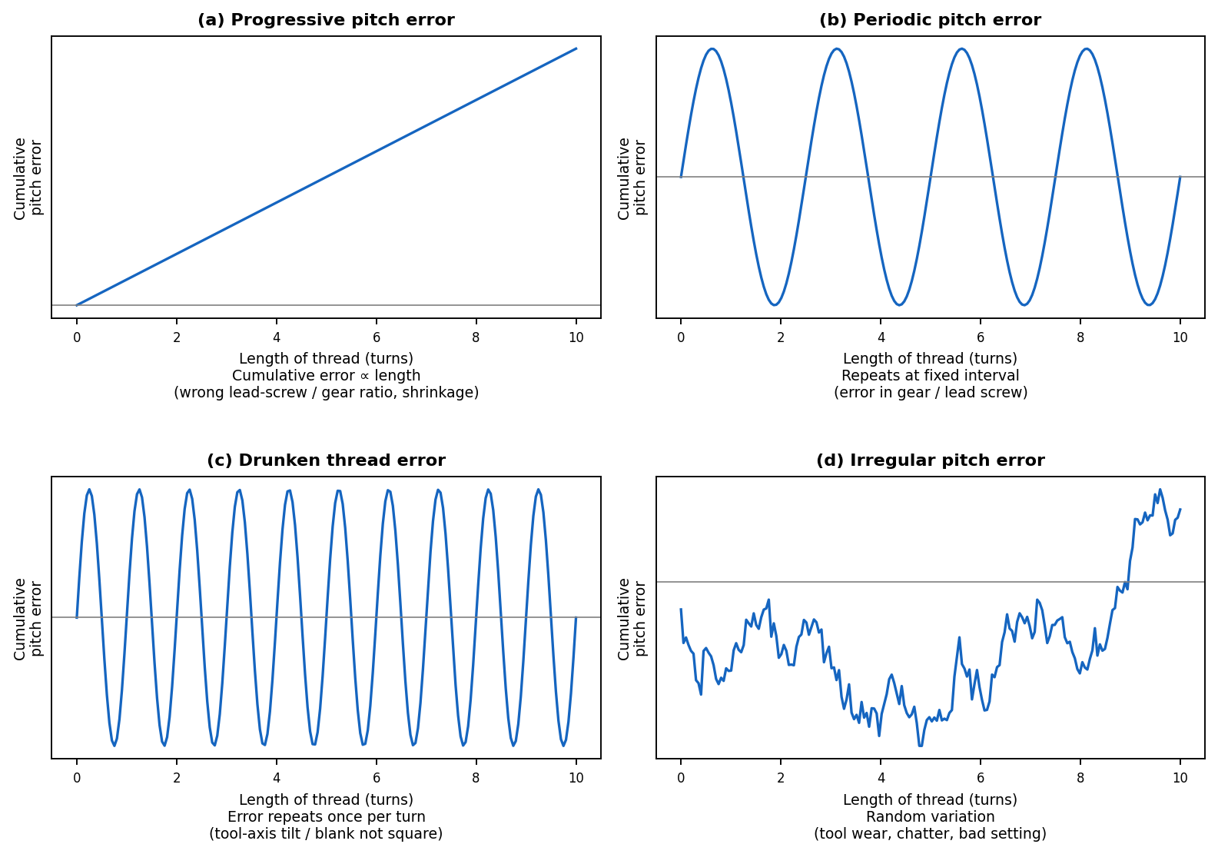
Fig. 11: Types of pitch errors in screw threads
Type | Description | Common cause
Progressive | Pitch is uniformly larger or smaller than correct, so the error accumulates linearly with the length of thread. | Wrong gear ratio or error in lead screw of the lathe; shrinkage or expansion of blank; temperature change.
Periodic | Error repeats at regular intervals along the axis. | Eccentricity or error in the lead-screw gear or in the machine's drive gear.
Drunken thread | A special periodic error that repeats once per revolution; the thread form is correct but the path is wavy. | Tool axis not perpendicular to the blank axis; blank face not square with the lead screw.
Irregular | Random variation of pitch along the thread. | Machine wear, vibration/chatter, uneven tool pressure, material variations.

Effect of pitch and flank-angle errors – virtual effective diameter
A bolt with a pitch error (or flank angle error) cannot be screwed into a perfect nut that would accept a perfect bolt of the same measured effective diameter. The thread behaves as if its effective diameter were larger than the measured one. This larger "functional" size is the virtual effective diameter:
Virtual effective dia (bolt) = measured E + ΔE(pitch) + ΔE(flank angle)
For a 60° thread, the increase in effective diameter due to a pitch error ΔP (the largest cumulative error over the length of engagement, taken positive) is
ΔE (pitch) = ΔP cot (α/2) = 1.732 ΔP (α = 60°, ΔP in mm)
Worked example C-1: Effect of pitch error
A bolt has a measured effective diameter of 18.376 mm and a largest cumulative pitch error of +0.02 mm over the engagement length.
ΔE = 1.732 × 0.02 = 0.0346 mm ⇒ virtual effective diameter ≈ 18.376 + 0.035 = 18.411 mm – this virtual size must stay within the upper limit of the effective-diameter tolerance.

C4. Measurement of thread elements
Element | Method / instrument | Remarks
Major diameter | Ordinary micrometer (bench micrometer for high accuracy); comparator with standard cylinder; floating carriage micrometer | Measured over the crests; thread should be clean and burr-free. A bench micrometer applies a uniform measuring force.
Minor diameter | Toolmaker's microscope; micrometer with small V-pieces / rollers / prisms that bridge the root; floating carriage micrometer with pointed styli | The root is hard to reach; hence an indirect method or an optical instrument is used.
Effective diameter | Two-wire / three-wire method; thread-gauge micrometer; floating carriage micrometer; profile projector / toolmaker's microscope | Most important, as it governs the fit of the screw.
Pitch | Screw-pitch gauge (leaf type) – quick check; toolmaker's microscope or profile projector; floating carriage with ball-ended stylus; pitch-measuring machine | Pitch is measured between corresponding points; cumulative error over several threads is the main interest.
Thread angle / form | Optical projector, toolmaker's microscope, thread gauges | Overlays of the standard profile are used for comparison.

C5. Two-wire method (effective diameter)
Two accurately made, hardened steel cylindrical wires of equal diameter d are placed in the thread grooves on opposite sides of the screw, and the distance M over the wires is measured with an ordinary micrometer (the anvils touching the wires). The effective diameter is then calculated from M and the wire diameter.
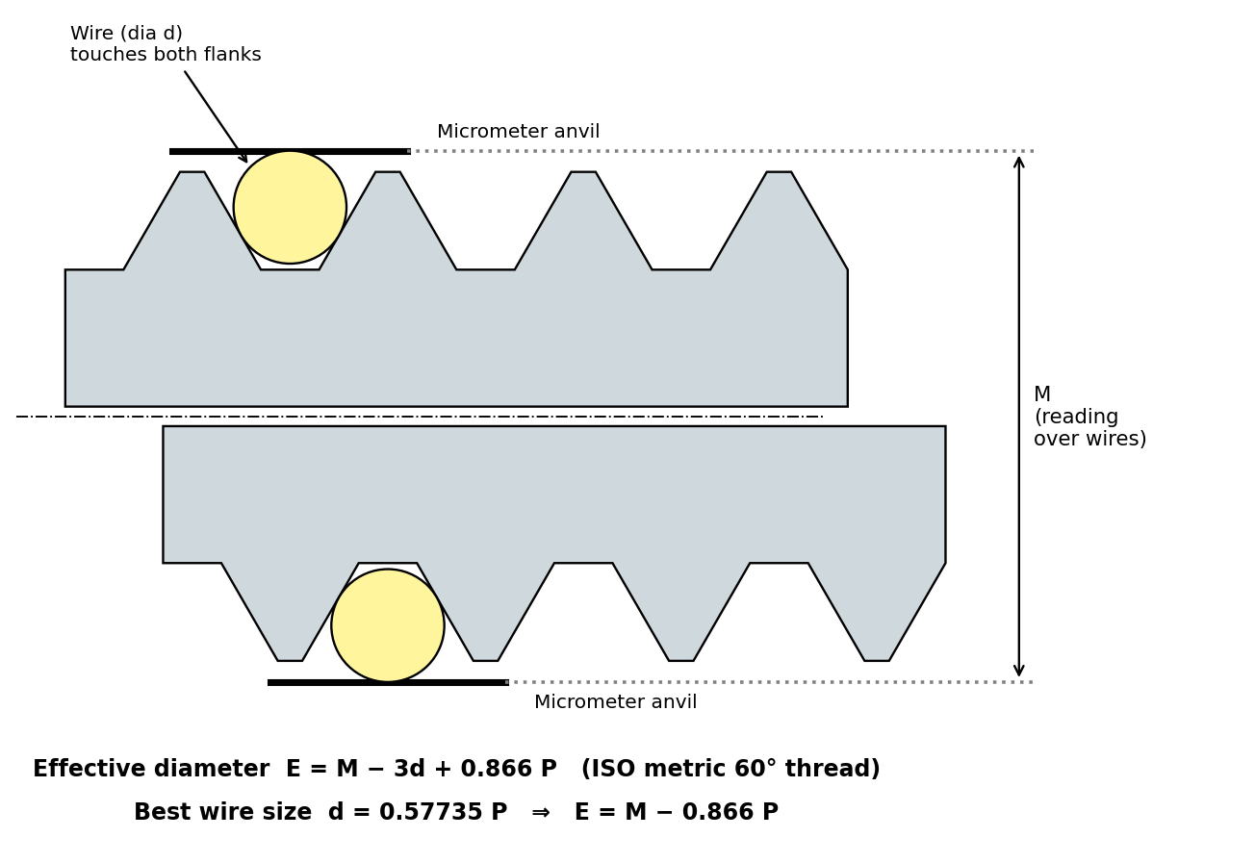
Fig. 12: Two-wire method of measuring effective diameter

Derivation (for a thread of flank angle α and pitch P)
For a wire of diameter d lying in the groove and touching both flanks, the height of the wire centre above the pitch line, and the extra length over the pitch-line width, can be found from the geometry of the groove. Summed on both sides, the micrometer reading over the wires is:
M = E + d (1 + cosec (α/2)) − (P/2) cot (α/2)
For ISO metric thread (α = 60°): cosec 30° = 2 and cot 30° = 1.732, therefore
M = E + 3d − 0.866 P ⇒ E = M − 3d + 0.866 P
For a Whitworth thread (α = 55°): E = M − 3.1657 d + 0.9605 P.

Best wire size
The best wire is the diameter that touches the flanks at the pitch (effective) line. At that point the error in M due to an error in the flank angle is practically zero, so the reading depends only on E and P. Its size is d = (P/2) sec (α/2):
d(best) = P / (2 cos 30°) = 0.57735 P (metric) ⇒ E = M − 0.866 P
For Whitworth threads, d(best) = 0.5637 P.
Worked example C-2: Two-wire measurement of a metric thread
Q. A M20 × 2.5 screw is measured with best-size wires and the micrometer reads M = 20.55 mm over the wires. Find the wire size and the effective diameter. What is the effective diameter of a perfect thread?
Best wire d = 0.57735 × 2.5 = 1.443 mm.
E = M − 3d + 0.866 P = 20.55 − 3 × 1.443 + 0.866 × 2.5 = 20.55 − 4.330 + 2.165 = 18.385 mm (or E = M − 0.866 P = 20.55 − 2.165 = 18.385 mm).
Basic effective dia = d − 0.6495 P = 20 − 1.624 = 18.376 mm. So the screw is 0.009 mm over the basic effective dia (check against the tolerance of the class used, e.g. 6g).

Worked example C-3: Expected reading over wires
Q. For an M10 × 1.5 thread what micrometer reading M over best wires is expected for a perfect thread?
d = 0.57735 × 1.5 = 0.866 mm; E = 10 − 0.6495 × 1.5 = 9.026 mm; M = E + 3d − 0.866 P = 9.026 + 2.598 − 1.299 = 10.325 mm.

Three-wire method
The three-wire method places two wires in adjacent grooves on one side and one wire in the opposite groove, and the micrometer measures over all three. This keeps the micrometer face square to the thread axis (it "floats" on the wires), which is why it is more accurate and is the usual method for precision work; the formula is exactly the same. The simple two-wire method needs more care because the micrometer anvils are only supported at two points.

Precautions
- Use wires made of hardened steel with accuracy of about 0.5 µm, and of the correct (best) size if possible.
- Apply the correct and uniform measuring pressure; take readings at several positions and average.
- A small correction for the lead angle (helix) and for elastic flattening of wires at contact is applied in high-precision work.
Real-world applications
• Checking the effective diameter of thread rolling dies, taps, hobs, thread-grinding wheels, and master screw gauges in the quality laboratory.
• In-process control in fastener factories (bolts, studs) when the accuracy of a quick GO/NO GO thread gauge is not enough.

C6. Thread gauge micrometer (screw thread micrometer)
This is a modification of the ordinary micrometer in which the usual flat measuring faces are replaced by a pointed (conical) spindle tip and a V-shaped anvil, both ground to the thread form (60° or 55°). The V-shaped anvil engages a groove on one side of the thread, and the conical point of the spindle enters the groove on the opposite side. The micrometer therefore measures effective diameter directly, without any calculation.
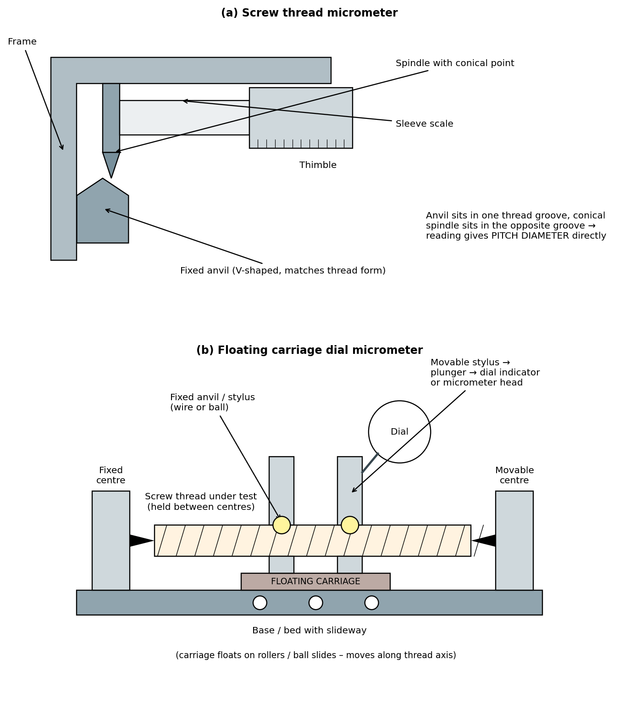
Fig. 13: Thread micrometer and floating carriage dial micrometer
- Anvils and spindle points are interchangeable, and a different pair is needed for each range of pitch (e.g. 0.4–0.5 mm, 0.6–0.9 mm, 1–1.75 mm, 2–3 mm).
- Before use, the instrument is set to zero against a setting standard or by closing the anvil and spindle together; the reading is the effective diameter. Because the contact points are at the pitch line, flank-angle errors have little effect.
- Advantages: quick, handy, no calculation, usable on the shop floor. Limitations: less accurate than the wire method; separate anvils are needed for each pitch; it does not detect pitch errors.
Real-world applications
• Used on the shop floor of bolt, stud and screw manufacturers to check effective diameter quickly while the thread is being rolled or cut.

C7. Floating carriage dial micrometer
The floating carriage dial micrometer (also called a floating carriage diameter-measuring machine or Newall type) is a precision bench instrument for checking screw gauges, taps, hobs and lead screws. It can measure major diameter, minor diameter, effective diameter and pitch on the same set-up.

Construction
- A rigid base / bed with a fixed headstock centre and a spring-loaded tailstock centre between which the screw is mounted so that its axis is horizontal.
- A carriage that is mounted on a very low-friction slideway (rollers or ball slides) – it "floats". It can move along the axis of the screw (for pitch) and across it (for diameter).
- On the carriage are two measuring heads (one fixed, one movable) carrying interchangeable styli – wires, ball ends, cylinders or pointed tips, according to the element. The movable head is connected to a dial indicator or micrometer thimble reading directly in units of 0.001 mm (1 µm) or finer.

Working
- Setting: a setting cylinder of known diameter (slightly greater than effective diameter) is placed between centres. The measuring heads are brought up to it, and the dial is set to zero (or the reading noted).
- Effective diameter: the cylinder is replaced by the screw; wires (best size) are laid in the grooves, held against the flanks by the fixed and movable styli. The carriage is allowed to float so that the pressure is equal at both ends. The dial reading difference between the screw and the cylinder, plus the wire correction, gives E.
- Major diameter: the same procedure with flat or cylindrical styli over the crests. Minor diameter: with special pointed styli or prism-shaped tips bridging the root.
- Pitch: a ball-ended stylus is placed in the first thread groove and the dial zeroed; the carriage is moved axially, one groove at a time, and the dial change at each new groove gives the pitch error (cumulative error is obtained by adding up).
Advantages | Limitations
• Measures major, minor, effective dia and pitch on one machine  • Constant measuring pressure due to floating carriage – gives very consistent results  • Reads directly to 1 µm; suitable for master gauges | • Costly and needs a controlled (lab) environment  • Skilled operator is needed  • Only suitable for external threads of limited length and diameter

Real-world applications
• Calibration of thread plug gauges and ring gauges; inspection of taps, dies, hobs, lead screws and ball screws in tool rooms and in aerospace and defence quality labs.

Thread gauges for production inspection (brief)
In production, threads are checked in a go/no-go style with thread plug gauges (for nuts) and thread ring / snap gauges (for bolts). The GO gauge has full thread form and checks the virtual effective diameter, major and minor diameters and pitch together; the NO GO gauge has a truncated form and few turns so it checks only the effective diameter. This is Taylor's principle again, applied to threads.
Quick revision – Part C
ISO metric: 60°, H = 0.866P, d₂ = d − 0.6495P, d₁ = d − 1.0825P. Designation M20×2.5–6H/6g.
Two-wire: E = M − 3d + 0.866P; best wire = 0.57735P ⇒ E = M − 0.866P. ΔE(pitch) = 1.732 ΔP.

PART D – QUESTION BANK

D1. Two-mark questions (with short answers)
Q1. Define tolerance.
Ans: The difference between the maximum and minimum permissible limits of size (upper deviation − lower deviation).
Q2. What is meant by interchangeability?
Ans: The ability to assemble any part with any mating part of the same specification, without selection or extra fitting.
Q3. Define allowance and distinguish it from tolerance.
Ans: Allowance is the intentional difference between maximum-material limits of mating parts (min. clearance / max. interference); tolerance is the permitted variation in the size of one part.
Q4. What are unilateral and bilateral tolerances?
Ans: Unilateral: variation on one side of the basic size only (25 +0.02/0). Bilateral: variation on both sides (25 ±0.02).
Q5. Name the three types of fits with one example each.
Ans: Clearance (H7/g6 – sliding), transition (H7/k6 – gear on shaft), interference (H7/p6 – bush in housing).
Q6. Why is the hole-basis system preferred?
Ans: Holes are made with fixed-size tools (reamers, drills); keeping hole size constant reduces the number of tools and cost.
Q7. How many tolerance grades are given in IS 919-1993? What is the standard tolerance unit?
Ans: 18 grades (IT01, IT0, IT1–IT16). i = 0.45 ∛D + 0.001 D (µm).
Q8. State Taylor's principle of gauging.
Ans: GO gauge checks all features (full form, full length) at once; NO GO gauge checks only one feature at a time.
Q9. What is wear allowance? On which gauge is it given?
Ans: A margin given on the GO gauge (≈10 % of gauge tolerance) to permit wear before the gauge goes outside the work limit.
Q10. What is multi-gauging?
Ans: Simultaneous measurement of several dimensions of a component in one set-up using multiple gauging heads.
Q11. State the principle of the sine bar.
Ans: sin θ = h / L, where h is the height of slip gauges under one roller and L the centre distance of rollers.
Q12. Why is the sine bar not recommended above 45°?
Ans: Because near 90° sin θ changes very slowly; a small error in h causes a large error in angle.
Q13. What is the least count of a universal bevel protractor?
Ans: 5 minutes (2° − 23°/12 = 1/12° = 5′).
Q14. State the working principle of a clinometer.
Ans: A spirit level on a rotatable graduated dial; the dial is turned until the bubble is central and the angle of inclination is read from the scale.
Q15. How many gauges are there in a standard angle-gauge set? Name them.
Ans: 13: 1°, 3°, 9°, 27°, 41°; 1′, 3′, 9′, 27′; 3″, 6″, 18″, 30″ (plus a square block).
Q16. Define effective diameter of a screw thread.
Ans: Diameter of the imaginary cylinder that cuts the thread so that groove width equals tooth width (P/2).
Q17. What is pitch error? Name its types.
Ans: Deviation of the actual pitch from the nominal; progressive, periodic (drunken) and irregular.
Q18. What is the best wire size for a metric thread?
Ans: d = 0.57735 P (touches the flanks on the pitch line).
Q19. What is the effective-diameter formula for the two-wire method (60° thread)?
Ans: E = M − 3d + 0.866 P.
Q20. Write the designation M20 × 2.5 – 6H/6g.
Ans: Metric thread, 20 mm major diameter, 2.5 mm pitch; internal thread class 6H, external thread class 6g.
Q21. What is the purpose of a floating carriage dial micrometer?
Ans: Measures major, minor and effective diameters and pitch of screw gauges, taps and hobs with constant measuring pressure.
Q22. Define virtual effective diameter.
Ans: The effective diameter of a thread increased by the amount equivalent to its pitch and flank-angle errors – it is the size the thread actually behaves as in assembly.

D2. Five-mark questions (with key points for the answer)
Q1. Explain with a neat sketch the terms: basic size, limits, deviations, tolerance and zero line.
Answer guide: Fig. 1 + the definitions table (A2); show upper/lower deviation, tolerance zone, example Ø25 H7/f7.
Q2. Differentiate between hole-basis and shaft-basis systems. Why is the hole-basis system preferred?
Answer guide: Table in A3; reasons: tooling cost, standard reamers, easy shaft production.
Q3. Describe clearance, transition and interference fits with sketches and examples.
Answer guide: Fig. 2 + table in A3 with conditions, results and applications.
Q4. A hole is 40 +0.025/0 mm and the shaft is 40 −0.025/−0.050 mm. Find max/min clearance and the type of fit.
Answer guide: Example A-2: 0.075 mm and 0.025 mm → clearance fit.
Q5. State and explain Taylor's principle with reference to plug and ring gauges.
Answer guide: A5: GO checks all features; NO GO checks one at a time; sketch Fig. 3.
Q6. Design a plug gauge for a hole Ø25 H7 (+0.021/0).
Answer guide: Example A-4: gauge tolerance 0.0021, wear allowance 0.0002 → GO 25.0002–25.0023, NO GO 25.0189–25.0210.
Q7. Explain the construction and working of a universal bevel protractor. Find its least count.
Answer guide: B2 with Fig. 6; LC = 5′; reading example.
Q8. Describe the sine bar. A 200 mm sine bar is to be set at 30°; find the slip-gauge height.
Answer guide: B3: principle sin θ = h/L; h = 100 mm; limitations.
Q9. Explain the construction and working of a spirit level and a clinometer.
Answer guide: B4 and B5 with Fig. 8; sensitivity; uses.
Q10. Show how angle gauges can be combined to make 32° 25′ 33″.
Answer guide: Example B-3 with add/subtract rule.
Q11. What are the types of pitch errors in a screw thread? Explain with graphs.
Answer guide: C3, Fig. 13: progressive, periodic, drunken, irregular – with causes.
Q12. Derive the formula for effective diameter by the two-wire method and state the best wire size.
Answer guide: C5: M = E + d(1 + cosec α/2) − (P/2)cot(α/2); metric: E = M − 3d + 0.866P; best wire d = 0.57735P.
Q13. Explain the working of a screw thread micrometer.
Answer guide: C6, Fig. 12(a): V anvil + conical spindle; reads effective dia directly; interchangeable anvils.

D3. Ten-mark questions (with answer outlines)
Q1. Explain the ISO (IS 919-1993) system of limits and fits. Describe tolerance grades, fundamental deviations and designation of fits with examples. Find the limits and type of fit for 25 H7/g6 (given: H7 = +21/0; g6 = −7/−20 µm).
Answer outline: A4 – 18 grades, i-formula, multiples of i (IT5–IT16), letters A–ZC and a–zc, designation 25 H7/g6; Example A-3(i): max clearance 41 µm, min clearance 7 µm → clearance fit; draw Fig. 1 / Fig. 2; table of common fits and uses.
Q2. What are limit gauges? Explain Taylor's principle, and design a plug gauge and a ring gauge for Ø25 H7/f7 using the 10 % rule for gauge tolerance and wear allowance.
Answer outline: A5; Fig. 3 and Fig. 4; GO/NO GO, wear allowance; Example A-4 (plug) and A-5 (ring) with final dimensions; advantages and limitations.
Q3. Explain the concept of inspection and multi-gauging. Draw a layout of a multi-gauging station and list its advantages and limitations. Mention industrial applications.
Answer outline: A6; Fig. 5; 100 % vs sampling inspection; engine block, piston-ring, bearing sorting.
Q4. Explain the construction, working and use of a universal bevel protractor; derive its least count. Explain how a sine bar can be used to measure and to set angles; solve a numerical.
Answer outline: B2 + B3; vernier principle (LC 5′), reading example B-1; sine bar sin θ = h/L, Fig. 7, Examples B-2 Q1–Q3; limitations above 45°.
Q5. Explain angle gauges. How are angles of 32° 25′ 33″ and 47° 12′ 9″ built from a standard 13-piece set? Draw sketches.
Answer outline: B6; table of gauges; add/subtract rule; Fig. 9; Examples B-3 and B-4.
Q6. Explain screw-thread terminology with a neat sketch. Describe ISO grades and fits of threads, and explain the errors in threads including pitch errors.
Answer outline: C1 (Fig. 10), C2 (tolerance grades/positions, M20×2.5–6H/6g), C3 (Fig. 13, virtual effective diameter, Example C-1).
Q7. Describe the two-wire method of measuring effective diameter. Derive the expression, define best wire size and solve: for M20×2.5 the reading over best wires is 20.55 mm; find E.
Answer outline: C5; Fig. 11; M = E + 3d − 0.866P; d = 1.443 mm; E = 18.385 mm (Example C-2); three-wire method and precautions.
Q8. Explain the working principle of a floating carriage dial micrometer and a thread gauge micrometer. How are major, minor and effective diameters and pitch measured on the floating carriage machine?
Answer outline: C6 + C7; Fig. 12; construction, working steps, advantages and limitations, applications.

D4. Formula sheet
Topic | Formula
Tolerance | Upper limit − lower limit (= upper deviation − lower deviation)
Tolerance unit | i = 0.45 ∛D + 0.001 D (µm); IT6 = 10i, IT7 = 16i, IT8 = 25i, IT9 = 40i, IT11 = 100i
Clearance / interference | Max cl. = Max hole − Min shaft; Min cl. = Min hole − Max shaft; Max int. = Max shaft − Min hole
Gauge design | Gauge tolerance = 10 % of work tolerance; wear allowance = 10 % of gauge tolerance (GO gauge only)
Bevel protractor LC | 2° − 23°/12 = 5′
Sine bar | sin θ = h / L ; h = L sin θ
ISO metric thread | H = 0.866 P; d₂ = d − 0.6495 P; d₁ = d − 1.0825 P
Pitch error effect | ΔE = 1.732 ΔP (60° thread); 1.921 ΔP (55° thread)
Two-wire (60°) | E = M − 3d + 0.866 P; best wire d = 0.57735 P ⇒ E = M − 0.866 P
Two-wire (55°) | E = M − 3.1657 d + 0.9605 P; best wire d = 0.5637 P

Gear Measurement and Machine Tool Testing
Lecture notes: gear inspection, gear errors, and alignment testing of machine tools (IS 2063 / IS 7010 practice), with a question bank.

Part A – Gear Measurement and Testing

1. Gear terminology (recap)
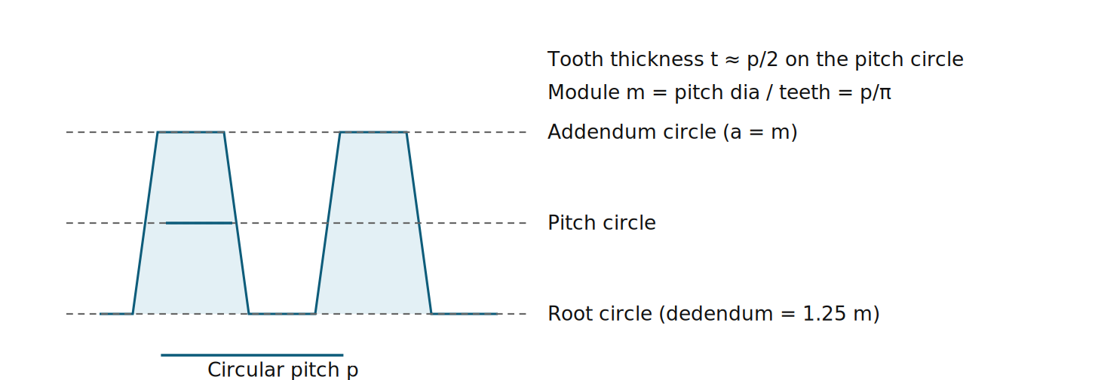
Fig 1. Basic tooth terms. Thick bar = tooth thickness on pitch circle.

2. Classification of gear inspection
Analytical (elemental) inspection measures each element separately: profile, pitch, tooth thickness, lead, runout, and so on. It tells the cause of an error, so it is used for diagnosis, master gears and process control. It needs gear tooth profile testers, pitch-measuring instruments, lead testers and gear tooth verniers.
Functional (composite) inspection meshes the gear with a master gear and checks the combined action. It is quick and gives the overall quality (GO / NO-GO), so it suits production inspection. It reveals the total effect of errors but not which element caused them.
Basis | Analytical | Functional (rolling test)
Measures | Individual elements | Combined effect on meshing
Time / skill | Slow, skilled | Fast, unskilled
Use | Diagnosis, masters, tool setting | Production, final acceptance
Result | Numerical error values | Graph of centre distance variation

3. Rolling (composite) gear test
The test gear is mounted on a floating carriage and held in tight mesh (double-flank contact) with an accurate master gear by a spring. When rotated, any error in the test gear changes the centre distance, which a dial gauge or recorder displays.
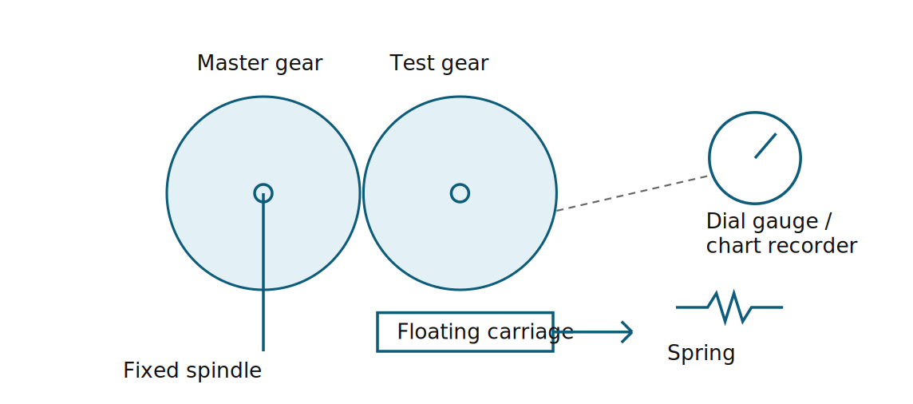
Fig 2. Layout of a rolling gear tester (double-flank).
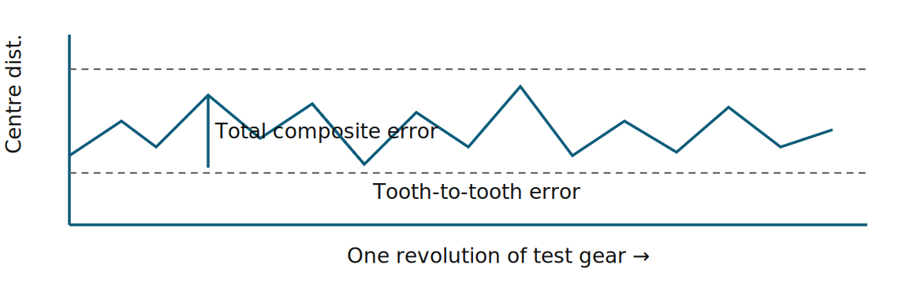
Fig 3. Composite error chart. Peak-to-peak height = total composite error; small jumps = tooth-to-tooth composite error; the slow wave = runout.
- Total composite error: maximum centre-distance variation in one full revolution.
- Tooth-to-tooth composite error: variation as the gear turns through one pitch.
- Single-flank testing (one flank in contact with a fixed centre distance) measures transmission error but needs costly equipment.

4. Tooth thickness by the constant chord method
The constant chord is the chord joining the points where the two flanks touch the mating rack's flanks, with the tooth symmetrical about the rack axis. It is independent of the number of teeth, so one set-up suits all gears of the same module and pressure angle.
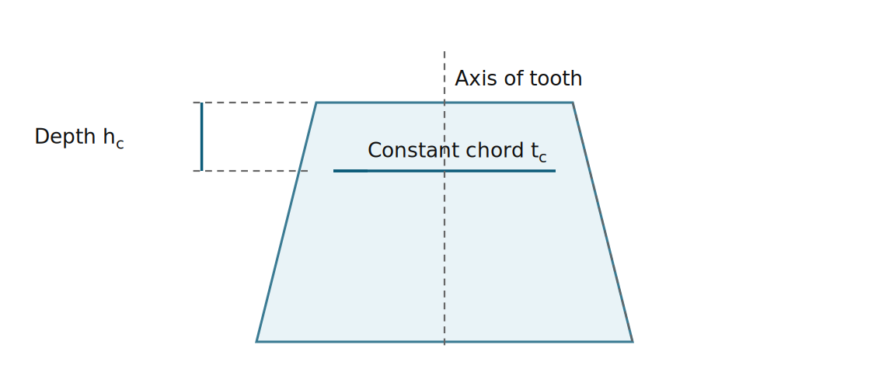
Fig 4. Constant chord and its depth below the tooth tip.
Formulae (standard 20° involute, module m, pressure angle α):
Constant chord t_{c} = m·(π/2)·cos²α = 1.3871 m (α = 20°)
Depth of chord from tip h_{c} = a − (m·π/8)·sin2α = 0.7476 m (taking a = m)
Check: (π/2)(0.8830)=1.3871; (π/8)(0.6428)=0.2524; 1 − 0.2524 = 0.7476.
Because t_{c} and h_{c} depend only on m and α, the vernier is set once for all gears of that module. Measured t_{c} is compared with the calculated value, and the difference is the thickness error (this also reveals backlash allowance).

5. Gear tooth vernier caliper
It has two perpendicular scales: the vertical scale sets the depth h (chordal addendum) and the horizontal scale measures the chordal thickness. It is placed on the tooth with the vertical slider resting on the addendum circle.
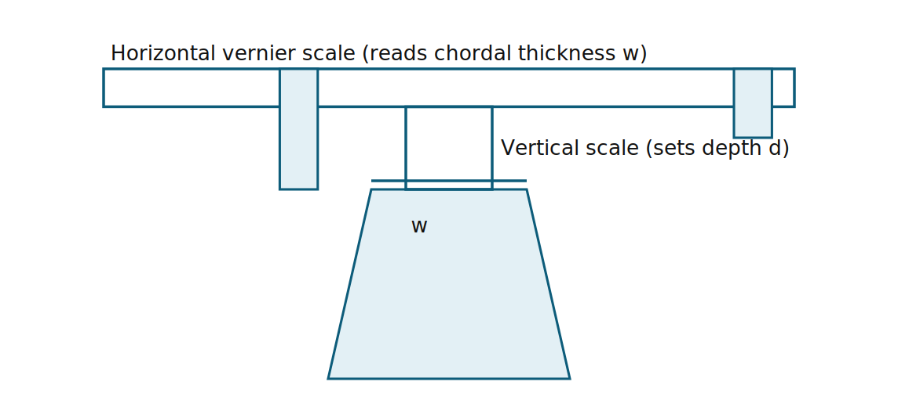
Fig 5. Gear tooth vernier on a tooth.
For a spur gear of N teeth, the chordal thickness and chordal addendum are:
w = N·m·sin(90°/N) d = m·[1 + (N/2)(1 − cos(90°/N))]
Example. m = 4 mm, N = 30: 90°/30 = 3°; w = 30·4·sin 3° = 6.280 mm; d = 4[1 + 15(1 − cos 3°)] = 4[1 + 15(0.001371)] = 4.082 mm.
Limitations: accuracy relies on the addendum circle being accurate; least count ≈ 0.02 mm; the two verniers need operator skill; only suited to coarse and medium gears. Where tip accuracy is doubtful, use the constant chord, span micrometer or base tangent method.

6. Gear errors
Error | Meaning | Effect
Backlash | Clearance between non-driving flanks of meshing teeth, measured along the pitch circle (or normal to the flank). Provided on purpose for lubrication and thermal expansion; it should be small and uniform. | Lost motion, noise, impact on reversal
Runout | Radial variation of tooth position relative to the axis, checked by a ball or pin placed in each tooth space and a dial gauge, taking the max–min reading in one rotation. | Cyclic variation of centre distance, vibration
Profile error | Deviation of the actual tooth form from the true involute | Noise, uneven load
Pitch error | Individual (adjacent), and cumulative error in tooth spacing | Uneven angular velocity
Lead error | Deviation of the helix of helical gears or tooth alignment of spur gears | Concentrated contact, uneven bearing
Composite error | Total and tooth-to-tooth variation found in the rolling test | Overall quality grading
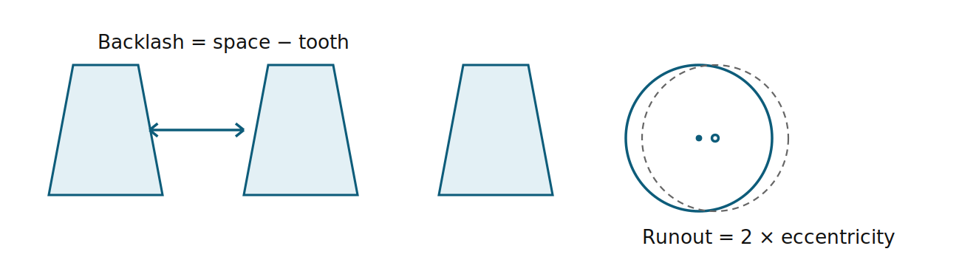
Fig 6. Backlash between flanks, and runout from eccentric mounting.

Part B – Machine Tool Testing
Machine tool testing (acceptance tests) is done to IS 2063 (general), IS 2063 Part 1, or the IS 7010 series for individual machines (lathe, drilling, milling, grinding, etc.). Tests check geometrical accuracy of the machine in an unloaded state, then practical accuracy by cutting a test piece. The machine is levelled on its foundation first (spirit level, 0.02 mm/m) and the instruments used are dial gauges, straightedges, test mandrels, precision levels, autocollimators, optical squares and master cylinders.
Each test has a tolerance and a measuring method. Typical practice for a lathe: the tolerance is quoted as a value over a stated length (e.g. 0.02 mm / 300 mm).

1. Straightness
Straightness of slideways, in the horizontal and vertical planes. Methods: precision straightedge with feeler gauges or a dial gauge, spirit level moved in steps along the bed, taut wire with microscope, or autocollimator for long beds. Level readings taken at equal intervals are plotted cumulatively to give the profile.
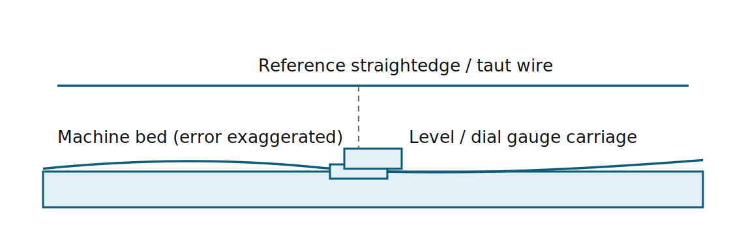
Fig 7. Straightness testing of a bed.

2. Parallelism
Used to check e.g. carriage movement parallel to the spindle axis, or a table parallel to its motion. A dial gauge is fixed on the moving unit and its stylus touches the datum surface or a mandrel. The carriage is moved along the full length and the maximum difference of readings is the parallelism error.
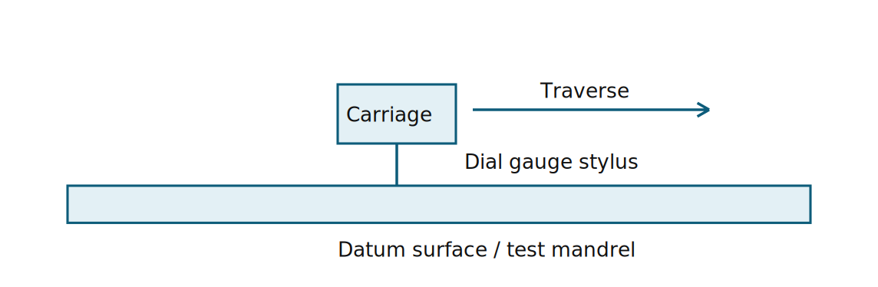
Fig 8. Parallelism check with a dial gauge.

3. Squareness
Checks the right angle between two axes or planes (e.g. cross-slide to the bed, column to table, spindle to table). Tools: a try-square with feeler or dial gauge, or a precision square. A dial gauge on the moving member reads along the square's blade. Method: place a master square on the reference surface, set the dial to zero on one end of the blade and read at the other end. Alternatively, a spindle-mounted dial indicator swings (180° apart) over a table to give perpendicularity of spindle to table, with error = difference in readings per diameter.
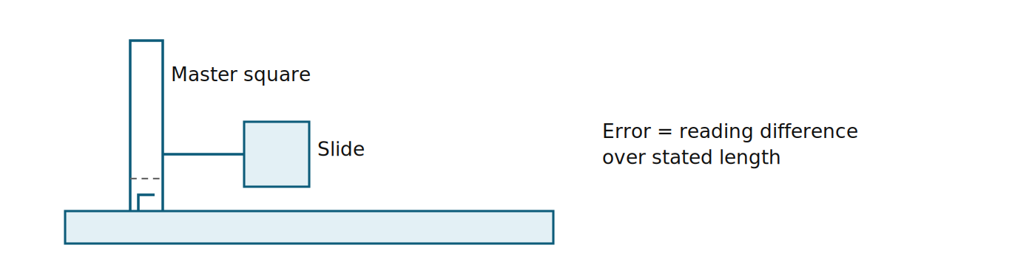
Fig 9. Squareness of slide to base, using a master square and dial gauge.

4. Coaxiality
Alignment of two axes on one line (e.g. headstock spindle and tailstock axis; spindle and the quill). A test mandrel is fixed in the spindle and a dial gauge reads on it, while a second mandrel is held in the tailstock or other part. The difference in readings in the vertical and horizontal planes, over a stated distance, gives the coaxiality error. The maximum reading is taken from two diametrically opposite positions.

5. Roundness
Roundness (circularity) of a spindle, mandrel or workpiece. Instruments: a roundness tester (rotating spindle or rotating table with a transducer), V-block with dial gauge, or a bench centre with a dial gauge. Roundness error is the largest radial distance between two concentric circles enclosing the profile (minimum zone circles). Out-of-roundness may be lobed (oval, three lobes); 2-point diameter measurement cannot detect odd lobes, so use a V-block or three-point method.
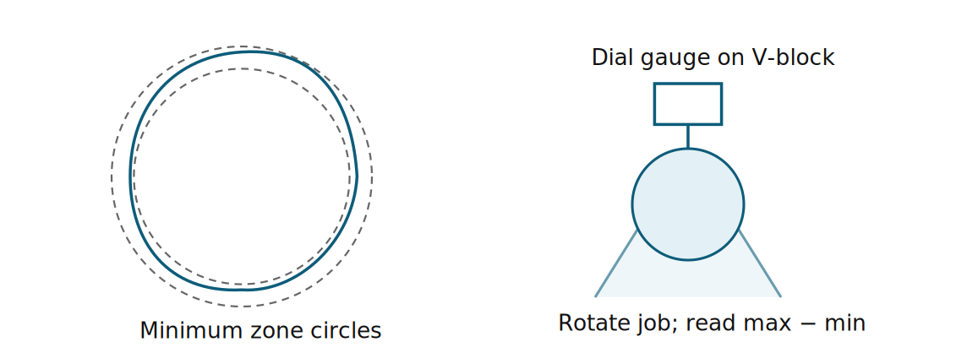
Fig 10. Roundness error zone, and a V-block test.

6. Runout
The variation shown by a dial gauge, with its stylus on a surface, as the part is rotated. Radial runout (axial-direction stylus perpendicular to the surface): checked at the spindle nose, taper bore, a test mandrel at two points (near and 300 mm away). Axial runout / face runout: the stylus on a face, parallel to the axis; also called wobble. Camlock / periodic axial slip is checked with the gauge on the spindle end while a force is applied.
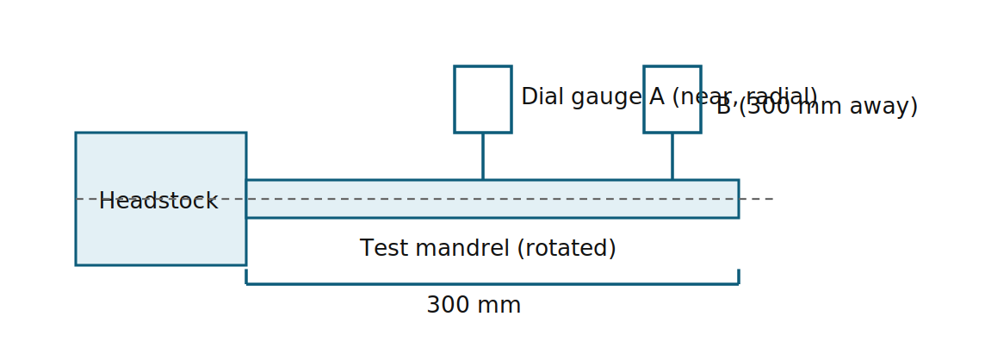
Fig 11. Radial runout of the spindle at the mandrel.

7. Alignment testing as per IS procedure (lathe example)
- Levelling of the machine: precision level on the carriage, at both ends of the bed; the bed should be level within about 0.02 mm/m in both directions.
- Straightness of bed: carriage movement in the vertical plane (level or straightedge) and horizontal plane (taut wire / straightedge). Tolerance is typically 0.02 mm up to 500 mm length of the bed, then grows with length.
- Spindle: camlock/axial slip (≤0.01 mm), radial runout at spindle nose or taper bore (≤0.01 mm), true running of the centre (≤0.01 mm).
- Spindle axis parallel to carriage movement: a mandrel in the spindle, dial gauge on the carriage, in the vertical and horizontal planes. Typical tolerance 0.02 mm per 300 mm, with free end of the mandrel inclined up and toward the tool only.
- Tailstock: its guideway parallel to carriage movement; the tailstock sleeve parallel to the carriage in both planes; the tailstock taper bore axis likewise.
- Alignment of headstock and tailstock centres: height difference, tailstock slightly higher than the headstock (only).
- Cross-slide squareness to the spindle axis: a disc or face plate and dial gauge, with tolerance about 0.02 mm per 300 mm (the face concave only).
- Lead screw: axial slip and periodic error; pitch accuracy.
- Practical tests: turn a test piece of the standard size (cylindrical turning, facing, threading); check roundness (≤0.01 mm) and cylindricity and flatness of the face.
Procedure rule: the machine is unloaded, warmed up for the stated time, geometric tests are done before practical tests, and instrument errors and readings are recorded to the specified least counts.
Tolerances above are indicative for a normal-accuracy lathe. Always confirm the figures against the relevant IS table for the machine, size class and accuracy grade used.

Question bank

2-mark questions
- Distinguish between analytical and functional gear inspection.
- What is a rolling gear test?
- What is meant by constant chord of a gear tooth?
- Write the expressions for chordal thickness and chordal addendum of a spur gear.
- Define backlash in gears.
- What is composite error? Name its two types.
- Define radial runout of a gear.
- Why is a gear tooth vernier unsuitable for high-precision gears?
- What is straightness error of a machine slideway?
- Give two methods of measuring straightness.
- Define coaxiality of two axes.
- What is roundness error?
- Why are geometrical tests done before practical tests on a machine?
- Name the Indian Standards that cover acceptance testing of machine tools.

5-mark questions
- Explain the constant chord method of measuring tooth thickness, deriving t_{c} and h_{c} for a 20° involute gear.
- Describe the gear tooth vernier with a neat sketch. Calculate the chordal thickness and chordal addendum for m = 5 mm, N = 36.
- Write short notes on gear errors: backlash, runout and pitch error.
- Compare analytical inspection with functional inspection of gears.
- With a sketch, explain how the straightness of a lathe bed is tested.
- Explain the squareness test of a machine slide with a neat sketch.
- How is the runout of a lathe spindle checked? Explain with a sketch.
- Describe the methods of measuring roundness.
- Explain parallelism and coaxiality tests used in machine tool testing.

10-mark questions
- With a neat sketch, describe a rolling (composite) gear tester. How is the composite error chart interpreted? Compare it with elemental testing.
- Derive the formulae for the constant chord and its depth from the tip, and explain how the gear tooth vernier is used to measure tooth thickness. Mention its limitations.
- Discuss the various gear errors (backlash, runout, profile, pitch, lead, composite), their causes, effects and methods of measuring them.
- Explain the geometrical alignment tests of a centre lathe as per the IS procedure, with sketches for at least five tests.
- Explain the testing of straightness, parallelism and squareness of machine tools, with the instruments and sketches used for each.
- Describe the methods of testing roundness, runout and coaxiality in a machine tool. How are the tolerances specified?

